**MINISTRY OF EDUCATION AND TRAINING**

**FPT UNIVERSITY**

Capstone Project Document

**Health Support Tracking System**

|  |  |
| --- | --- |
| **Group 2** | |
| **Group members** | Ha Kim Quy – QuyHKSE61160  Tran Dang Quan – QuanTDSE60878  Man Huynh Khuong - KhuongMHSE61148  Phan Nhat Anh – AnhPNSE90158 (Dropped out)  Nguyen Duy Khuong – Khuongnd60493 (Dropped out) |
| **Supervisor** | Mr. Kieu Trong Khanh |
| **Ext. Supervisor** | N/A |
| **Capstone Project code** | HSTS |

-Ho Chi Minh City, 09/09/2015-

# Table of Contents

Table of Contents 3

List of Tables 5

List of Figures 6

Definitions, Acronyms, and Abbreviations 7

A. Introduction 8

1. Project Information 8

2. Introduction 8

3. Current Situation 8

4. Problem Definition 8

5. Proposed Solution 9

5.1. Feature functions 9

5.2. Advantages and disadvantages 9

6. Functional Requirements 9

6.1. Nurse. 10

6.2. Doctor. 10

6.3. Admin. 10

6.4. Staff. 10

6.5. Patient. 10

7. Role and Responsibility 10

B. Software Project Management Plan 11

1. Problem Definition 11

1.1. Name of this Capstone Project 11

1.2. Problem Abstract 11

1.3. Project Overview 11

2. Project organization 13

2.1. Software Process Model 13

2.2. Roles and responsibility 14

2.3. Tools and Techniques 15

3. Project Management Plan model 15

3.1. Software development life cycle 15

3.2. Phase Detail 16

4. Coding Convention 18

C. Software Requirement Specification 19

1. User Requirement Specification 19

1.1. Doctor requirement 19

1.2. Staff requirement 19

1.3. Patient requirement 19

1.4. Admin requirement 19

2. System Requirement Specification 20

2.1. External Interface Requirement 20

2.2. System Overview Use Case 21

2.3. List of Use Case 22

3. Software System Attribute 67

3.1. Usability 67

3.2. Reliability 67

3.3. Availability 67

3.4. Security 67

3.5. Maintainability 67

3.6. Portability 67

3.7. Performance 68

# List of Tables

Table 1: Definitions, Acronyms, and Abbreviations 11

Table 2: Role and Responsibility 14

Table 3: Hardware requirement for continuous integrating server 16

Table 4: Hardware requirement for web development 17

Table 5: Hardware requirement for mobile development 17

Table 6: Software requirement for this project 17

Table 7: Roles and Responsibility Details 19

Table 8: Tools and Techniques 19

Table 9: Software development lifecycle 20

Table 10: Phase 1: Requirement Analysis 20

Table 11: Phase 2: Design 21

Table 12: Phase 3: Implementation 21

Table 13: Phase 4: Testing 21

Table 14: Phase 5: Maintenance 21

Table 15: Use Case WG01 - <Guest> Login 28

Table 16: Use Case WU01 - <Authorized User> Logout 30

Table 17: Use Case WD01 - <Doctor> Make Prescription 33

Table 18: Use Case WD02 - <Doctor> View Patient Medical History 34

Table 19: Use Case WDM01 - <Doctor Manager> Insert Regimen 37

Table 20: Use Case WDM02 - <Doctor Manager> Update Regimen 40

Table 21: Use Case WDM03 - <Doctor Manager> Delete Regimen 42

Table 22: Use Case WND01 - <Nutrition Doctor> Make Nutritional Ingredient 45

Table 23: Use Case WND02 - <Nutrition Doctor> Insert Food’s Nutrition 47

Table 24: Use Case WND03 - <Nutrition Doctor> Update Food’s Nutrition 48

Table 25: Use Case WND04 - <Nutrition Doctor> Delete Food’s Nutrition 50

Table 26: Use Case WN01 - <Nurse> Register Medical Examination 53

Table 27: Use Case WN02 - <Nurse> Print Prescription 54

Table 28: Use Case WS01 - <Scheduler> Analyse Data Of Wristband 56

Table 29: Use Case WA01 - <Admin> Insert Account 58

Table 30: Use Case WA02 - <Admin> Update Account 59

Table 31: Use Case WA03 - <Admin> Delete Account 61

Table 32: Use Case WST01 - <Staff> Insert Wristband 63

Table 33: Use Case WST02 - <Staff> Update Wristband 65

Table 34: Use Case WST03 - <Staff> Delete Wristband 67

Table 35: Use Case WST04 - <Staff> Update Formula 69

Table 36: Use Case WAL01 - <Analyst> Suggest Treatment 73

Table 37: Use Case WAL02 - <Analyst> Analyse Meal 74

Table 38: Use Case WAL03 - <Analyst> Analyse Meal By Voice 77

Table 39: Use Case MP01 - <Patient> Logout 78

Table 40: Use Case MP02 - <Patient> Pair Device 79

Table 41: Use Case MG01 - <Guest> Login 81

Table 42: Use Case MS01 - <Scheduler> Analyse New Treatment 82

Table 43: Use Case MS02 - <Scheduler> Remind Patient 83

Table 44: Use Case MS03 - <Scheduler> Get Data From Wristband 85

Table 45: Use Case MS04 - <Scheduler> Synchronize Practice Data 86

Table 46: Use Case MS05 - <Scheduler> Notice Result Data 87

Table 47: Use Case MS06 - <Scheduler> Check Notification Of Patient 89

Table 48: Component Dictionary - Describes components 93

Table 49: Class dictionary: Describe Class 95

Table 50: Class Diagram Explanation - Account 96

Table 51: Class Diagram Explanation - Role 96

Table 52: Class Diagram Explanation - Notify 96

Table 53: Class Diagram Explanation - Doctor 96

Table 54: Class Diagram Explanation - Patient 96

Table 55: Class Diagram Explanation – ParamMearsurement 97

Table 56: Class Diagram Explanation - Appointment 97

Table 57: Class Diagram Explanation - Wristband 97

Table 58: Class Diagram Explanation - Food 97

Table 59: Class Diagram Explanation - FoodIngredient 98

Table 60: Class Diagram Explanation - Illness 98

Table 61: Class Diagram Explanation - MedicalRecord 98

Table 62: Class Diagram Explanation - MedicalRecordData 99

Table 63: Class Diagram Explanation - Medicine 99

Table 64: Class Diagram Explanation - Phase 99

Table 65: Class Diagram Explanation – Practice 99

Table 66: Class Diagram Explanation - PreventCheck 100

Table 67: Class Diagram Explanation - PropertyRecord 100

Table 68: Class Diagram Explanation - Regimen 100

Table 69: Class Diagram Explanation - Role 100

Table 70: Class Diagram Explanation - Treatment 100

Table 71: Class Diagram Explanation - UnitOfFood 100

Table 72: Component Interface 131

Table 73: Web Design – Register Patient Field 134

Table 74: Web Design – Register Patient Button/HyperLinks 134

Table 75: Web Design – Register Patient With Old Man Fields 136

Table 76: Web Design – Register Patient With Old Man Buttons/HyperLinks 137

Table 77: Web Design – Patient Management Field 137

Table 78: Web Design – Patient Management Buttons/HyperLinks 137

Table 79: Web Design – Regimen Management Field 138

Table 80: Web Design – Regimen Management Buttons/HyperLinks 139

Table 81: Web Design – Create Regimen Fields 139

Table 82: Web Design – Create Regimen Buttons/HyperLinks 139

Table 83: Web Design – Update Regimen Fields 140

Table 84: Web Design – Update Regimen Buttons/HyperLinks 140

Table 85: Web Design – Delete Regimen Buttons/HyperLinks 141

Table 86: Web Design – Details Regimen Buttons/HyperLinks 141

Table 87: Web Design – Create New Phase Fields 141

Table 88: Web Design – Buttons/HyperLinks 142

Table 89: Web Design – Update Phase Fields 142

Table 90: Web Design – Update Phase Buttons/HyperLinks 142

Table 91: Web Design – Buttons/HyperLinks 142

Table 92: Mobile Design – Guest Home Fields 144

Table 93: Mobile Design – Guest Home Buttons/HyperLinks 144

Table 94: Mobile Design – Guest Home ItemList 145

Table 95: Mobile Design – Patient Home Page Fields 146

Table 96: Mobile Design – Patient Home Page Buttons 146

Table 97: Mobile Design – Scheduler Remind Patient Fields 147

Table 98: Mobile Design – Scheduler Remind Patient ListView 147

Table 99: ERD - Entity Dictionary 149

Table 100: Database - Data Dictionary 163

Table 101: Web application - Test Cases 163

Table 102: Web application - Test Result 164

Table 103: Mobile Application - Test Environment 165

Table 104: Mobile Application - Test Cases 165

Table 105: Mobile Application - Test Result 166

Table 106: Web Application Test Case - <Guest>Login 169

Table 107: Web Application Test Case - <Authorized User>Logout 169

Table 108: Web Application Test Case - <Doctor>Make Prescription 173

Table 109: Web Application Test Case - <Doctor>Insert Regimen 173

Table 110: Web Application Test Case - <Doctor Manager>Update Regimen 176

Table 111: Web Application Test Case - <Doctor Manager>Delete Regimen 177

Table 112: Web Application Test Case - <Nutrition Doctor>Make Nutritional Ingredient 179

Table 113: Web Application Test Case - <Nurse>Register Medical Examination 182

Table 114: Web Application Test Case - <Nurse>Print Prescription 183

Table 115: Web Application Test Case - <Admin>Insert Account 183

Table 116: Web Application Test Case - <Admin>Update Account 184

Table 117: Web Application Test Case - <Admin>Delete Account 184

Table 118: Web Application Test Case - <Analyst>Suggest Treatment 186

Table 119: Web Application Test Case - <Analyst>Analyse Meal By Voice 188

Table 120: Web Application Test Case - <Analyst>Analyse Meal 190

Table 121: Mobile Application Test Case - <Patient>Logout 190

Table 122: Mobile Application Test Case - <Patient>Device 190

Table 123: Mobile Application Test Case - <Guest> Login 191

Table 124: Mobile Application Test Case - <Scheduler>Remind Patient 191

Table 125: Mobile Application Test Case - <Scheduler>Notice Practice Result 193

Table 126: Installation Guide - Hardware Requirement 193

Table 127: Installation Guide - Software Requirement 193

# List of Figure

Figure 1 Modified Waterfall Development Model 18

Figure 2: System Overview Use Case – Web Application 25

Figure 3: System Overview Use Case – Mobile Application 26

Figure 4: Web Application Use Case – <Guest>Overall Use Case 26

Figure 5: Web Application Use Case – <Guest>Login 27

Figure 6: Web Application Use Case – <Authorized User>Overall Use Case 28

Figure 7: Web Application Use Case – <Authorized User>Logout 29

Figure 8: Web Application Use Case – <Doctor>Overall Use Case 30

Figure 9: Web Application Use Case – <Doctor>Make Prescription 30

Figure 10: Web Application Use Case – <Doctor>View Patient Medical History 33

Figure 11: Web Application Use Case – <Doctor Manager>Overall Use Case 35

Figure 12: Web Application Use Case – <Doctor Manager>Insert Regimen 35

Figure 13: Web Application Use Case – <Doctor Manage>Update Regimen 38

Figure 14: Web Application Use Case – <Doctor Manager>Delete Regimen 40

Figure 15: Web Application Use Case – <Nutrition Doctor>Overall Use Case 42

Figure 16: Web Application Use Case – <Nutrition Doctor>Make Nutritional Ingredient 43

Figure 17: Web Application Use Case – <Nutrition Doctor> Insert Food's Nutrition 46

Figure 18: Web Application Use Case – <Nutrition Doctor>Update Food's Nutrition 47

Figure 19: Web Application Use Case – <Nutrition Doctor>Delete Food's Nutrition 49

Figure 20: Web Application Use Case – <Nurse>Overall Use Case 50

Figure 21: Web Application Use Case – <Nurse>Register Medical Examination 50

Figure 22: Web Application Use Case – <Nurse>Print Prescription 53

Figure 23: Web Application Use Case – <Scheduler>Overall Use Case 54

Figure 24: Web Application Use Case – <Scheduler>Analyse Data Of Wristband 55

Figure 25: Web Application Use Case – <Admin>Overall Use Case 56

Figure 26: Web Application Use Case – <Admin>Insert Account 56

Figure 27: Web Application Use Case – <Admin>Update Account 58

Figure 28: Web Application Use Case – <Admin>Delete Account 60

Figure 29: Web Application Use Case – <Staff>Overall Use Case 61

Figure 30: Web Application Use Case – <Staff>Insert Wristband 61

Figure 31: Web Application Use Case – <Staff>Update Wristband 63

Figure 32: Web Application Use Case – <Staff>Delete Wristband 65

Figure 33: Web Application Use Case – <Staff>Update Formula 67

Figure 34: Web Application Use Case – <Analyst>Overall Use Case 69

Figure 35: Web Application Use Case – <Analyst>Suggest Treatment 70

Figure 36: Web Application Use Case – <Analyst>Analyse Meal 73

Figure 37: Web Application Use Case – <Analyst>Analyse Meal By Voice 75

Figure 38: Mobile Application Use Case – <Patient>Overall Use Case 77

Figure 39: Mobile Application Use Case – <Patient>Logout 77

Figure 40: Mobile Application Use Case – <Patient>Pair Device 78

Figure 41: Mobile Application Use Case – <Guest>Overall Use Case 80

Figure 42: Mobile Application Use Case – <Guest>Login 80

Figure 43: Mobile Application Use Case – <Scheduler>Overall Use Case 82

Figure 44: Mobile Application Use Case – <Scheduler>Analyse New Treatment 82

Figure 45: Mobile Application Use Case – <Scheduler>Remind Patient 83

Figure 46: Mobile Application Use Case – <Scheduler>Get Data From Wristband 84

Figure 47: Mobile Application Use Case – <Scheduler>Synchronize Practice Data 85

Figure 48: Mobile Application Use Case – <Scheduler>Notice Practice Result 86

Figure 49: Mobile Application Use Case – <Scheduler>Check Notifications Of Patient 87

Figure 50: Conceptual Diagram 90

Figure 51: System Architecture Design 91

Figure 52: Component Diagram 92

Figure 53: Class Diagram 94

Figure 54: Web Sequence Diagram - <Guest>Login 101

Figure 55: Web Sequence Diagram - <Authorized User>Logout 102

Figure 56: Web Sequence Diagram - <Doctor>Make Prescription 103

Figure 57: Web Sequence Diagram - <Doctor>View Patient Medical History 103

Figure 58: Web Sequence Diagram - <Doctor Manager>Insert Regimen 104

Figure 59: Web Sequence Diagram - <Doctor Manager>Update Regimen 106

Figure 60: Web Sequence Diagram - <Doctor Manager>Delete Regimen 108

Figure 61: Web Sequence Diagram - <Nutrition Doctor>Make Nutritional Ingredient 110

Figure 62: Web Sequence Diagram - <Nutrition Doctor>Insert Food's Nutrition 110

Figure 63: Web Sequence Diagram - <Nutrition Doctor>Update Food's Nutrition 111

Figure 64: Web Sequence Diagram - <Nutrition Doctor>Delete Food's Nutrition 111

Figure 65: Web Sequence Diagram - <Nurse>Register Medical Examination 113

Figure 66: Web Sequence Diagram - <Nurse>Register Medical Examination With Old Patient 113

Figure 67: Web Sequence Diagram - <Nurse>Print Prescription 114

Figure 68: Web Sequence Diagram - <Scheduler>Analyse Data Of Wristband 115

Figure 69: Web Sequence Diagram - <Admin>Insert Account 116

Figure 70: Web Sequence Diagram - <Admin>Update Account 117

Figure 71: Web Sequence Diagram - <Admin>Delete Account 117

Figure 72: Web Sequence Diagram - <Staff>Insert Wristband 118

Figure 73: Web Sequence Diagram - <Staff>Update Wristband 119

Figure 74: Web Sequence Diagram - <Staff>Delete Wristband 120

Figure 75: Web Sequence Diagram - <Staff>Update Formula 120

Figure 76: Web Sequence Diagram - <Analyst>Suggest Treatment 121

Figure 77: Web Sequence Diagram - <Analyst>Analyse Meal By Voice 122

Figure 78: Web Sequence Diagram - <Analyst>Analyse Meal 123

Figure 79: Mobile Sequence Diagram - <Patient>Logout 124

Figure 80: Mobile Sequence Diagram - <Patient>Pair Wristband 124

Figure 81: Mobile Sequence Diagram - <Guest>Login 125

Figure 82: Mobile Sequence Diagram - <Scheduler>Analyse New Treatment 126

Figure 83: Mobile Sequence Diagram - <Scheduler>Remind Patient 127

Figure 84: Mobile Sequence Diagram - <Scheduler>Get Data From Wristband 128

Figure 85: Mobile Sequence Diagram - <Scheduler>Synchronize Practice Data 128

Figure 86: Mobile Sequence Diagram - <Scheduler>Notice Practice Result 129

Figure 87: Mobile Sequence Diagram - <Scheduler>Check Notification Of Patient 129

Figure 88: Web Application Design - <Nurse>Register Medical Examination 133

Figure 89: Web Application Design - <Nurse>Register Medical Examination With Old Patient 135

Figure 90: Web Application Design - <Nurse>Patient Management Design 137

Figure 91: Web Application Design - <Nurse>Print Prescription 138

Figure 92: Web Application Design - <Doctor Manager>Regimen Management 138

Figure 93: Web Application Design - <Doctor>Manager>Create Regimen 139

Figure 94: Web Application Design - <Doctor Manager>Update Regimen 140

Figure 95: Web Application Design - <Doctor Manager>Delete Regimen 140

Figure 96: Web Application Design - <Doctor Manager>Detail Regimen 141

Figure 97: Web Application Design - <Doctor Manager>Create New Phase 141

Figure 98: Web Application Design - <Doctor Manager> Update Phase 142

Figure 99: Web Application Design - <Doctor Manager>Delete Phase 142

Figure 100: Web Application Design - <Doctor Manager>Detail Phase 143

Figure 101: Mobile Application Design - <Guest>Home Page 144

Figure 102: Mobile Application Design - <Patient>Pair Device 145

Figure 103: Mobile Application Design - <Patient>Home Page 146

Figure 104: Mobile Application Design - <Scheduler>Remind Patient 147

Figure 105: ERD - Entity Relationship Diagram 148

Figure 106: Algorithms - Analyse Meal By Voice - Flow Chart 153

Figure 107: Algorithms - Mail Scheduler Process - Flow Chart 155

Figure 108: Algorithms - Medical Record State 156

Figure 109: Algorithms - Appointment State 156

Figure 110: Algorithms - Analyse Medical Record Data Process - Flow Chart 157

Figure 111: Algorithms - Analyse Treatment From Server - Flow Chart 159

Figure 112: Physical Diagram - Database 161

Figure 113: Web Application - Test Result 164

Figure 114: Mobile Application - Test Result 165

Figure 115: Communication Diagram - Web Application 167

Figure 116: Communication Diagram - Mobile Application 168

Figure 117: User Guide - <Nurse>Register Medical Examination 197

Figure 118: Mobile Application Design - <Nutrition Doctor>Make Food Ingredient 199

Figure 119: User Guide - <Doctor>Make Prescription 204

Figure 120: User Guide - <Patient>Login 208

Figure 121: User Guide - Pair Device 209

Figure 122:User Guide - <Patient>Remind Patient 210

# Definitions, Acronyms, and Abbreviations

|  |  |  |
| --- | --- | --- |
| **No.** | **Abbreviation & Acronym** | **Definition** |
| 1 | BLE | Bluetooth Low Energy |
| 2 | HSTS | Health Support Tracking System |

*Table 1: Definitions, Acronyms, and Abbreviations*

# Introduction

## Project Information

- Project name: **Health Support Tracking System**

- Project Code: **HSTS**

- Product Type: **Mobile Application, Website**

- Start Date: **September 07th, 2015**

- End Date: **December 12th, 2015**

## Introduction

In modern society, people take care more about their health and the fat is one of the most common illnesses. Patient doesn’t often pay attention while eating food or drink until going to the hospital. Doctor diagnoses patient as using which medicine and practicing exercises. However, patient uses medicine without exercises or forgets to use medicine that cause problem in effective treatment. Besides, some patient need to be followed and updated treatment after a period. Patient need to consult in time to treatment.

Today, there are many difference kinds of smart activity wristband providing functional with tracking workouts, calories burned and steps. Besides, that device can synchronize Bluetooth automatically with computer and over 150 leading smart phones.

So, these system can help doctor tracking practice information of patient, then doctor can setup new treatment for patient. We will remind patient when using medicine, doing exercise. Doctor can make appointment to patient but patient don’t need to waste time for meeting doctor. Patient’s treatment will update day by day following what they did.

## Current Situation

When someone need to track their practice, they will choose one wristband and install suitable mobile application for managing this device. People walk, run… every day and then the mobile app collects practical data and displays out to screen. In the next day, the data of wristband will be reset and counted again. Besides, some wristbands support to store data at stock’s server.

Process of fat medical examination at Ho Chi Minh Nutrition Center:

* Step 1: Patient buys health records and fill in information about profile.
* Step 2: Before payment, casher will insert patient profile to system based on health records.
* Step 3: Patient goes to Nutrition department and is checked general examination by nurse to get information about blood pressure, weight, height.
* Step 4: Patient walks to Health Monitor and have prevention check about body structure, calculate lipid mass in body.
* Step 5: Patient moves to Menu Creation department and is asked about what patient ate in one day by doctor. Doctor will calculate calories and evaluation index, for example, protein, starch, lipid, and calcium … which patient get in one day.
* Step 6: Patient comes back to Nutrition department and meets doctor to make medical examination and make prescription.
* Advantages:
* Patient can control all medical examination processes when they go to hospital.
* Doctor can make prescription easy.
* Disadvantages:
* All health records are recorded in paper, so if patients lose it, they will lose all past record.
* The registering procedure is complex.
* A process needs over 2 nurses.
* Patient moves many when going to hospital.
* System managing in hospital is very complex with all information of examine appeared in one page.
* Doctor cannot control patient’s following treatment, so making prescription for the patient is harder in next appointment.
* Time in making prescription is static, so system just only deploy in this hospital.

Process of fat medical examination at Ho Chi Minh Traditional Medical Hospital:

* Step 1: Patient buys health records and fill information about patient.
* Step 2: Before payment, a nurse will ask patient about which illness patient want to examination and insert patient’s profile into system.
* Step 3: Patient goes to polyclinic department, nurse will get information about blood pressure, weight, height and had general examination by doctor.
* Step 4: If patient has illness, doctor will make prescription and patient move to nurse to make Surgical Examination Form
* Step 5: Patient buy medicines from medical store.
* Advantages:
* Medical examination is simple.
* Hospital can make prescription for many patients in short time.
* Patient pay as less time as possible for making prescription.
* Disadvantages:
* Medical examination process is general and polyclinic doctor makes prescription clearly in a specific illness.
* Health record isn’t fully about specific illness.
* All health records are recorded in paper, so if patients lose it, they will lose all past record.
* Every doctor have difference prescription templates.
* Time in making prescription is static, so system just only deploy in this hospital.

There are some android applications which just help patient to making appointment with specific doctors, such as “So Kham Benh”, “Easycare” … And they cannot help patient tracking treatment’s status, reminding patient to use medicines, eat, and practice on time, synchronize treatment …

## Problem Definition

Below are the advantages and disadvantages of some activity and healthy tracking applications and on Android smartphone:

* Advantages.
  + Easy and fast tracking information like number of step, calories burned.
  + Have a group use that app to practice together.
* Disadvantages:
  + Do not have participation of doctor.
  + Only support for one smartphone or one wristband.
  + Cannot suggestion the treatment or exercises.
  + Cannot notify to doctor, patients.
  + Unusable regiment in treatment.
  + Display unusable information.
  + If patients lost health records, they cannot review recently examination histories.

## Proposed Solution

The application uses a combination between a smart phone and a wristband to gather the patient’s number of steps, calories burned, and others. Basing on the collected data, the doctor makes the treatment decision within system suggestion. The system will collect data from patient to propose the suggestion to the doctor, then doctor will make treatment decision and help patients to save examination histories.

### Feature functions

* The nurse can input the basic information of patient.
* The mobile application can collect patient’s data and send to server every day.
* The system compares it with standard regimen, then suggests for doctor.
* The doctor can view, edit and approve the regimen.
* The patient can receive treatment plan, notification from doctor.
* The system will remind the patient what he/she should do following treatment plan every day.
* The doctor can make the next appointment schedule.
* The patient can see current information of wristband, history and edit their information.

### Advantages and disadvantages

* Advantages:
  + The system provides for doctor pieces of tracking information to make treatment plan more effectively.
  + The patient will receive doctor’s treatment suggestions frequently.
  + The patient limits forgetting to use medicines or does others because this system will remind them.
* Disadvantages:
  + The doctor must have the personal computer and internet connection to access tracking information.
  + This system only used with people from 20 - 60 ages and does not have special diseases.
  + The patient also must have a suitable smartphone with wristband and internet connection to send information as well as receive treatment plan.
  + The patient must always use mobile application and wristband in the right way. In some cases, the patient is unnecessary to use wristband (for example: the flu). If not the system will collect wrong data and the treatment may be worse...
  + This system doesn’t support patient to make appointment with doctor, make prescription with specific doctor.
  + This system doesn’t manage medicines, prescriptions, food nutrition.

## Functional Requirements

Function requirements of the system are listed as below:

### Nurse.

* Nurse register medical examination for patient before patient meets the doctor.
* Nurse prints prescription for patient.

### Doctor.

* Doctor can view patient’s medical history.
* Doctor can view treatment suggestion provided by system.
* Doctor can edit treatment, do treatment.
* Doctor can make appointment.

### Doctor Manager.

* Doctor Manager can manage regimen.

### Admin.

* Admin can manage nurse, doctor and patient account.

### Nutrition Doctor.

* Nutrition Doctor researchs patient’s meals to analyse nutrition of each meal.

### Staff.

* Staff can manage supported wristbands, such as add new wristband specification to database.

### Patient.

Patient only uses a mobile application:

* Patient can view treatment plan.
* Patient can be remind to use medicine, do exercises… every day.
* Patient can view appointment.
* Patient can send a simple notice to doctor.

### Scheduler.

Scheduler will hit configured time to:

* Analyse data of wristband.
* Analyse new treatment for patient in smartphone.
* Remind patient.
* Get data from wristband.
* Synchronize practice data to server.
* Notice practice result to patient.
* Check notifications of patient.

## Role and Responsibility

|  |  |  |  |  |
| --- | --- | --- | --- | --- |
| No | Full Name | Role | Position | Contact |
| 1 | Kieu Trong Khanh | Project Manager | Instructor | khanhkt@fpt.edu.vn |
| 2 | Ha Kim Quy | Developer | Leader | quyhkse61160@fpt.edu.vn |
| 3 | Tran Dang Quan | Developer | Member | quantdse60878@fpt.edu.vn |
| 4 | Man Huynh Khuong | Developer | Member | khuongmhse61148@fpt.edu.vn |
| 5 | Phan Nhat Anh | Developer | Member | anhpnse90158@fpt.edu.vn |
| 6 | Nguyen Duy Khuong | Developer | Member | Khuongnd60493@fpt.edu.vn |

*Table 2: Role and Responsibility*

# Software Project Management Plan

## Problem Definition

### Name of this Capstone Project

Heal Support Tracking System (HSTS).

### Problem Abstract

At the moment, there is no system can connect between doctor and patient effectively in Vietnam. Large hospitals can manage their patient’s profile very good, but there is no system that collect and manage all patient’s profile. In fact a doctor can’t access patient’s record from different hospital. This situation makes problem that missing information, then the effective of treatment is always not best like people hope.

Another reason that they have not provided the doctor a good way to track their patient actively yet. The patient also do treatment following doctor’s guide without necessary support. Sometime, they forget to use medicine or miss the appointment, etc. Therefore, the effect of treatment is very low. For a common disease like fat, the treatment require patient having to use medicine and do exercise every day. However if they do exercise over guideline, they may be cause an unexpected problem when do exercise in high frequency.

For the goal that improving the treatment, we provide a system to make more communication between doctor and patient. By collecting patient’s information every day, the doctor can make the treatment more effectively. For example, the doctor can change the medicine immediately. The patient can save their time because they can receive newest medicine over a message or a notification. The patient also will be remind to meet appointment with doctor, etc.

### Project Overview

#### Current Situation

Below are the problems encountered in this project:

* **Collect requirement**: The medical treatment of a lot of diseases is the privacy asset of hospitals so we are difficult to access these documents.
* **Medical knowledge**: This project requires member have enough medical knowledge about treatments, common diseases and process.
* **Technique**: Some manufacturer do not use standard of Bluetooth developer.
* **Absent of the team member**: team members can get sick or unexpected problems.

#### The Proposed System

According to technology researches, we found out that a wristband with Bluetooth connection can help us resolving the problem of tracking fat patient’s treatment effective. We can use basic feature of a wristband such as measuring distance, calories burned to help doctor tracking the effective of treatment. Then doctor can improve the treatment for patient.

To resolve the medical knowledge problem, we gone to some large hospitals in Ho Chi Minh City such as Ho Chi Minh Nutrition Center and Traditional Medical Hospital. Then we find out their processes, real treatment for fat. We also find the necessary help to access some medical documents from our friends.

We assign responsibility in vertical to make sure if any members cannot continue to work in our team, there will be the least harmful to the project processes.

Our system include two subsystems:

- An online application for nurse, doctor, nutrition doctor, doctor manager, staff and administrator.

- A mobile application for patient.

##### Mobile Application

This application is used by patient, include below functions:

* Show treatment which accepted by doctor.
* Remind using medicine, doing exercises, appointment with doctor.
* Collect data from wristband and send to server.

##### Web Application

For nurse:

* Register medical examination for patient.
* Print prescription for patient.

For doctor:

* Make prescription.
* View patient medical history.

For administrator:

* Manage accounts.

For staff:

* Manage supported wristband.
* Update formula to support calculating calories.

For nutrition doctor

* Make nutritional ingredient.
* Manage food’s nutrition.

For doctor manager

* Manage regimen.

For scheduler

* Analyse data of wristband

For analyst

* Suggest treatment
* Analyse meal by voice
* Analyse meal.

#### Boundaries of the System

The system is built basing on real processes of some hospital and medical clinics in Vietnam. Our main target is improving the medical process of treating fat and other common diseases. We recommend that the age limitation of patient is from 20 to 60 years old only.

Especially, this system will not intent to solve below problems:

Firstly, patient’s profile management and missed information among hospitals.

Secondly, any complex diseases that require more human resources or higher technology equipment such as cancer and HIV/AIDS.

#### Development Environment

##### Hardware requirements

* For continuous integrating server:

|  |  |  |
| --- | --- | --- |
| Hardware | Minimum Requirements | Recommended |
| Internet Connection | 512Kbps | 4 Mbps |
| Operating System | Ubuntu Server 12 LTS | Ubuntu Server 14.04.2 LTS |
| Computer Processor | Intel® Pentium II | Intel® Core(TM) i5 CPU , M 460 @ 2.53GHz |
| Computer Memory | 1GB of RAM | 4GB of RAM or more |

*Table 3: Hardware requirement for continuous integrating server*

* For web development:

|  |  |  |
| --- | --- | --- |
| Hardware | Minimum Requirements | Recommended |
| Internet Connection | 512Kbps | 8 Mbps |
| Operating System | Windows Vista, 7, 8 | Windows 7, 8 |
| Computer Processor | 1 GHz | Intel® Core(TM) i5 CPU , M 460 @ 2.53GHz |
| Computer Memory | 2GB of RAM | 4GB of RAM or more |

*Table 4: Hardware requirement for web development*

* For mobile development:

|  |  |  |
| --- | --- | --- |
| Hardware | Minimum Requirements | Recommended |
| Internet Connection | 512Kbps | Wi-Fi Connection 12MB |
| Operating System | Android 4.3 | Android 4.4.2 |
| Hardware | Bluetooth 4.0 | Bluetooth 4.0 |
| Memory | 512 MB of RAM | 1GB of RAM or more |

*Table 5: Hardware requirement for mobile development*

* For wristband:

|  |  |  |
| --- | --- | --- |
| Hardware | Minimum Requirements | Recommended |
| Bluetooth Connection | BLE Supported | BLE Supported |
| Firmware Revision | 01011206 | 01011206 |
| Hardware | Bluetooth 4.0 | Bluetooth 4.0 |
| Memory | 64Kb of RAM | 64Kb of Ram |

*Table 6: Hardware requirement for wristband*

##### Software requirements

.

|  |  |
| --- | --- |
| Tools | Uses |
| MySQL Server 5.6 | Used for creating and manage the database for system. |
| IntelliJ IDEA 14.1.4 | Used for implementing website and web service. |
| Android Studio 1.3.2 | Used for implementing Android mobile |
| Github server | Used for storing source codes, documents. |
| SourceTree 1.6.20 | Used for version control |
| Software Ideas Modeler 8 | Used for creating models and diagrams |

*Table 7: Software requirement for this project*

## Project organization

### Software Process Model

This project is developed under waterfall model. We apply customized waterfall model to capable with current situation in our team. We choose this model because the following reasons:

* This is a project with clear requirement.
* Based on researches and clarify standard regimen of diseases are stable, clear, fixed and well understood by all team members.
* This project use BLE technology, which we have standard in bluetooth developer and android support.



*Figure 1 Modified Waterfall Development Model*

Reference: Page 30, chapter 2, Software process model, SOFTWARE ENGINEERING 9th Edition, by Ian Sommerville

### Roles and responsibility

|  |  |  |  |
| --- | --- | --- | --- |
| **No** | **Full name** | **Role in Group** | **Responsibilities** |
| **1** | Kieu Trong Khanh | Supervisor/Project Manager | * Specify user requirement * Control the development process * Give out technique and business analysis support |
| **2** | Ha Kim Quy | Team leader, BA, DEV, Tester | * Managing process * Clarifying requirements * Prepare documents * GUI Design * Designing database * Coding * Create test plan * Testing |
| **3** | Tran Dang Quan | BA, DEV, Tester | * Clarifying requirements * Prepare documents * GUI Design * Designing database * Coding * Create test plan * Testing |
| **4** | Phan Nhat Anh | BA, DEV, Tester | * Clarifying requirements * Prepare documents * GUI Design * Designing database * Coding * Create test plan * Testing |
| **5** | Man Huynh Khuong | BA, DEV, Tester | * Clarifying requirements * Prepare documents * GUI Design * Designing database * Coding * Create test plan * Testing |

*Table 8: Roles and Responsibility Details*

### Tools and Techniques

|  |  |
| --- | --- |
| Tool / Technique | Name / version |
| Frontend | HTML, CSS, JavaScript, jQuery, Bootstrap |
| Backend | JavaEE, Spring, Hibernate |
| Web server | Apache Tomcat 7 |
| Development tool | IntelliJ IDEA 14.1.4 |
| DBMS | MySQL 5.6 |
| Source control | SourceTree 1.6.20 |
| Modeling tool | Software Ideas Modeler |
| Document tool | Microsoft Word 2013 |

*Table 9: Tools and Techniques*

## Project Management Plan model

### Software development life cycle

|  |  |  |  |  |  |
| --- | --- | --- | --- | --- | --- |
| **Phase** | **Description** | **Deliverables** | **Resource needed** | **Dependencies and**  **Constrains** | **Risks** |
| **Requirement Analysis** | - Collect requirements from customer.  -Identify and clarify requirements for the system in general. | -Introduction of proposed system.  -Software requirement specification.  -Project Task Plan.  - Prototypes | 20 man- days | N/A | - Missing requirement  - Unclear scope of  project  - Lack of member share  of understand |
| **Design** | - Architecture design for the system  - Detail design using top-down break down  - Choose Architecture style | - Software Design Document  - Base code structure  - Technology notes | 20 man- days | Depend on  “Requirement  Analysis” | - Lack of experience.  - Not fulfil requirement. |
| **Implementation** | - Coding system core functions and other feature with GUI  - Unit test | - Main user’s functions on mobile and website  - Unit test document | 50 man- days | Depend on “Design”. | - Lack of experience and knowledge.  - Human mistake. |
| **Testing** | - Integration test the system  - Alpha test  - Correct bugs  - Beta test  - Acceptance test | - Test document  - Defect log | 20 man- days | Depend on  “Implementation” | - Lack of experience  - Missing test case |
| **Maintenance** | - Deploy on sever and mobile | - Installation guide  - User Manual | 10 man- days | Depend on  “Testing” | - Lack of experience. |

*Table 10: Software development lifecycle*

### Phase Detail

#### Phase 1: Requirement Analysis

|  |  |  |
| --- | --- | --- |
| **Task** | **Description** | **Author** |
| **1. Collect requirements** | Find which systems currently provide similar service, their strengths and weakness. | QuyHK, QuanTD, AnhPN, KhuongMH |
| **2. Identify and clarify main functions.** | Define which main functions system should provide. | QuyHK, QuanTD, AnhPN, KhuongMH |
| **3. Create System**  **Introduction.** | Complete Introduction Report. | QuyHK |
| **4. Software Project**  **Management Plan.** | Prepare Project Management Plan. | QuyHK |
| **5. Prototype.** | Build a prototype of proposed system (Website/Mobile). | QuyHK, AnhPN, KhuongMH |
| **6. SRS** | Create SRS document. | QuyHk, QuanTD, AnhPN, KhuongMH |

*Table 11: Phase 1: Requirement Analysis*

#### Phase 2: Design

|  |  |  |
| --- | --- | --- |
| **Task** | **Description** | **Author** |
| **1. Detailed Design** | Compare new document with existed documents of system. | QuyHK, QuanTD, AnhPN, KhuongMH |
| **2. Database Design** | Based on parsed data to recommendation.  Based on other needs to recommendation. | QuyHK, QuanTD, AnhPN, KhuongMH |
| **3. Technology research** | BLE, Gatt Service. | QuyHK |
| **4. Design Document** | Create software design document | QuyHK, Quan TD, AnhPN, KhuongMH |

*Table 12: Phase 2: Design*

#### Phase 3: Implementation

|  |  |  |
| --- | --- | --- |
| **Task** | **Description** | **Author** |
| **1. Front-end web functions** | Implement front-end functions on web | AnhPN |
| **2. Front-end mobile functions** | Implement front-end functions on mobile | QuyHK, KhuongMH |
| **3. Back-end web functions** | Implement back-end functions on web | QuanTD, AnhPN, KhuongMH |
| **4. Mobile functions** | Implement mobile application | QuyHK |
| **5. Unit testing** | Write test case and testing for web functions | QuanTD, AnhPN, KhuongMH |
| Write test case and testing for mobile functions | QuyHK |

*Table 13: Phase 3: Implementation*

#### Phase 4: Testing

|  |  |  |
| --- | --- | --- |
| **Task** | **Description** | **Author** |
| **1. Integration testing** | Write test case and testing systems | QuyHK, AnhPN, KhuongMH, QuanTD |
| **2. Alpha testing** | Do alpha test with customer. | QuyHk |

*Table 14: Phase 4: Testing*

#### Phase 5: Maintenance

|  |  |  |
| --- | --- | --- |
| **Task** | **Description** | **Author** |
| **1. Installation guide** | Write installation guide | QuyHK |
| **2. User Manual** | Write user manual | QuanTD, KhuongMH, AnhPN |

*Table 15: Phase 5: Maintenance*

**3.3 All Meeting Minutes**

Refer to Meeting Minutes folder.

## Coding Convention

Java: Using to develop website.

Summary:

* Naming Convention:
  + Variable names should be short yet meaningful. The choice of a variable name should be designed to indicate to the casual observer the intent of its use.
  + Methods should be verbs, in mixed case with the first letter lowercase, with the first letter of each internal word capitalized.
* Declarations Convention:
  + One declaration per line is recommended since it encourages commenting.

Using Java Code Convention From:

<http://www.oracle.com/technetwork/java/codeconvtoc-136057.html>

# Software Requirement Specification

## User Requirement Specification

### Doctor requirement

Doctor is user who uses service of system. The doctor can use some following functions:

* View patient’s medical history
* Make prescription

### Doctor Manager requirement

Doctor Manager is user who manages regimen of examming process. The doctor manager can use some following functions:

* Manage regiment
  + Insert regimen.
  + Update regimen.
  + Delete regimen.

### Nutrition Doctor requirement

Nutrition Doctor is user who manages nutrition of foods. The doctor manager can use some following functions:

* Make Nutrition Ingredient.
* Manage Nutrition Of Foods
* Insert food’s nutrition.
* Update food’s nutrition.
* Delete food’s nutrition.

### Staff requirement

Staff is user who manages formula to calculate data and data of wristband. The staff can use some following functions:

* Manage formula.
* Manage wristband
* Insert wristband
* Delete wristband
* Update wristband

### Patient requirement

Patient is people who use service of system. The patient can use some following functions:

* Pair wristband.
* Logout

### Admin requirement

Admin is people who manages account. Administrator can use some following functions:

* Manage account includes:
* Remove account.
* Add account based on template.
* Update specific account.

### Nurse requirement

Nurse is user who uses service of system. The doctor can use some following functions:

* Register Medical Examination.
* Print prescription.

### Guest requirement

Guest is user does not login to this system. Guest only has one function.

* Login

### Authorized User requirement

Authorized User is user who has logged into system. Authorized User only has on function.

* Logout

## System Requirement Specification

### External Interface Requirement

#### User interface

* The user interface uses Vietnamese language in android app and English language in web application.
* The user interface displays best on 1024x768-screen size.

#### Hardware Interface

* Android Smartphone:
  + Bluetooth 4.0 or above.
  + RAM: 1GB
  + CPU: 1.2GHz
* Wristband:
  + Bluetooth 4.0 or above.
  + RAM: 64Kb
* ROM: 64Kb

#### Software Interface

* Web application: work with Firefox(v30 or above), Chromes(v25 or above), Explorer(v10 or above).
* Mobile Application: Android operating system (v 4.3 or above), BLE technology supported.
* Wristband: Firmware revision: 01011206.

#### Communication Protocol

* Use HTTP protocol 1.1 for communication between the web browser and the web server.
* Use HTTP protocol 1.1 for communication between the mobile application and the web service.

### System Overview Use Case

#### Web Application

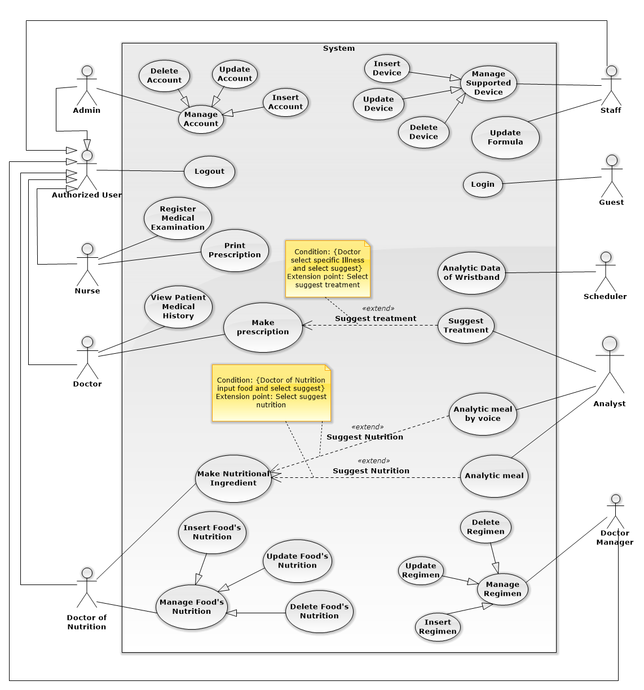

*Figure 2: System Overview Use Case – Web Application*

#### Mobile Application



*Figure 3: System Overview Use Case – Mobile Application*

### List of Use Case

#### Web Application

##### <Guest> Overall Use Case



*Figure 4: Web Application Use Case – <Guest>Overall Use Case*

###### <Guest> Login



*Figure 5: Web Application Use Case – <Guest>Login*

|  |  |  |  |
| --- | --- | --- | --- |
| **USE CASE – WG01** | | | |
| **Use Case No.** | WG01 | **Use Case Version** | 2.0 |
| **Use Case Name** | Log in | | |
| **Author** | QuanTD | | |
| **Date** | 1/10/2015 | **Priority** | Normal |
| **Actor:**   * Guest.   **Summary:**   * This use case allows authorized user to log in system.   **Goal:**   * Guest can log in the system.   **Triggers:**   * Guest sends the login command.   **Preconditions:**   * N/A.   **Post Conditions:**   * **Success:** User login system. * **Fail:** Show error message.   **Main Success Scenario:**   |  |  |  | | --- | --- | --- | | Step | Actor Action | System Response | | 1 | Guest goes to login view. | System require information:   * Username: free text input. * Password: free text input. | | 2 | User inputs information  [Exception 1,2] |  | | 3 | User sends login command. | Guest will login system with their specified role.  [Alternative 1] |   **Alternative Scenario:**   |  |  |  | | --- | --- | --- | | Step | Cause | System Response | | 1 | User inputs wrong credential information | System show error message that wrong username or password. |   **Exceptions:**  [Exception 1]   |  |  |  | | --- | --- | --- | | No | Cause | System Response | | 1 | User does not input username, or input username including special characters | System notice that user need to input valid username. |   [Exception 2]   |  |  |  | | --- | --- | --- | | No | Cause | System Response | | 2 | User does not input password, or input password including special characters | System notice that user need to input valid password. |   **Relationships:** N/A  **Business Rules:**   * After login to system, actor will see suitable view: * Doctor will see doctor view, including list of patient today. * Nurse will see nurse view, including list of patient and register patient view. * Doctor Manager will see list of regimen. * Administrator will see list of user account. * Staff will see list of available wristband. * Guest can’t use patient account to log in web view of system. * Password must be encrypted before sending to server. | | | |

*Table 16: Use Case WG01 - <Guest> Login*

##### <Authorized User> Overall Use Case



*Figure 6: Web Application Use Case – <Authorized User>Overall Use Case*

###### <Authorized User> Logout



*Figure 7: Web Application Use Case – <Authorized User>Logout*

|  |  |  |  |
| --- | --- | --- | --- |
| **USE CASE – WU01** | | | |
| **Use Case No.** | WU01 | **Use Case Version** | 2.0 |
| **Use Case Name** | Log out | | |
| **Author** | QuanTD | | |
| **Date** | 1/10/2015 | **Priority** | High |
| **Actor:**   * Authorized user.   **Summary:**   * This use case allows authorized user to log out of system.   **Goal:**   * User can log out of system.   **Triggers:**   * User sends logout command * User sends other command after not available too long.   **Preconditions:** N/A  **Post Conditions:**   * **Success:** Display login view. * **Fail:** N/A.   **Main Success Scenario:**   |  |  |  | | --- | --- | --- | | Step | Actor Action | System Response | | 1 | User sends log out command  [Alternative 1] | System clear session state if have, takes user out of system.  System display login view. |   **Alternative Scenario:**  [Alternative 1]   |  |  |  | | --- | --- | --- | | Step | Actor Action | System Response | | 1 | User sends any command after not available too long. | System check the session state then takes user out of system.  System display login view. |   **Exceptions:** N/A  **Relationships:** N/A  **Business Rules:**   * If user is not available longer than 30 minutes, they will see the login view when they be back. | | | |

*Table 17: Use Case WU01 - <Authorized User> Logout*

##### <Doctor> Overall Use Case



*Figure 8: Web Application Use Case – <Doctor>Overall Use Case*

###### <Doctor> Make Prescription



*Figure 9: Web Application Use Case – <Doctor>Make Prescription*

|  |  |  |  |
| --- | --- | --- | --- |
| **USE CASE – WD01** | | | |
| **Use Case No.** | WD01 | **Use Case Version** | 1.0 |
| **Use Case Name** | Make prescription | | |
| **Author** | QuyHK | | |
| **Date** | 16/11/2015 | **Priority** | High |
| **Actor:**   * Doctor.   **Summary:**   * This use case allows doctor to make prescription to patient.   **Goal:**   * New prescription data is created.   **Triggers:**   * Doctor sends command to make prescription request.   **Preconditions:**   * Actor logged in the system with role “Doctor”. * Patient has had a Prevention Check with nurse. * Patient has had a Food Ingredient with Nutrition Doctor.   **Post Conditions:**   * **Success:** New prescription is sent to patient. * **Fail:** Display error message.   **Main Success Scenario:**   |  |  |  | | --- | --- | --- | | Step | Actor Action | System Response | | 1 | Doctor goes make prescription of patient view. | System display view with following information:   * Name: text, read only. * Age: text, read only. * Gender: text, read only. * Illness: text, read only. * Status: text, read only. * Description: text area, read only. * List days of medical history of patient with information: * + Date: datetime * + Appointment: datetime * Suggest: button.   - Diagnostic: text input with option, required, length 3-40.  - Medicines:  + Name of medicine: text input with option, required.  + Times: text input with option, required, range value 1-6.  + Number of quantity per time: number text input, required, range value 1-10.  + Unit of medicine: text input, required, value depend on medicine.  + Advice: free text input.  - Food:  + Name of food: text input with option, required.  + Time: text input with option, required, range value 1-6.  + Number of quantity per time: number text input, required.  + Unit of food: text input with option, required, value depend on food.  + Advice: free text input.  - Practice:  + Name of practice: free text input, required.  + Time: text input with option, required, range value 1-6.  + Quantitative: free text input, required.  + Advice: free text input.  +Calories Estimate: free text input  - Appointment Date: date, required.  - Note: free text area. | | 2 | Doctor inputs diagnostic, medicines, food, practice, Note, appointment date.  [Alternative 1, 2] | System validate information. | | 3 | Doctor sends make prescription command with inputted information. | System display popup finish treatment request for confirmation. | | 4 | Doctor sends command to confirmation request.  [Alternative 3] | System create new prescription, display popup information of new prescription |   **Alternative Scenario:**  [Alternative 1]   |  |  |  | | --- | --- | --- | | Step | Actor Action | System Response | | 1 | Doctor sends suggest treatment of illness for diagnostic | System input automatically information of medicines, practices, foods. |   [Alternative 2]   |  |  |  | | --- | --- | --- | | Step | Actor Action | System Response | | 1 | Doctor sends make prescription command without inputting information | System show alert message to doctor. |   [Alternative 3]   |  |  |  | | --- | --- | --- | | Step | Actor Action | System Response | | 1 | Doctor sends command to No request. | System close popup confirmation. |   **Exceptions: N/A**  **Relationships:** Extend with “Suggest treatment”  **Business Rules:**   * List days of medical history is included: * Date is the day when doctor make prescription. * Appointment is appointment date. * The prescription must be included medicines, foods and practices. * Appointment must be in the future and not over 15 days from current day. * Format of date must be “dd/mm/yyyy”, ex: 25/09/2015. * Appointment date get default day is next 7 days form current day. * Calories Estimate has to suggest by using “total calories” in Food Ingredient subtract “basal metabolic rate” in Prevention Check. * Diagnostic input only use option. * Medicine input only use option. * Doctor can make patient’s Food Ingredient in tab food. * Doctor can view patient’s Food Ingredient in tab food. * If this appointment is re-examination, doctor can view patient’s medical record data in tab practice. * Quantitative in food, medicine should be use option. Quantitative in practice should be use free text input. | | | |

*Table 18: Use Case WD01 - <Doctor> Make Prescription*

###### <Doctor> View Patient Medical History



*Figure 10: Web Application Use Case – <Doctor>View Patient Medical History*

|  |  |  |  |
| --- | --- | --- | --- |
| **USE CASE – WD02** | | | |
| **Use Case No.** | WD02 | **Use Case Version** | 2.0 |
| **Use Case Name** | View Patient Medical History | | |
| **Author** | QuyHK | | |
| **Date** | 16/11/2015 | **Priority** | High |
| **Actor:**   * Doctor.   **Summary:**   * This use case allows doctor to view medical history of patient.   **Goal:**   * Show medical history of patient for doctor.   **Triggers:**   * Doctor select an appointment date to view.   **Preconditions:**   * User logged in system with role “Doctor”. * Doctor has selected a patient before.   **Post Conditions:**   * **Success:** Medical history of patient show for doctor. * **Fail:** Show error message   **Main Success Scenario:**   |  |  |  | | --- | --- | --- | | Step | Actor Action | System Response | | 1 | Doctor selects an appointment date to view. | System display medical history of patient in specific day.  - Date of appointment: text, read only.  - Medicines:  + Name of medicine: text input, read only.  + Times: text input, read only.  + Number of quantity per time: text input, read only.  + Unit of medicine: text input, read only.  + Advice: text input, read only.  - Food:  + Name of food: text input, read only.  + Time: text input, read only.  + Number of quantity per time: text input, read only.  + Unit of food: text input, read only.  + Advice: text input, read only.  - Practice:  + Name of practice: text input, read only.  + Time: text input, read only.  + Quantitative: text input, read only  + Advice: text input, read only.  [Exception 1] |   **Alternative Scenario:** N/A  **Exceptions:**  [Exception 1]   |  |  |  | | --- | --- | --- | | No | Cause | System Response | | 1 | Doctor manager sends cancel command | System display main view. |   **Relationships:** N/A  **Business Rules:**   * When doctor chooses a specific medical history day, system will load specific patient’s medical history data in that day included medicines, foods and practices. These data help doctor to make prescription more clear and correct. | | | |

*Table 19: Use Case WD02 - <Doctor> View Patient Medical History*

##### <Doctor Manager> Overall Use Case



*Figure 11: Web Application Use Case – <Doctor Manager>Overall Use Case*

###### <Doctor Manager> Insert Regimen



*Figure 12: Web Application Use Case – <Doctor Manager>Insert Regimen*

|  |  |  |  |
| --- | --- | --- | --- |
| **USE CASE – WDM01** | | | |
| **Use Case No.** | WDM01 | **Use Case Version** | 2.0 |
| **Use Case Name** | Insert regimen | | |
| **Author** | QuanTD | | |
| **Date** | 1/10/2015 | **Priority** | Normal |
| **Actor:**   * Doctor Manager.   **Summary:**   * This use case allows doctor manager to create new regimen.   **Goal:**   * Doctor Manager can create new regimen.   **Triggers:**   * Doctor Manager sends create regimen command.   **Preconditions:**   * Actor logged in system with role “Doctor Manager”.   **Post Conditions:**   * **Success:** New regimen data is inserted into storage. * **Fail:** System display error message.   **Main Success Scenario:**   |  |  |  | | --- | --- | --- | | Step | Actor Action | System Response | | 1 | Doctor manager sends create new regimen command | System require input fields:   * Name of regimen: free text input, required, length is 1- 100. * Name of illness: free text input, required, length is 1-100. * Detail of treatment phases:   + Number of day per a phase: free text input, required, value is 1-100.  + Medicine:   * Medicine name: text input with suggestion, required. * Quantitative: free text input with suggestion, required, value is 1-10. * Number of time: free text input, required, value is 1-7. * Advice: free text input, not required.   + Food:   * Food name: text input with suggestion, required. * Food unit: text input with suggestion, required. * Quantitative: free text input with suggestion, required, value is 1-10. * Number of time: free text input, required, value is 1-7. * Advice: free text input, not required.   + Practice:   * Practice name: text input with suggestion, required. * Time duration: free text input, required. * Number of time: free text input, required, value is 1-7. * Advice: free text input, not required. | | 2 | Doctor manager inputs all required field. | System validate information.  [Exception 1] | | 3 | Doctor manager sends create regimen command | System required doctor manager confirming all inputted information. | | 4 | Doctor manager sends submit command  [Alternative 1] | New regimen and detail of phases, medicines, foods and practices data are created in storage. System display main view.  [Exception 2] |   **Alternative Scenario:**  [Alternative 1]   |  |  |  | | --- | --- | --- | | Step | Actor Action | System Response | | 1 | Doctor manager sends cancel command | System display main view. |   **Exceptions:**  [Exception 1]   |  |  |  | | --- | --- | --- | | No | Cause | System Response | | 1 | Doctor manager does not input required fields. | System notice that user need to input required field.   * Regimen name: System ask user to input valid regimen name. * Name of illness: System ask user to input valid illness name. * Detail of treatment phases:   + Number of treatment day per phase: System ask user to input valid number of treatment day.  + Medicine:   * Medicine name: System ask user to input valid medicine name. * Quantitative: System ask user to input valid quantitative value. * Number of time: System ask user to input valid number of time value.   + Food:   * Food name: System ask user to input valid food name. * Food unit: System ask user to input valid food unit. * Quantitative: System ask user to input valid quantitative value. * Number of time: System ask user to input valid number of time value.   + Practice:   * Practice name: System ask user to input valid practice name. * Time duration: System ask user to input valid time duration value. * Number of time: System ask user to input valid number of time value. |   [Exception 2]   |  |  |  | | --- | --- | --- | | No | Cause | System Response | | 2 | Doctor manager sends submit command | System display error message that can’t create new regimen data. Creating regimen request is aborted. |   **Relationships:** N/A.  **Business Rules:**   * Name of regimen must be unique. * Regimen will be used to suggest doctor making prescription. | | | |

*Table 20: Use Case WDM01 - <Doctor Manager> Insert Regimen*

###### <Doctor Manager> Update Regimen



*Figure 13: Web Application Use Case – <Doctor Manage>Update Regimen*

|  |  |  |  |
| --- | --- | --- | --- |
| **USE CASE – WDM02** | | | |
| **Use Case No.** | WDM02 | **Use Case Version** | 2.0 |
| **Use Case Name** | Update regimen | | |
| **Author** | QuanTD | | |
| **Date** | 1/10/2015 | **Priority** | Normal |
| **Actor:**   * Doctor Manager.   **Summary:**   * This use case allows doctor manager to update regimen.   **Goal:**   * Doctor Manager can update an available regimen.   **Triggers:**   * Doctor Manager sends update regimen command.   **Preconditions:**   * Actor logged in system with role “Doctor Manager”. * The regimen must be available before.   **Post Conditions:**   * **Success:** New regimen data is inserted into storage. * **Fail:** System display error message.   **Main Success Scenario:**   |  |  |  | | --- | --- | --- | | Step | Actor Action | System Response | | 1 | Doctor manager sends update regimen command | System require input fields:   * Name of regimen: free text input, required, length is 1- 100. * Name of illness: free text input, required, length is 1-100. * Detail of treatment phases:   + Number of day per a phase: free text input, required, value is 1-100.  + Medicine:   * Medicine name: text input with suggestion, required. * Quantitative: free text input with suggestion, required, value is 1-10. * Number of time: free text input, required, value is 1-7. * Advice: free text input, not required.   + Food:   * Food name: text input with suggestion, required. * Food unit: text input with suggestion, required. * Quantitative: free text input with suggestion, required, value is 1-10. * Number of time: free text input, required, value is 1-7. * Advice: free text input, not required.   + Practice:   * Practice name: text input with suggestion, required. * Time duration: free text input, required. * Number of time: free text input, required, value is 1-7. * Advice: free text input, not required. | | 2 | Doctor manager inputs all required field.  [Alternative 1] | System validate information.  [Exception 1] | | 3 | Doctor sends update regimen command | System required doctor confirming all inputted information  [Alternative 1]  [Exception 1] | | 4 | Doctor sends submit command | System validate all information. If all information is valid, regimen information and detail of phases, medicines, foods and practices data are updated into storage. |   **Alternative Scenario:**  [Alternative 1]   |  |  |  | | --- | --- | --- | | Step | Actor Action | System Response | | 1 | Doctor manager sends cancel command | Display main view. Regimen data is not updated into storage. |   **Exceptions:**  [Exception 1]   |  |  |  | | --- | --- | --- | | No | Cause | System Response | | 1 | Doctor manager sends update regimen command without inputting all required fields. | System notice that user need to input required field.   * Regimen name: System ask user to input valid regimen name. * Name of illness: System ask user to input valid illness name. * Detail of treatment phases:   + Number of treatment day per phase: System ask user to input valid number of treatment day.  + Medicine:   * Medicine name: System ask user to input valid medicine name. * Quantitative: System ask user to input valid quantitative value. * Number of time: System ask user to input valid number of time value.   + Food:   * Food name: System ask user to input valid food name. * Food unit: System ask user to input valid food unit. * Quantitative: System ask user to input valid quantitative value. * Number of time: System ask user to input valid number of time value.   + Practice:   * Practice name: System ask user to input valid practice name. * Time duration: System ask user to input valid time duration value. * Number of time: System ask user to input valid number of time value. |   [Exception 2]   |  |  |  | | --- | --- | --- | | No | Cause | System Response | | 2 | Doctor manager sends cancel command | Regimen data is not updated into storage.  System display main view. |   **Relationships:** N/A.  **Business Rules:**   * After regimen is updated in storage, all information will be used for suggesting doctor make prescription to patient. | | | |

*Table 21: Use Case WDM02 - <Doctor Manager> Update Regimen*

###### <Doctor Manager> Delete Regimen



*Figure 14: Web Application Use Case – <Doctor Manager>Delete Regimen*

|  |  |  |  |
| --- | --- | --- | --- |
| **USE CASE – WDM03** | | | |
| **Use Case No.** | WDM03 | **Use Case Version** | 2.0 |
| **Use Case Name** | Delete regimen | | |
| **Author** | QuanTD | | |
| **Date** | 24/09/2015 | **Priority** | Normal |
| **Actor:**   * Doctor Manager.   **Summary:**   * This use case allows doctor manager to delete a regimen.   **Goal:**   * Doctor Manager can delete a regimen.   **Triggers:**   * Doctor sends delete regimen command.   **Preconditions:**   * Actor logged in system with role “Doctor Manager”. * The regimen must be available before.   **Post Conditions:**   * **Success:** The regimen has been deleted. * **Fail:** Display error message.   **Main Success Scenario:**   |  |  |  | | --- | --- | --- | | Step | Actor Action | System Response | | 1 | Doctor sends delete command | System require doctor manager to confirm deletion | | 2 | Doctor sends submit command  [Alternative 1] | System display main view. The regimen request is deleted from storage.  [Exception 1] |   **Alternative Scenario:**  [Alternative 1]   |  |  |  | | --- | --- | --- | | Step | Actor Action | System Response | | 1 | Doctor sends cancel command | Display main view. Regimen data is not deleted from storage. |   **Exceptions:**  [Exception 1]   |  |  |  | | --- | --- | --- | | No | Cause | System Response | | 1 | Doctor sends submit command | System display error message that can’t delete regimen data. Deleting regimen request is aborted. |   **Relationships:** N/A.  **Business Rules:**   * The regimen is deleted from storage. * After deleting regimen, old treatments won’t be affected. * This regimen can’t be used to suggest doctor making prescription continuously | | | |

*Table 22: Use Case WDM03 - <Doctor Manager> Delete Regimen*

##### <Nutrition Doctor> Overall Usecase



*Figure 15: Web Application Use Case – <Nutrition Doctor>Overall Use Case*

###### <Nutrition Doctor> Make Nutritional Ingredient



*Figure 16: Web Application Use Case – <Nutrition Doctor>Make Nutritional Ingredient*

|  |  |  |  |
| --- | --- | --- | --- |
| **USE CASE – WND01** | | | |
| **Use Case No.** | WND01 | **Use Case Version** | 2.0 |
| **Use Case Name** | Make Nutritional Ingredient | | |
| **Author** | QuyHK | | |
| **Date** | 30/09/2015 | **Priority** | Normal |
| **Actor:**   * Nutrition doctor.   **Summary:**   * This use case allows staff to be able to add food ingredient survey of patient.   **Goal:**   * Nutrition doctor will have more information of patient.   **Triggers:**   * Nutrition doctor selects a patient in list.   **Preconditions:**   * User logged in to the system as nutrition doctor role. * Specific patient must be registered by nurse.   **Post Conditions:**   * **Success:** System add information into patient’s medical record. * **Fail:** Error message displayed.   **Main Success Scenario:**   |  |  |  | | --- | --- | --- | | Step | Actor Action | System Response | | 1 | Nutrition doctor selects a patient. | System list following information:   * Microphone: Button * Breakfast * Result : free text input, length no limit * Breaktime Morning * Result : free text input, length no limit * Lunch * Result : free text input, length no limit * Breaktime Afternoon * Result : free text input, length no limit * Dinner * Result : free text input, length no limit * Eat late at night * Result : free text input, length no limit * Suggest: Button | | 3 | Nutrition doctor inputs fields and sends suggest foods command.  [Alternative 1] | System analyse foods to nutrition.  System show nutrition view with following information:   * Meal Assessment * Breakfast: numeric input, required * Breaktime Morning: numeric input, required * Lunch: numeric input, required * Breaktime Afternoon: numberic text input, required * Dinner: numeric input, required * Eat Late At Night: numeric input, required * Nutritional Assessment * Starch: numeric input, required * Protein: numeric input, required * Fat: numeric input, required * Animal Protein: numeric input, required * Animal Fat: numeric input, required * Calcium: numeric input, required * Sodium: numeric input, required * Iron: numeric input, required * Zinc: numeric input, required * Vitamin B1: numeric input, required * Vitamin C: numeric input, required * Vitamin B2: numeric input, required * Vitamin PP: numeric input, required * Fiber: numeric input, required | | 4 | Nutrition doctor input fields | System validate inputted information.  [Exception 1] | | 5 | Nutrition doctor send make nutrition ingredient command | Information of patient’s nutrition is create in storage. System redirect to list patients. |   **Alternative Scenario:**  [Alternative 1]   |  |  |  | | --- | --- | --- | | Step | Actor Action | System Response | | 1 | Nutrition doctor selects microphone. | System is enable voice | | 2 | Nutrition doctor says a sentence of meal. | System selects specific meal. | | 3 | Nutrition doctor says a sentence of food | System fill information to “Result” automatically. |   **Exceptions:**  [Exception 1]   |  |  |  | | --- | --- | --- | | No | Cause | System Response | | 1 | Nutrition doctor inputs wrong format. | System show wrong format message. |   **Relationships:** Extend with “Analyse meal” and “Analyse meal by voice”.  **Business Rules:**   * Nutrition’s unit of measure has to show on screen. * All values in numeric fields have to have value bigger than 0. * Breakfast, breaktime morning, lunch, breaktime afternoon, dinner, eat late at night have to have unit of measure which is calculated as kcal. * Starch, protein, fat, animal protein, animal fat, fiber have to have unit of measure is g. * Calcium, sodium, iron, zinc, vitaminB1, vitaminB2, vitaminC, vitaminPP have to have unit of measure is mg. * If there is no nutrition for analysis, valid will be set default is 0.0 * Inputted values in meal’s result field must be in format with a comma, such as “ăn một tô bún thịt nướng, ăn một bát cơm …” * After analysis foods by splited with a comma, system will calculate food nutrition for each food based on each unit of food, for example: 1 bát cơm = 200 Kcal. | | | |

*Table 23: Use Case WND01 - <Nutrition Doctor> Make Nutritional Ingredient*

###### <Nutrition Doctor> Insert Food’s Nutrition



*Figure 17: Web Application Use Case – <Nutrition Doctor> Insert Food's Nutrition*

|  |  |  |  |
| --- | --- | --- | --- |
| **USE CASE – WND02** | | | |
| **Use Case No.** | WND02 | **Use Case Version** | 2.0 |
| **Use Case Name** | Insert Food’s Nutrition | | |
| **Author** | KhuongMH | | |
| **Date** | 19/11/2015 | **Priority** | High |
| **Actor:**   * Nutrition doctor.   **Summary:**   * This use case allows nutrition doctor to create new food’s nutrition.   **Goal:**   * New food’s nutrition is created.   **Triggers:**   * Nutrition doctor sends create food’s nutrition command.   **Preconditions:**   * Actor logged in the system with role “Nutrition Doctor”.   **Post Conditions:**   * **Success:** New Food’s Nutrition is create. * **Fail:** Display error message.   **Main Success Scenario:**   |  |  |  | | --- | --- | --- | | Step | Actor Action | System Response | | 1 | Doctor sends create new food command. | System show following information:   * Food name: free text input, length 2 – 30, required. * Default Unit name: free text input, length 1 – 10, required. * Default Kcal Estimate: numeric number input, required. * Evaluation index: * Starch: numeric input, default value is 0.0 * Protein: numeric input, default value is 0.0 * Fat: numeric input, default value is 0.0 * Animal Protein: numeric input, default value is 0.0 * Animal Fat: numeric input, default value is 0.0 * Calcium: numeric input, default value is 0.0 * Sodium: numeric input, default value is 0.0 * Iron: numeric input, default value is 0.0 * Zinc: numeric input, default value is 0.0 * VitaminB1: numeric input, default value is 0.0 * VitaminC: numeric input, default value is 0.0 * VitaminB2: numeric input, default value is 0.0 * VitaminPP: numeric input, default value is 0.0 * Fiber: numeric input, default value is 0.0 | | 3 | Doctor inputs data. | System validate inputted information.  [Exception 1] | | 4 | Doctor sends command to create request.  [Alternative 1] | New food’s nutrition is created in storage. System redirect to list foods view. |   **Alternative Scenario:**  [Alternative 1]   |  |  |  | | --- | --- | --- | | Step | Actor Action | System Response | | 1 | Doctor cancels request. | System cancel command. |   **Exceptions:**  [Exception 1]   |  |  |  | | --- | --- | --- | | No | Cause | System Response | | 1 | Nutrition doctor inputs wrong format. | System show wrong format message. |   **Relationships:** N/A.  **Business Rules:**   * New food will stored with least one unit of food. * Value in defaults calories estimate field is calculated based on unit name. * Food name must not be duplicated. * After creating new food, nutrition doctor can make nutritional ingredient with these food. | | | |

*Table 24: Use Case WND02 - <Nutrition Doctor> Insert Food’s Nutrition*

###### <Nutrition Doctor> Update Food’s Nutrition



*Figure 18: Web Application Use Case – <Nutrition Doctor>Update Food's Nutrition*

|  |  |  |  |
| --- | --- | --- | --- |
| **USE CASE – WND03** | | | |
| **Use Case No.** | WND03 | **Use Case Version** | 2.0 |
| **Use Case Name** | Update Food’s Nutrition | | |
| **Author** | AnhPN | | |
| **Date** | 19/11/2015 | **Priority** | High |
| **Actor:**   * Nutrition doctor.   **Summary:**   * This use case allows nutrition doctor to update Food’s Nutrition.   **Goal:**   * Edit information of Food’s Nutrition.   **Triggers:**   * Nutrition doctor sends command to update Food’s Nutrition request.   **Preconditions:**   * Actor log in the system by role nutrition doctor.   **Post Conditions:**   * **Success:** Information Food’s Nutrition is edit. * **Fail:** Display error message.   **Main Success Scenario:**   |  |  |  | | --- | --- | --- | | Step | Actor Action | System Response | | 1 | Doctor select specific food and send updating food command. | System display popup with inputted information:   * Food name: free text input, length 2 – 30, required. * Default Unit name: free text input, length 1 – 10, required. * Default Kcal Estimate: numeric number input, required. * Evaluation index: * Starch: numeric input, default value is 0.0 * Protein: numeric input, default value is 0.0 * Fat: numeric input, default value is 0.0 * Animal Protein: numeric input, default value is 0.0 * Animal Fat: numeric input, default value is 0.0 * Calcium: numeric input, default value is 0.0 * Sodium: numeric input, default value is 0.0 * Iron: numeric input, default value is 0.0 * Zinc: numeric input, default value is 0.0 * VitaminB1: numeric input, default value is 0.0 * VitaminC: numeric input, default value is 0.0 * VitaminB2: numeric input, default value is 0.0 * VitaminPP: numeric input, default value is 0.0   Fiber: numeric input, default value is 0.0 | | 2 | Doctor change information about foods. | System validate inputted values.  [Exception 1] | | 3 | Doctor sends command to update request.  [Alternative 1] | System update information of food in storage.  System send redirect to list foods view. |   **Alternative Scenario:**  [Alternative 1]   |  |  |  | | --- | --- | --- | | No | Actor Action | System Response | | 1 | Doctor sends command to cancel request. | System hide form update food. |   **Exceptions:**  [Exception 1]   |  |  |  | | --- | --- | --- | | No | Cause | System Response | | 1 | Nutrition doctor inputs wrong format. | System show wrong format message. |   **Relationships:** N/A.  **Business Rules:**   * If nutrition doctor change unit of food, system will update specific food’s new unit of food. * After updating new food, all calculated data won’t be calculate again. | | | |

*Table 25: Use Case WND03 - <Nutrition Doctor> Update Food’s Nutrition*

###### <Nutrition Doctor> Delete Food’s Nutrition



*Figure 19: Web Application Use Case – <Nutrition Doctor>Delete Food's Nutrition*

|  |  |  |  |
| --- | --- | --- | --- |
| **USE CASE – WND04** | | | |
| **Use Case No.** | WND04 | **Use Case Version** | 2.0 |
| **Use Case Name** | Delete Food’s Nutrition | | |
| **Author** | AnhPN | | |
| **Date** | 19/11/2015 | **Priority** | High |
| **Actor:**   * Nutrition doctor.   **Summary:**   * This use case allows nutrition doctor to delete food’s nutrition.   **Goal:**   * Nutrition doctor can delete food’s nutrition.   **Triggers:**   * Nutrition doctor sends command to delete food’s nutrition request.   **Preconditions:**   * Actor log in the system by role nutrition doctor.   **Post Conditions:**   * **Success:** Food’s Nutrition is delete. * **Fail:** Display error message.   **Main Success Scenario:**   |  |  |  | | --- | --- | --- | | Step | Actor Action | System Response | | 1 | Doctor send delete specific food command | System show success message.System reload page. [Exception 1] |   **Alternative Scenario:** N/A  **Exceptions:**  [Exception 1]   |  |  |  | | --- | --- | --- | | No | Cause | System Response | | 1 | Food has been using for making prescription for patients | System show wrong message. |   **Relationships:** N/A.  **Business Rules:**   * System will delete all specific food’s units before deleting food. * System cannot delete food which is made prescription for patients or is in a regimen. | | | |

*Table 26: Use Case WND04 - <Nutrition Doctor> Delete Food’s Nutrition*

##### <Nurse> Overall Use Case



*Figure 20: Web Application Use Case – <Nurse>Overall Use Case*

###### <Nurse> Register Medical Examination



*Figure 21: Web Application Use Case – <Nurse>Register Medical Examination*

|  |  |  |  |
| --- | --- | --- | --- |
| **USE CASE – WN1** | | | |
| **Use Case No.** | WN1 | **Use Case Version** | 2.0 |
| **Use Case Name** | Register Medical Examination | | |
| **Author** | QuanTD | | |
| **Date** | 1/10/2015 | **Priority** | High |
| **Actor:**   * Nurse.   **Summary:**   * This use case allows nurse to register new patient profile.   **Goal:**   * Nurse can create new patient profile.   **Triggers:**   * Nurse sends create patient profile command.   **Preconditions:**   * Actor logged in system before with role “Nurse”.   **Post Conditions:**   * **Success:**   + New patient profile is stored.  + Credential information is sent to patient.  + Doctor will see new appointment with patient in his/her scheduler.   * **Fail:** Display error message.   **Main Success Scenario:**   |  |  |  | | --- | --- | --- | | Step | Actor Action | System Response | | 1 | Nurse sends create patient profile command. | System require inputting information:   * Patient name: free text input, required, length is 3- 50. * Birthdate: date time input, required, year old value is 20-60. * Male: option input, value is choose or not. * Weight: free text input, required, value is 2- 300, unit: kilogram. * Height: free text input, required, value = 100 - 250, unit: centimetre. * Doctor: text input with suggestion, required. * Medicine usage history: free text input. * Medical history: free text input. * Symptom: free text input, required, length = 10 – 1000. * Email: free text input, required, length = 10 – 100, unique. * Heart beat: free text input, required, value is 20-200, unit: times/minute. * Blood pressure: free text input, required, value is 20-200, unit: mmHg. * Waits: free text input, required, value is 50-300. * Body fat: free text input, required, value is 1-100, unit: %. * Visceral fat: free text input, required, value is 1-100, unit: level. * Muscle mass: free text input, required, value is 1-100, unit: %. * Body water: free text input, required, value is 1-100, unit: %. * Phase angle: free text input, required, value is 1-100, unit: o. * Impedance: free text input, required, value is 1-100, unit: Ohm. * Basal metabolic rate: free text input, value is 1-5000, unit: kilo calories. | | 2 | Nurse inputs all required information  [Alternative 1] | System validate information.  [Exception 1] | | 3 | Nurse sends register patient profile command | Display message that profile has been created. Credential information is sent to patient’s email.  [Exception 2] |   **Alternative Scenario:**  [Alternative 1]   |  |  |  | | --- | --- | --- | | Step | Actor Action | System Response | | 1 | Nurse sends cancel command. | Display main view. |   **Exceptions:**  [Exception 1]   |  |  |  | | --- | --- | --- | | No | Cause | System Response | | 1 | Nurse does not input all required fields, or input wrong some fields. | System notice that user need to input all required field.  + Patient name: System ask user to input patient name.  + Birthday: System ask user to input valid birthday.  + Weight: System ask user to input valid weight.  + Height: System ask user to input valid height.  + Doctor: System ask user to input valid doctor name.  + Symptom: System ask user input symptom, do not make it blank.  + Email: System ask user to input a valid email.  + Heart beat: System ask user input symptom, do not make it blank.  + Blood pressure: System ask user input blood pressure, do not make it blank.  + Waits: System ask user input waits, do not make it blank.  + Body fat: System ask user input body fat, do not make it blank.  + Visceral fat: System ask user input visceral fat, do not make it blank.  + Muscle mass: System ask user input muscle mass, do not make it blank.  + Body water: System ask user input body water, do not make it blank.  + Phase angle: System ask user input phase angle, do not make it blank.  + Impedance: System ask user input impedance, do not make it blank.  + Basal metabolic rate: System ask user input basal metabolic rate, do not make it blank. |   [Exception 2]   |  |  |  | | --- | --- | --- | | No | Cause | System Response | | 2 | Nurse inputs email that existed in system. | System notify user that email is existed in system, required user inputting again. |   **Relationships:** N/A.  **Business Rules:**   * With old patient, nurse don’t need to create new patient profile. System will suggest if nurse input duplicate name. * An email contain username and password should be send to patient, patient can use this credential information to login system. * The initial status of patient account will be set to INACTIVE. * New medical record data will be created with status AWAITING TO CHECK. * Email pattern should be: **/^[a-zA-Z0-9.!#$%&'*+\/=?^_`{|}~-]+@[a-zA-Z0-9](?:[a-zA-Z0-9-]{0,61}[a-zA-Z0-9])?(?:\.[a-zA-Z0-9](?:[a-zA-Z0-9-]{0,61}[a-zA-Z0-9])?)*$/** (following *RFC 5322 standard).* | | | |

*Table 27: Use Case WN01 - <Nurse> Register Medical Examination*

###### <Nurse> Print Prescription



*Figure 22: Web Application Use Case – <Nurse>Print Prescription*

|  |  |  |  |
| --- | --- | --- | --- |
| **USE CASE – WN02** | | | |
| **Use Case No.** | WN02 | **Use Case Version** | 2.0 |
| **Use Case Name** | Print prescription. | | |
| **Author** | QuanTD | | |
| **Date** | 1/10/2015 | **Priority** | High |
| **Actor:**   * Nurse.   **Summary:**   * This use case allows nurse to print prescription for a patient.   **Goal:**   * Nurse can view prescription document and print it.   **Triggers:**   * Nurse send printing prescription command.   **Preconditions:**   * Actor logged in system before with role “Nurse”. * Exist at least one treatment with status “On Treating” for current patient in storage.   **Post Conditions:**   * **Success:** Display prescription document. * **Fail:** Display error message.   **Main Success Scenario:**   |  |  |  | | --- | --- | --- | | Step | Actor Action | System Response | | 1 | Nurse send printing prescription command.  [Alternative 1] | System check available prescription for current patient. Then build a prescription document, display to nurse.  [Exception 1] |   **Alternative Scenario:**  [Alternative 1]   |  |  |  | | --- | --- | --- | | Step | Actor Action | System Response | | 1 | Nurse send printing prescription command. | System display message that no available prescription for current patient. |   **Exceptions:**  [Exception 1]   |  |  |  | | --- | --- | --- | | No | Cause | System Response | | 1 | Nurse send printing prescription command. | System display error message that can’t print prescription document. |   **Relationships:** N/A.  **Business Rules:**   * When nurse send print prescription command, system will check the existence of last treatment with status “On Treating” in storage. If it is existed, system will get the detail content of medicines part for building prescription document. * The detail content of prescription document included:   + Diagnostic.  + Next appointment date.  + All medicines and information of times, quantity, unit, note belong medicine defined in that treatment.  + Name of doctor.   * The output prescription document can be viewed directly, printed, or saved. It can’t be modified by another people except doctor. | | | |

*Table 28: Use Case WN02 - <Nurse> Print Prescription*

##### <Scheduler> Overall Use Case



*Figure 23: Web Application Use Case – <Scheduler>Overall Use Case*

###### <Scheduler> Analyse data of wristband



*Figure 24: Web Application Use Case – <Scheduler>Analyse Data Of Wristband*

|  |  |  |  |
| --- | --- | --- | --- |
| **USE CASE – WS01** | | | |
| **Use Case No.** | WS01 | **Use Case Version** | 1.1 |
| **Use Case Name** | Analyse data of wristband | | |
| **Author** | QuyHK | | |
| **Date** | 29/09/2015 | **Priority** | High |
| **Actor:**   * Scheduler.   **Summary:**   * This use case allows scheduler to use formula for analyse number of step from wristband.   **Goal:**   * Calculating calories burned, distance from patient’s data.   **Triggers:**   * The time hits configured time.   **Preconditions:**   * Analyse time has been configured.   **Post Conditions:**   * **Success**: System update data of patient. * **Fail**: Error detail will be tracked in a log file.   **Main Success Scenario:**   |  |  |  | | --- | --- | --- | | Step | Actor Action | System Response | | 1 | Server checks the current time.  If it hits configured time, analyse data process starts. | System use formula to calculate and response:   * Calories burned. * Distance walking or running.   System compares the number of calories recommended by doctors, calculate ratio complete practice every day and save in system.  [Exception 1] |   **Alternative Scenario:** N/A  **Exceptions:**  [Exception 1]   |  |  |  | | --- | --- | --- | | No | Cause | System Response | | 1 | System timer task is interrupted | Error detail will be tracked in a log file. |   **Relationships:** N/A  **Business Rules:**   * System have to analyse data using formula had latest update from staff. * System timer will check event at 23:00 every day, this config time is fixed. * System calculate and use data every day. * Log file has to save follow this structure: Analyse data from wristbands - [Datetime] – [Error message] – [Patient data] | | | |

*Table 29: Use Case WS01 - <Scheduler> Analyse Data Of Wristband*

##### <Admin> Overall Use Case



*Figure 25: Web Application Use Case – <Admin>Overall Use Case*

###### <Admin> Insert Account



*Figure 26: Web Application Use Case – <Admin>Insert Account*

|  |  |  |  |
| --- | --- | --- | --- |
| USE CASE – WA01 | | | |
| Use Case No. | WA01 | **Use Case Version** | 2.0 |
| Use Case Name | Insert Account | | |
| Author | KhuongMH | | |
| Date | 23/09/2015 | **Priority** | High |
| Actor:   * Admin   Summary:   * This use case allows admin to create new account in system.   Goal:   * Admin can create new account.   Triggers:   * Admin sends command to create new account in system.   Preconditions:   * User logged in the system with role “Admin”.   Post Conditions:   * Success: New account will be created for doctor, nurse or staff. * Fail: Show error message.   Main Success Scenario:   |  |  |  | | --- | --- | --- | | Step | Actor Action | System Response | | 1 | Admin goes to the register form. | System list information of account in system and components:   * Full Name: free text input, required, length 3 - 80 * Email: free text input, required, length 5 - 45 * Role: select one of the options * Date Of Birth: Date, required, value from 1900 to current year. * Gender: select one of the options. * Button imports excel list of information of account. * Button sends register command. * Button cancels register process. | | 2 | Admin fills in information of account.  [Alternative 1, 2] | System validate inputted information.  [Exception 1] | | 3 | Admin sends command to register new account with inputted information to system. | System shows message account has been created successfully.  [Exception 2] |   Alternative Scenario:  [Alternative 1]   |  |  |  | | --- | --- | --- | | Step | Actor Action | System Response | | 1 | Admin click on Cancel button to cancel the register process. | System redirect to previous page. |   [Alternative 2]   |  |  |  | | --- | --- | --- | | Step | Actor Action | System Response | | 1 | Admin import excel included list of information of accounts |  | | 2 | Admin sends command to create list of account to system. | System shows message account has been created successfully.  [Exception 1] |   Exceptions:  [Exception 1]   |  |  |  | | --- | --- | --- | | No | Cause | System Response | | 1 | Admin inputs invalid data. | System notices admin to fill:   * Full Name: System ask admin to input full name. * Email: System ask admin to input email. * Date of Birth: System ask admin to input date. |   [Exception 2]   |  |  |  | | --- | --- | --- | | No | Cause | System Response | | 1 | Admin sends command to create new account to system | System shows error message user cannot create because duplicated username. |   Relationships: N/A  Business Rules:   * New Account will be created with status In-Active. * System must ensure has not duplicated username. * When admin add account from register form, system will automatic generate username by splitting FullName, random password and save it to system, for example:  |  |  |  | | --- | --- | --- | | **Name** | **Username** | **Password** | | Man Huỳnh Khương | khuongmh | 3aY032fp |  * When admin import a file excel included list of information about accounts, system will read file and generate username and password for each in list and save it to system, for example of excel file :  |  |  |  |  |  | | --- | --- | --- | --- | --- | | Email | Full Name | Date Of Birth | Gender | Role | | [ANV@gmail.com](mailto:ANV@gmail.com) | Nguyễn Văn A | 31-12-2015 | MALE | DOCTOR | | | | |

*Table 30: Use Case WA01 - <Admin> Insert Account*

###### <Admin> Update Account



*Figure 27: Web Application Use Case – <Admin>Update Account*

|  |  |  |  |
| --- | --- | --- | --- |
| USE CASE – WA02 | | | |
| Use Case No. | WA02 | **Use Case Version** | 2.0 |
| Use Case Name | Update Account | | |
| Author | KhuongMH | | |
| Date | 23/09/2015 | **Priority** | High |
| Actor:   * Admin   Summary:   * This use case allows admin to update account’s profile.   Goal:   * Updating new information of account in system.   Triggers:   * Admin sends command to update account’s profile to system.   Preconditions:   * User has to log in to the system as Admin role.   Post Conditions:   * Success: New information of account will update to system. * Fail: Show error message.   Main Success Scenario:   |  |  |  | | --- | --- | --- | | Step | Actor Action | System Response | | 1 | Admin goes to see account’s profile | System list out information of account in system and components:   * Username: free text input, read-only * New Password: free text input, least length is 6 * Confirm New Password: free text input, least length is 6 * Full Name: free text input, required, length 3 - 80 * Address: free text input, length 3 - 250 * Role: select one of the options * Status: select one of the options * Update: Button * Cancel: Button | | 2 | Admin fill in updated information of account and click on update button.  [Alternative 1] | System validate inputted information.  [Exception 1] | | 3 | Admin sends command to update account to system. | System shows message account has been updated successfully. |   Alternative Scenario:  [Alternative 1]   |  |  |  | | --- | --- | --- | | No | Actor Action | System Response | | 1 | Admin cancels the register process. | System redirect to previous page. |   Exceptions:  [Exception 1]   |  |  |  | | --- | --- | --- | | No | Cause | System Response | | 1 | Admin inputs invalid data. | System notices admin to fill:   * Full Name: System ask admin to input full name. * Email: System ask admin to input email. * Date of Birth: System ask admin to input date. |   Relationships: N/A  Business Rules:   * Status of account will be changed | | | |

*Table 31: Use Case WA02 - <Admin> Update Account*

###### <Admin> Delete Account



*Figure 28: Web Application Use Case – <Admin>Delete Account*

|  |  |  |  |
| --- | --- | --- | --- |
| USE CASE – WA03 | | | |
| Use Case No. | WA03 | **Use Case Version** | 2.0 |
| Use Case Name | Delete Account | | |
| Author | KhuongMH | | |
| Date | 24/09/2015 | **Priority** | High |
| Actor:   * Admin   Summary:   * This use case allows admin to delete account in system.   Goal:   * Deleting account in system.   Triggers:   * Admin sends command to delete account in system.   Preconditions:   * User has to log in to the system as Admin role.   Post Conditions:   * Success: Admin is able to delete account. * Fail: Show error message.   Main Success Scenario:   |  |  |  | | --- | --- | --- | | Step | Actor Action | System Response | | 1 | Admin sends command to delete account to system. | System shows message options to confirm command. | | 2 | Admin confirms to delete account  [Alternative 1] | System delete account in system and show message deleting successful. |   Alternative Scenario:  [Alternative 1]   |  |  |  | | --- | --- | --- | | No | Actor Action | System Response | | 1 | Admin cancel confirmation to delete account | System abort to delete account. |   Exceptions: N/A  Relationships: N/A  Business Rules:   * Admin cannot delete himself. * Admin can delete wrong inputted accounts and accounts which have status “In-Active”. * Admin cannot delete accounts which were using. | | | |

*Table 32: Use Case WA03 - <Admin> Delete Account*

##### <Staff> Overall Use Case



*Figure 29: Web Application Use Case – <Staff>Overall Use Case*

###### <Staff> Insert Wristband



*Figure 30: Web Application Use Case – <Staff>Insert Wristband*

|  |  |  |  |
| --- | --- | --- | --- |
| **USE CASE – WST01** | | | |
| **Use Case No.** | WST01 | **Use Case Version** | 1.1 |
| **Use Case Name** | Insert Wristband | | |
| **Author** | QuyHK | | |
| **Date** | 30/09/2015 | **Priority** | Normal |
| **Actor:**   * Staff   **Summary:**   * This use case allows staff being able to add new wristband.   **Goal:**   * System can support reading data of many type of wristband.   **Triggers:**   * Staff sends adding new wristband command.   **Preconditions:**   * User logged in to the system as staff role.   **Post Conditions:**   * **Success:** Wristband’s specification is stored. * **Fail:** Error message displayed.   **Main Success Scenario:**   |  |  |  | | --- | --- | --- | | Step | Actor Action | System Response | | 1 | Staff goes to add new wristband view. | System list following information:   * Brand Name: free text input, required, length 2 - 24. * Brand UUID: free text input, required, required length 8 * Number of Step UUID: free text input, required, must be 8 characters. * Position Number of Step: free text input, required, value from 0 - 20   Text input UUID has to have example: **0000180a** | | 2 | Staff inputs Brand Name, UUID Brand Name, UUID Number of Step, and Position of Number of Step. | When user finishes input one field, if condition doesn’t match. System will show an error message next to that field. | | 3 | Staff sends adding new wristband command to system. | System add new wristband information to system.  System show new list of wristband and message that wristband is created successfully. [Exception 1, 2, 3, 4] |   **Alternative Scenario:** N/A  **Exceptions:**  [Exception 1]   |  |  |  | | --- | --- | --- | | No | Cause | System Response | | 1 | Missing of required fields | Show message notify staff which field is required. |   [Exception 2]   |  |  |  | | --- | --- | --- | | No | Cause | System Response | | 2 | Wrong format of UUID | System message notify staff use right format of UUID |   [Exception 3]   |  |  |  | | --- | --- | --- | | No | Cause | System Response | | 3 | Length of field’s value is out of range | Show message notify staff which field’s value is out of range |   [Exception 4]   |  |  |  | | --- | --- | --- | | No | Cause | System Response | | 4 | Wristband had existed in system | Show message notify entered wristband is existed |   **Relationships:** N/A  **Business Rules:**   * UUID has to right format of Bluetooth standard on page <https://developer.bluetooth.org/gatt/characteristics/Pages/CharacteristicsHome.aspx> * A valid UUID must start with “0000” characters. * System will insert new wristband information including: Brand name, Brand UUID, Number of step UUID, Position number of step to system. * Brand name does not have special characters. | | | |

*Table 33: Use Case WST01 - <Staff> Insert Wristband*

###### <Staff> Update Wristband



*Figure 31: Web Application Use Case – <Staff>Update Wristband*

|  |  |  |  |
| --- | --- | --- | --- |
| **USE CASE – WST02** | | | |
| **Use Case No.** | WST02 | **Use Case Version** | 1.1 |
| **Use Case Name** | Update Wristband | | |
| **Author** | QuyHK | | |
| **Date** | 29/09/2015 | **Priority** | Normal |
| **Actor:**   * Staff   **Summary:**   * This use case allows staff be able to update wristband.   **Goal:**   * System can read data of wristband with new specification.   **Triggers:**   * Staff sends the update wristband command.   **Preconditions:**   * User logged in to the system as staff role. * Staff selects a wristband exist in system.   **Post Conditions:**   * **Success:** Wristband information will be updated. * **Fail:** Show error message.   **Main Success Scenario:**   |  |  |  | | --- | --- | --- | | Step | Actor Action | System Response | | 1 | Staff goes to update wristband information. | System list following information:   * Brand Name: free text input, required, length 2 - 24. * Brand UUID: free text input, required, length 8 * Number of Step UUID: free text input, required, must have 8 characters. * Position Number of Step: free text input, required, value from 0 - 20   Text input UUID have to have example: **0000180a** | | 2 | Staff edits information of wristband. | When user finishes updating one field, if condition doesn’t match. System will show an error message next to that field. | | 3 | Staff sends command to save new information | System update information of wristband and show message notify wristband is updated successfully.  [Exception 1, 2, 3, 4] |   **Alternative Scenario:** N/A  **Exceptions:**  [Exception 1]   |  |  |  | | --- | --- | --- | | No | Cause | System Response | | 1 | Missing of required fields | Show message notify staff which field is required. |   [Exception 2]   |  |  |  | | --- | --- | --- | | No | Cause | System Response | | 2 | Wrong format of UUID | System message notify staff use right format of UUID |   [Exception 3]   |  |  |  | | --- | --- | --- | | No | Cause | System Response | | 3 | Length of field’s value is out of range | Show message notify staff which field’s value is out of range |   [Exception 4]   |  |  |  | | --- | --- | --- | | No | Cause | System Response | | 4 | Wristband had exist in system | Show message notify entered wristband is exist |   **Relationships:** N/A  **Business Rules:**   * An UUID must start with 0000. * System will update new wristband information including: Brand name, Brand UUID, Number of step UUID, Position number of step to system. * Brand name does not have special characters. | | | |

*Table 34: Use Case WST02 - <Staff> Update Wristband*

###### <Staff> Delete Wristband



*Figure 32: Web Application Use Case – <Staff>Delete Wristband*

|  |  |  |  |
| --- | --- | --- | --- |
| **USE CASE – WST03** | | | |
| **Use Case No.** | WST03 | **Use Case Version** | 1.1 |
| **Use Case Name** | Delete Wristband | | |
| **Author** | QuyHK | | |
| **Date** | 23/09/2015 | **Priority** | Normal |
| **Actor:**   * Staff   **Summary:**   * This use case allows staff to delete wristband.   **Goal:**   * System removes wristband.   **Triggers:**   * Staff sends deleting wristband command.   **Preconditions:**   * User logged in to the system as staff role.   **Post Conditions:**   * **Success:** Wristband is deleted. * **Fail:** Show error message.   **Main Success Scenario:**   |  |  |  | | --- | --- | --- | | Step | Actor Action | System Response | | 1 | Staff goes to manage wristbands view | System list out information of wristbands in system:   * Brand Name: text, read only. * Brand UUID: text, read only. * Number of Step UUID: text, read only. * Position Number of Step: text, read only. | | 2 | Staff selects wristband to delete in list. |  | | 3 | Staff sends command to delete wristband | System confirm with staff to delete wristband. | | 4 | Staff accepts to delete wristband  [Alternative 1] | System delete wristband and show message notify wristband is deleted successfully.  [Exception 1] |   **Alternative Scenario:**  [Alternative 1]   |  |  |  | | --- | --- | --- | | Step | Actor Action | System Response | | 1 | Staff sends cancel command. | System show list wristband for staff. |   **Exceptions:**  [Exception 1]   |  |  |  | | --- | --- | --- | | No | Cause | System Response | | 1 | Admin sends command to delete wristband. | System shows error message wristband cannot remove themselves from the system. |   **Relationships:** N/A  **Business Rules:**   * System must be at least 01 wristband. * Wristband have to exist in system. | | | |

*Table 35: Use Case WST03 - <Staff> Delete Wristband*

###### <Staff> Update Formula



*Figure 33: Web Application Use Case – <Staff>Update Formula*

|  |  |  |  |
| --- | --- | --- | --- |
| **USE CASE – WST04** | | | |
| **Use Case No.** | WST04 | **Use Case Version** | 1.1 |
| **Use Case Name** | Update Formula | | |
| **Author** | QuyHK | | |
| **Date** | 30/09/2015 | **Priority** | Normal |
| **Actor:**   * Staff   **Summary:**   * This use case allows staff being able to change formula to calculate calories, distance.   **Goal:**   * System can calculate data from patients based on formula.   **Triggers:**   * Staff sends editing formula command.   **Preconditions:**   * User logged in to the system as staff role.   **Post Conditions:**   * **Success:** System save formula and use to calculate calories, distance. * **Fail:** Error message displayed.   **Main Success Scenario:**   |  |  |  | | --- | --- | --- | | Step | Actor Action | System Response | | 1 | Staff goes to formula view. | System list following information:   * Formula to calculate distance: free text input, required. * Formula to calculate calories: free text input, required. * List variable, text view. * Name data of patient represent each variable. Drop down list. | | 2 | Staff inputs formula and select scan. | System find all variable in formula. | | 3 | Staff choose name data of patient represent each variable and select check formula. | System validate formula not divide “0” and calories, distance have to bigger than 0. If condition does match, System give staff can setup new formula.  [Exception 1] | | 4 | Staff choose setup formula. | System confirm with staff to change formula. | | 5 | Staff accept change formula.  [Alternative 1] | System change formula and variable and save in system |   **Alternative Scenario:**  [Alternative 1]   |  |  |  | | --- | --- | --- | | No | Actor Action | System Response | | 1 | Staff does not accept change formula. | System show old formula. |   **Exceptions:**  [Exception 1]   |  |  |  | | --- | --- | --- | | No | Cause | System Response | | 1 | Condition does not match | System show message notify staff input wrong formula. |   **Relationships:** N/A  **Business Rules:**   * Formula will be loaded once time when system starts. * New formula will save in text file. * New formula has to value above “0” and must not be divide with “0”. | | | |

*Table 36: Use Case WST04 - <Staff> Update Formula*

##### <Analyst> Overall Use Case



*Figure 34: Web Application Use Case – <Analyst>Overall Use Case*

###### <Analyst> Suggest Treatment



*Figure 35: Web Application Use Case – <Analyst>Suggest Treatment*

|  |  |  |  |
| --- | --- | --- | --- |
| **USE CASE – WAL01** | | | |
| **Use Case No.** | WAL01 | **Use Case Version** | 2.0 |
| **Use Case Name** | Suggest Treatment | | |
| **Author** | AnhPN | | |
| **Date** | 16/11/2015 | **Priority** | High |
| **Actor:**   * Analyst.   **Summary:**   * This use case allows analyst suggest treatment for doctor.   **Goal:**   * Doctor can be suggested base on regimen.   **Triggers:**   * Doctor sends command to make prescription request.   **Preconditions:**   * User log in the system by role doctor. * Doctor selected a patient before.   **Post Conditions:**   * Success: Show suggest treatment. * Fail: Log error.   **Main Success Scenario:**   |  |  |  | | --- | --- | --- | | Step | Actor Action | System Response | | 1 | Doctor goes make prescription of patient view. | System display   * Name: text, read only. * Age: text, read only. * Gender: text, read only. * Illness: text, read only. * Status: text, read only. * Description: text area, read only. * List day of medical history of patient with information:   + Date: the day when doctor make prescription, format day dd-mm-yyyy, ex: “29-10-2015”.  + Appointment: appointment of Date, format day dd-mm-yyyy, ex: “29-10-2015”.  Suggest treatment information.  Diagnostic: text input with option, required, length 3-40.  - Medicines:  + Name of medicine: text input with option, required.  + Times: text input with option, required, range value 1-6.  + Number of quantity per time: number text input, required, range value 1-10.  + Unit of medicine: text input, required, value depend on medicine.  + Advice: free text input.  - Food:  + Name of food: text input with option, required.  + Time: text input with option, required, range value 1-6.  + Number of quantity per time: number text input, required.  + Unit of food: text input with option, required, value depend on food.  + Advice: free text input.  - Practice:  + Name of practice: free text input, required.  + Time: text input with option, required, range value 1-6.  + Quantitative: free text input, required.  + Advice: free text input.   * Appointment Date: default 1 week form current day, format day “dd/mm/yyyy”. * Note: free text area. | | 2 | Doctor input diagnostic. | System validation information. | |  | Doctor sends command to suggest prescription | System display   * Name: text, read only. * Age: text, read only. * Gender: text, read only. * Illness: text, read only. * Status: text, read only. * Description: text area, read only. * List day of medical history of patient with information:   + Date: the day when doctor make prescription, format day dd-mm-yyyy, ex: “29-10-2015”.  + Appointment: appointment of Date, format day dd-mm-yyyy, ex: “29-10-2015”.   * Suggest treatment information.   - Diagnostic: text input with option, required, length 3-40.  - Medicines:  + Name of medicine: text input with option, required.  + Times: text input with option, required, range value 1-6.  + Number of quantity per time: number text input, required, range value 1-10.  + Unit of medicine: text input, required, value depend on medicine.  + Advice: free text input.  - Food:  + Name of food: text input with option, required.  + Time: text input with option, required, range value 1-6.  + Number of quantity per time: number text input, required.  + Unit of food: text input with option, required, value depend on food.  + Advice: free text input.  - Practice:  + Name of practice: free text input, required.  + Time: text input with option, required, range value 1-6.  + Quantitative: free text input, required.  + Advice: free text input.   * Appointment Date: default 1 week form current day, format day “dd/mm/yyyy”. * Note: free text area. |   **Alternative Scenario:** N/A  **Exceptions:** N/A  **Relationships:** Extend to “Make Prescription”  **Business Rules:**   * Diagnostic field is the name of illness which is identified by doctor. Doctor should be supported to find the exactly illness name defined in system when input the diagnostic field. * When doctor sends “Suggest Treatment” command, system will calculate current day is belong to which phase of suitable regimen. Then system will display the detail of phase: * All medicines with information of times, quantity, unit, note belong medicine defined in that phase. * All foods with information of times, quantity, unit, note belong food defined in that phase. * All practices with information of times, quantity, note belong practice defined in that phase. * All above information is help doctor making prescription follow standard medical process and regimen within least time. However, doctor can modify detail of output prescription basing on each patient when making prescription. * In case of doctor identify that diagnostic (stand for illness name) is different than the last diagnostic defined in storage, system understands that **“Patient is fine with old illness, but they are getting new sick”,** and it will get the first phase of suitable regimen belong to new diagnostic for displaying. | | | |

*Table 37: Use Case WAL01 - <Analyst> Suggest Treatment*

###### <Analyst> Analyse Meal



*Figure 36: Web Application Use Case – <Analyst>Analyse Meal*

|  |  |  |  |
| --- | --- | --- | --- |
| **USE CASE – WAL02** | | | |
| **Use Case No.** | WAL02 | **Use Case Version** | 1.1 |
| **Use Case Name** | Analyse meal. | | |
| **Author** | QuyHK | | |
| **Date** | 30/09/2015 | **Priority** | Normal |
| **Actor:**   * Nutrition doctor.   **Summary:**   * This use case analyse a text input to quantity, unit and food name.   **Goal:**   * System can help nutrition doctor analyse and calculate nutritional ingredients.   **Triggers:**   * Nutrition doctor sends analyse food command.   **Preconditions:**   * User logged in to the system as nutrition doctor role. * Nutrition doctor had selected patient.   **Post Conditions:**   * **Success:** System open Nutritional Ingredients view and input which field have values. * **Fail:** Error message displayed.   **Main Success Scenario:**   |  |  |  | | --- | --- | --- | | Step | Actor Action | System Response | | 1 | Nutrition doctor input information about foods.  Nutrition doctor sends analyse command. | System analyse meal to name, unit and quantity.  System calculate nutritional ingredients of meal.  System open Nutritional Ingredients view.  System input value of nutritional ingredients follow data had analyse.  [Exception 1] |   **Alternative Scenario:** N/A  **Exceptions:** N/A  **Relationships:** N/A  **Business Rules:**   * Format of food before analysis is :  |  |  |  | | --- | --- | --- | | Quantative | Unit Of Food | Name Of Food | | 2 | tô | Bún thịt nướng |  * If nutrition doctor input food with wrong format, system will skip it. * Every food will be wrote in same line and separated by commas. | | | |

*Table 38: Use Case WAL02 - <Analyst> Analyse Meal*

###### <Analyst> Analyse Meal By Voice



*Figure 37: Web Application Use Case – <Analyst>Analyse Meal By Voice*

|  |  |  |  |
| --- | --- | --- | --- |
| **USE CASE – WAL03** | | | |
| **Use Case No.** | WAL03 | **Use Case Version** | 1.1 |
| **Use Case Name** | Analyse meal by voice. | | |
| **Author** | QuyHK | | |
| **Date** | 30/09/2015 | **Priority** | Normal |
| **Actor:**   * Nutrition Doctor.   **Summary:**   * This use case allows nutrition doctor to input meal, unit and quantity by voice.   **Goal:**   * System support nutrition doctor input meal.   **Triggers:**   * Staff sends analyse meal by voice command.   **Preconditions:**   * User logged in to the system as nutrition doctor role and nutrition doctor had selected a patient.   **Post Conditions:**   * **Success:** System show meal had analyse on screen of doctor. * **Fail:** Error message displayed.   **Main Success Scenario:**   |  |  |  | | --- | --- | --- | | Step | Actor Action | System Response | | 1 | Nutrition doctor goes to analyse meal view. | System list following information:   * Button open voice input. * List meal (breakfast, break time morning, lunch, break time afternoon, dinner, eat late at night). * Meal of patient: free text input. | | 2 | Nutrition doctor sends command open voice input. | System enable record voice and convert to text. | | 3 | Nutrition doctor say name of meal. | System auto select and open corresponding meal. | | 4 | Nutrition doctor say food with unit. | System get meal and analyse text to unit, quantity and food name.  [Alternative 1] | | 5 | Nutrition doctor send suggest nutrition command. | * System analyse nutritional ingredients * System open Food Ingredient. * System input nutritional ingredients corresponding which field in Nutritional Ingredients view. |   **Alternative Scenario:**  [Alternative 1]   |  |  |  | | --- | --- | --- | | Step | Cause | System Response | | 1 | Food’s nutritional ingredients does not exist in system. | System does not analyse that food. |   **Exceptions:** N/A  **Relationships:** N/A  **Business Rules:**   * Nutrition doctor have to say meal before say meal. * Nutrition doctor can edit what’s system analyse from voice. * Format of meal in speech before analysis is:  |  |  | | --- | --- | | Meal | Time Of Meal | | “Bữa” or “Buổi” | “Sáng”, “Trưa” or “Tối” |  * Format of food in speech before analysis is  |  |  |  |  | | --- | --- | --- | --- | | Action | Quantative | Unit Of Food | Name Of Food | | ăn | 1 | ổ | bánh mì |  * If nutrition doctor input food with wrong format, system will skip it. * Every food will be wrote in same line and separated by commas. | | | |

*Table 39: Use Case WAL03 - <Analyst> Analyse Meal By Voice*

#### Mobile Application

##### <Patient> Overall Use Case



*Figure 38: Mobile Application Use Case – <Patient>Overall Use Case*

###### <Patient> Logout



*Figure 39: Mobile Application Use Case – <Patient>Logout*

|  |  |  |  |
| --- | --- | --- | --- |
| **USE CASE – MP01** | | | |
| **Use Case No.** | MP01 | **Use Case Version** | 1.1 |
| **Use Case Name** | Logout | | |
| **Author** | Ha Kim Quy | | |
| **Date** | 24/09/2015 | **Priority** | Normal |
| **Actor:**   * Patient   **Summary:**   * This use case allows patient logout of system.   **Goal:**   * User can logout to change account or out of system.   **Triggers:**   * User select “Logout” button.   **Preconditions:**   * User logged in the system.   **Post Conditions:**   * **Success:** Display login layout. * **Fail:** Error message cannot logout system..   **Main Success Scenario:**   |  |  |  | | --- | --- | --- | | Step | Actor Action | System Response | | 1 | Patient send logout command. | System remove session and all data about patient.  System redirect to login view. |   **Alternative Scenario:** N/A  **Exceptions:** N/A  **Relationships:** N/A  **Business Rules:**   * When patient reinstall application, system will clear all patient’s data in cache included patient’s profile. | | | |

*Table 40: Use Case MP01 - <Patient> Logout*

###### <Patient> Pair Device



*Figure 40: Mobile Application Use Case – <Patient>Pair Device*

|  |  |  |  |
| --- | --- | --- | --- |
| **USE CASE – MP02** | | | |
| **Use Case No.** | MP02 | **Use Case Version** | 1.1 |
| **Use Case Name** | Pair Device | | |
| **Author** | Ha Kim Quy | | |
| **Date** | 24/09/2015 | **Priority** | Normal |
| **Actor:**   * Patient   **Summary:**   * This use case allows patient to select a wristband and pair it with smartphone.   **Goal:**   * Patient pairs wristband with smartphone to help tracking treatment.   **Triggers:**   * Patient active Bluetooth. * Patient select a wristband to device.   **Preconditions:**   * User logged in the system.   **Post Conditions:**   * **Success:** Get data from wristband. * **Fail:** Showerror message.   **Main Success Scenario:**   |  |  |  | | --- | --- | --- | | Step | Actor Action | System Response | | 1 | Patient login into application. | System display list of wristbands through Bluetooth.  [Exception 1] | | 2 | Patient selects a wristband. | System pair wristband with smartphone and display home screen. |   **Alternative Scenario:** N/A  **Exceptions:**  [Exception 1]   |  |  |  | | --- | --- | --- | | No | Cause | System Response | | 1 | Smartphone is turned off Bluetooth. | System asked patient to turn on Bluetooth to scan wristbands. |   **Relationships:** N/A  **Business Rules:**   * Patient’s smartphone must be supported by Bluetooth BLE. * Wristband must have connection with Bluetooth. * Pairing device between smartphone and wristband must be accepted by patient. | | | |

*Table 41: Use Case MP02 - <Patient> Pair Device*

##### <Guest> Overall Use Case



*Figure 41: Mobile Application Use Case – <Guest>Overall Use Case*

###### <Guest> Login



*Figure 42: Mobile Application Use Case – <Guest>Login*

|  |  |  |  |
| --- | --- | --- | --- |
| **USE CASE – MG01** | | | |
| **Use Case No.** | MG01 | **Use Case Version** | 1.1 |
| **Use Case Name** | Log in | | |
| **Author** | Ha Kim Quy | | |
| **Date** | 23/09/2015 | **Priority** | Normal |
| **Actor:**   * Guest   **Summary:**   * This use case allows patient logging into system.   **Goal:**   * Patient can view the main page of android application.   **Triggers:**   * Patient input username and password on login page, then press “Log in”.   **Preconditions:**   * None.   **Post Conditions:**   * **Success:** Main page displayed. * **Fail:** Error message displayed that wrong username or password.   **Main Success Scenario:**   |  |  |  | | --- | --- | --- | | Step | Actor Action | System Response | | 1 | User input username and password, then press “Log in” button.  [Alternative 1] | System display main page if username and password are valid.  [Exception 1] |   **Alternative Scenario:** N/A  **Exceptions:**  [Exception 1]   |  |  |  | | --- | --- | --- | | No | Cause | System Response | | 1 | Patient inputs wrong username and password. | System show error message: “Wrong username or password.” |   **Relationships:** N/A  **Business Rules:**   * The username is not empty or include whitespace, special character, max length is 20 characters. * The password is not empty or include whitespace, special character, max length is 20 characters. | | | |

*Table 42: Use Case MG01 - <Guest> Login*

##### <Scheduler> Overall Use Case



*Figure 43: Mobile Application Use Case – <Scheduler>Overall Use Case*

###### <Scheduler> Analyse New Treatment



*Figure 44: Mobile Application Use Case – <Scheduler>Analyse New Treatment*

|  |  |  |  |
| --- | --- | --- | --- |
| USE CASE – MS01 | | | |
| Use Case No. | MS01 | **Use Case Version** | 2.0 |
| Use Case Name | Analyse New Treatment | | |
| Author | KhuongMH | | |
| Date | 03/10/2015 | **Priority** | High |
| Actor:   * Scheduler   Summary:   * This use case allows scheduler to analyse new treatment from server and update it automatically.   Goal:   * Patient can be updated latest treatment from server.   Triggers:   * The timer hits configured time.   Preconditions:   * New treatment has been created in server. * Analyse time has been configured.   Post Conditions:   * Success: Device notify to patients. * Fail: Show error message.   Main Success Scenario:   |  |  |  | | --- | --- | --- | | Step | Actor Action | System Response | | 1 | System checks the current time, if it hits configured time, it notify to patient. | System get new treatment from server and analyse it.  System updates new treatment information automatically. |   Alternative Scenario: N/A  Exceptions: N/A  Relationships: N/A  Business Rules:   * Timer repeat every 5’ for checking new treatment from server. * If there is no new treatment, system will do nothing. * When date in patient’s smartphone is same with next appointment’s date, system will reset patient’s current treatment to “Không có bệnh”. | | | |

*Table 43: Use Case MS01 - <Scheduler> Analyse New Treatment*

###### <Scheduler> Remind Patient



*Figure 45: Mobile Application Use Case – <Scheduler>Remind Patient*

|  |  |  |  |
| --- | --- | --- | --- |
| USE CASE – MS02 | | | |
| Use Case No. | MS02 | **Use Case Version** | 2.0 |
| Use Case Name | Remind Patient | | |
| Author | KhuongMH | | |
| Date | 03/10/2015 | **Priority** | High |
| Actor:   * Scheduler   Summary:   * This use case allows scheduler remind patient.   Goal:   * Patient can be reminded by scheduler to use medicines, eat, practice.   Triggers:   * The timer hits configured time.   Preconditions:   * Remind time has been configured.   Post Conditions:   * Success: Device notify to patients. * Fail: Show error message.   Main Success Scenario:   |  |  |  | | --- | --- | --- | | Step | Actor Action | System Response | | 1 | System checks the current time, if it hits configured time, it notify to patient. | * Show message to notify patient which food they must eat, which medicine they must use. |   Alternative Scenario: N/A  Exceptions: N/A  Relationships: N/A  Business Rules:   * Timer repeat every 5’ for reminding patient if patient ignores the message. * When date in patient’s smartphone is same with next appointment’s date, system will remind patient going to re-make appointment and stop reminding patient using foods, medicines, practicing. | | | |

*Table 44: Use Case MS02 - <Scheduler> Remind Patient*

###### <Scheduler> Get Data From Wristband



*Figure 46: Mobile Application Use Case – <Scheduler>Get Data From Wristband*

|  |  |  |  |
| --- | --- | --- | --- |
| **USE CASE – MS03** | | | |
| **Use Case No.** | MS03 | **Use Case Version** | 1.1 |
| **Use Case Name** | Get Data From Wristband | | |
| **Author** | QuyHK | | |
| **Date** | 24/09/2015 | **Priority** | Normal |
| **Actor:**   * Scheduler   **Summary:**   * This use case allows scheduler to get number of step from wristband.   **Goal:**   * Helping system to get latest number of step of patient.   **Triggers:**   * The time hits configured time.   **Preconditions:**   * Users logged in to system as patient role. * Android application has to pair with wristband * Android application is running. * Patient bring wristband near with smartphone. * Android application has connected with wristband.   **Post Conditions:**   * **Success:** Number of step from wristband is stored. * **Fail:** Get data from wristband again after 30 minutes.   **Main Success Scenario:**   |  |  |  | | --- | --- | --- | | Step | Actor Action | System Response | | 1 | System checks the current time. If it hits configured time, system start to get data from wristband*.* | System gets data from wristband (number of steps) base on Bluetooth UUID and stores it.  [Exception 1, 2] |   **Alternative Scenario:** N/A  **Exceptions:**  [Exception 1]   |  |  |  | | --- | --- | --- | | No | Actor Action | System Response | | 1 | Scheduler is interrupted | System get data from wristband again after 30 minutes. |   [Exception 2]   |  |  |  | | --- | --- | --- | | No | Actor Action | System Response | | 1 | Wristband cannot sends number of step. | System get data from wristband again after 30 minutes. |   **Relationships:** N/A  **Business Rules:**   * Scheduler will repeat getting data every 30 minutes from 4:00AM to 10:00PM. * System reset saved data in mobile every day. * System will remind patient to open Bluetooth and bring wristband near with their smartphone at 09:50 pm to get number of step last time. | | | |

*Table 45: Use Case MS03 - <Scheduler> Get Data From Wristband*

###### <Scheduler> Synchronize Practice Data



*Figure 47: Mobile Application Use Case – <Scheduler>Synchronize Practice Data*

|  |  |  |  |
| --- | --- | --- | --- |
| USE CASE – MS04 | | | |
| Use Case No. | MS04 | **Use Case Version** | 2.0 |
| Use Case Name | Synchronize Practice Data | | |
| Author | KhuongMH | | |
| Date | 03/10/2015 | **Priority** | High |
| Actor:   * Scheduler   Summary:   * This use case allows scheduler send practice data of patient to server.   Goal:   * Help doctor tracking patient’s illness status.   Triggers:   * The time hits configured time.   Preconditions:   * Patient’s smartphone must have new data of wristband and connection. * Application is opened before.   Post Conditions:   * Success: Server receive data from patient. * Fail: Log error message.   Main Success Scenario:   |  |  |  | | --- | --- | --- | | Step | Actor Action | System Response | | 1 | System checks the current time, if it hits configured time, it send data to server. | System get saved data of wristband in android application.  System send data to server.  [Exception 1, 2] |   Alternative Scenario: N/A  Exceptions:  [Exception 1]   |  |  |  | | --- | --- | --- | | No | Cause | System Response | | 1 | System timer task is interrupted | No notification will be sent. Error detail will be tracked in a log file. |   [Exception 2]   |  |  |  | | --- | --- | --- | | No | Cause | System Response | | 2 | System lost connection | System show message to notice patient. |   Relationships: N/A  Business Rules:   * Scheduler will synchronize data at 10:00PM every day: * Step 1: Enter storage to find patient’s practical data * Step 2: Analyse practical data to measurements, such as number of step. * Step 3: Synchronize practical data to server. * If scheduler doesn’t have connection, dialog will show for asking patient to open connection option. | | | |

*Table 46: Use Case MS04 - <Scheduler> Synchronize Practice Data*

###### <Scheduler> Notice Result Data



*Figure 48: Mobile Application Use Case – <Scheduler>Notice Practice Result*

|  |  |  |  |
| --- | --- | --- | --- |
| USE CASE – MS05 | | | |
| Use Case No. | MS05 | **Use Case Version** | 2.0 |
| Use Case Name | Notice Result Data | | |
| Author | KhuongMH | | |
| Date | 03/10/2015 | **Priority** | High |
| Actor:   * Scheduler   Summary:   * This use case allows scheduler notice to patient about practice result status in yesterday.   Goal:   * Notice patient about practice result status in yesterday   Triggers:   * The time hits configured time.   Preconditions:   * Patient’s smartphone must have new data of wristband and connection.   Post Conditions:   * Success: Show notice message. * Fail: Log error message.   Main Success Scenario:   |  |  |  | | --- | --- | --- | | Step | Actor Action | System Response | | 1 | System checks the current time, if it hits configured time, it send data to server. | System get practice data of wristband in smartphone and notice to patient that he/she do exercise enough or not. [Exception 1] |   Alternative Scenario: N/A  Exceptions:  [Exception 1]   |  |  |  | | --- | --- | --- | | No | Cause | System Response | | 1 | System timer task is interrupted | No notification will be sent. Error detail will be tracked in a log file. |   Relationships: N/A  Business Rules:   * Scheduler will repeat check data of wristband in storage at 7:00AM. If it’s exist, scheduler will notice to patient. * If patient finish practice above 130 per day, scheduler will notice to patient to do exercise harder * If patient finish practice below 85 per day, scheduler will notice patient not to do exercise so hard. | | | |

*Table 47: Use Case MS05 - <Scheduler> Notice Result Data*

###### <Scheduler> Check Notifications Of Patient



*Figure 49: Mobile Application Use Case – <Scheduler>Check Notifications Of Patient*

|  |  |  |  |
| --- | --- | --- | --- |
| **USE CASE – MS06** | | | |
| **Use Case No.** | MS06 | **Use Case Version** | 2.0 |
| **Use Case Name** | Check Notifications Of Patient | | |
| **Author** | QuanTD | | |
| **Date** | 1/10/2015 | **Priority** | High |
| **Actor:**   * Scheduler.   **Summary:**   * This use case allows patient receive notification.   **Goal:**   * Patient can receive notification.   **Triggers:**   * The time hits configured time.   **Preconditions:**   * The scheduling time is configured.   **Post Conditions:**   * **Success:** Patient will receive notification. * **Fail:**   + Patient won’t receive notification.  **+** Log file will record error and time.  **Main Success Scenario:**   |  |  |  | | --- | --- | --- | | Step | Actor Action | System Response | | 1 | System checks the current time. If it hits configured time, scheduler process starts. | System try to get new notification from server.  If notification notice that new treatment for patient is available, system will try to get new treatment for patient. If notification notice that practice result is low or high, system will alert to patient for notify.  [Alternative 1]  [Exception 1, 2]   * Generate log file. |   **Alternative Scenario:**   |  |  |  | | --- | --- | --- | | Step | Actor Action | System Response | | 1 | System checks the current time. If it hits configured time, scheduler process starts. | If notification notice that practice result is good or bad, system will notice patient about their practice result. |   **Exceptions:**   |  |  |  | | --- | --- | --- | | No | Actor action | Cause | | 1 | System checks the current time. If it hits configured time, scheduler process starts. | Scheduler can’t start:   * Generate log file with error and time. | | 2 | System checks the current time. If it hits configured time, scheduler process starts. | System can’t get notification from server:   * Generate log file with error and time. |   **Relationships:** N/A.  **Business Rules:**   * Scheduler is configured run 1 time/minute. | | | |

*Table 48: Use Case MS06 - <Scheduler> Check Notification Of Patient*

## Software System Attribute

### Usability

#### Graphic User Interface

All the texts, labels and alerts of android app will be written by Vietnamese and web app will be written by English.

#### Usability

The system usability is easy to use that will need less than 1 days for training to doctor, nurse and staff to use system. We support patients to be able to use this system and do not training more.

#### Installation

User can follow installation and manual guide for installation. If there are any problems, user can contact to developer for helping.

### Reliability

* Android app will collect data of patient and send to server whenever having Internet.

### Availability

* N/A

### Security

* Input data is validated if necessary before saving to database.
* Users is authenticated/authorized for all users when they logged in to the system.

### Maintainability

* System is separated into modules.

### Portability

* Admin, staff, nurse, doctor, doctor manager and nutrition doctor can use application on every OS supported web browsers.
* Patient can use mobile application on every Android smartphone that supported Android API greater than 4.3, Bluetooth 4.0.

### Performance

* Requests from web application are responded in less than 10 seconds at 5 Mbps bandwidth speed.
* Mobile application tracking data of wristband every 10 second and getting treatment from server less than 1 minute at 2Mbps bandwidth speed.

## Conceptual Diagram

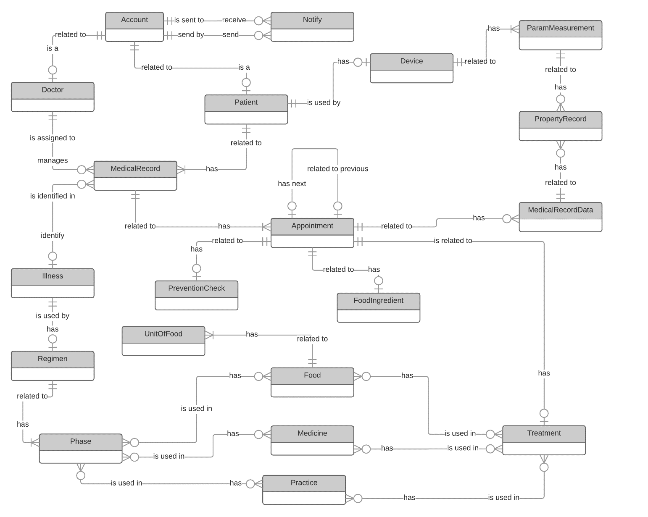

*Figure 50: Conceptual Diagram*

# Software Design Description

## Design Overview

* The architectural design describes the overall architecture of the system and the architecture of each main component and subsystem.
* The detailed design describes static and dynamic structure for each component and functions. It includes class diagrams, class explanations and sequence diagrams for each use cases.
* The database design describes the relationships between entities and details of each entity.
* Document overview:
  + Section 2: gives an overall description of the system architecture design.
  + Section 3: gives component diagrams that describe the connection and integration of the system.
  + Section 4: gives the detail design description, which includes class diagram, class explanation, and sequence diagram to details the application functions.
  + Section 5: describe a fully attributed Entity Relationship Diagram.

## `System Architecture Design

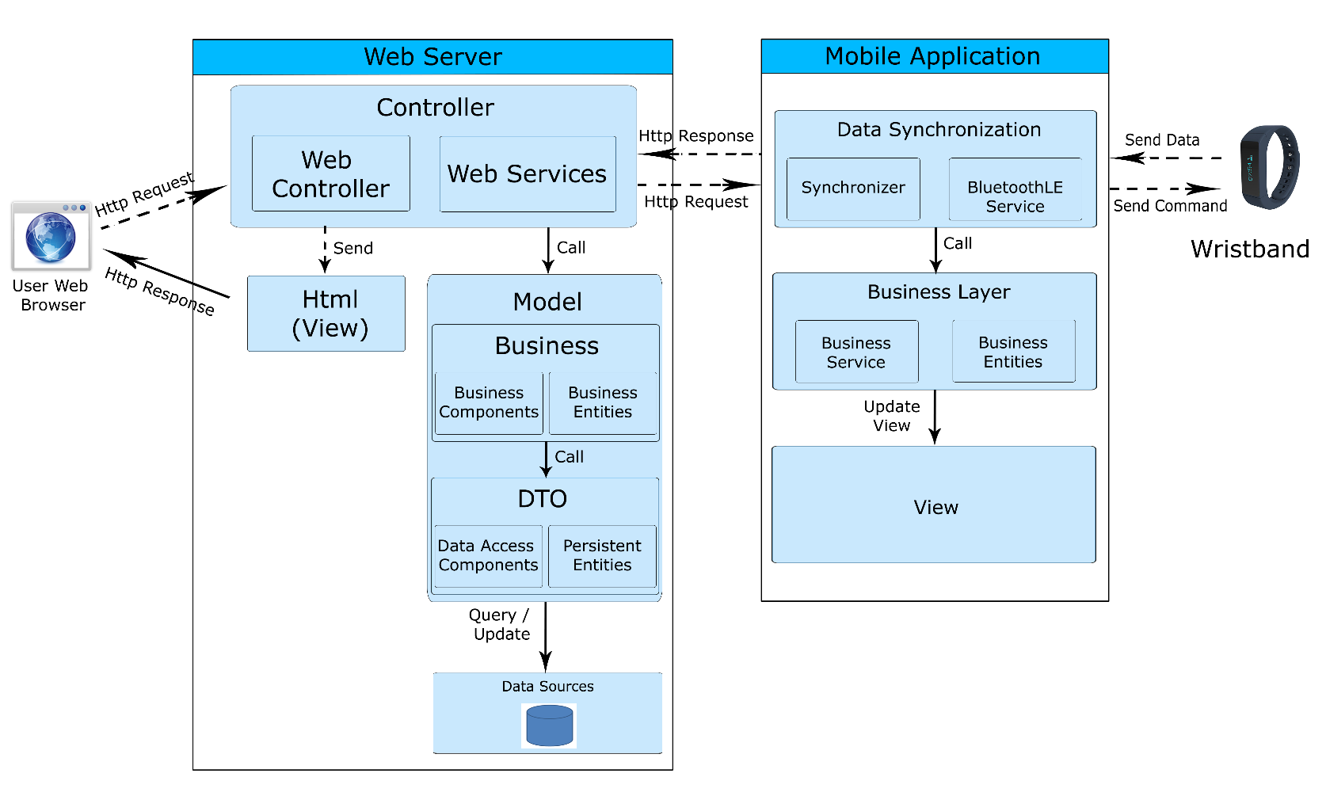

*Figure 51: System Architecture Design*

### Web Application architecture description

In Web Application, the system is developed under Spring MVC architecture style. We choose this architecture for Web application because of following advantages:

* Web app contains Web services with MVC architecture, we can separate business code with Controller and View. So we can use the business code in web service without repeat the code.
* We can organize the code better for maintainability, extensibility, reusability so we can expand the scope to other kind of illnesses such as flu, fever…
* In scope of 3-members team, MVC architecture make it easier to split the big project into small modules and make it easier to assign each module for members in our team.

This project follows MVC architecture with following components:

* **Controller** is the parts of the application that acts like event handler to handles user interaction. Typically, controller read data from a request and calls appropriate Business’s method then selects view to return to user.
* **HTML (View)** is the parts of the application that handles the display of the data. The selection of View is under control of Controller.
* **Business** is the parts of the application that do business processing to solve domain problems.
* **Model** is the parts of the application that acts like a data transfer object between the system and database.
* **Web Service** is the parts of the application that acts like event handler for web and mobile communication via REST method.

### Mobile Application architecture description

The application is developed as an Android native application. In general, the application architecture conforms to Android architecture.



**Reference:** [Android Developer Guide - Application Fundamentals](http://developer.android.com/guide/components/fundamentals.html)

http://developer.android.com/guide/components/fundamentals.html

This project follows Android application architecture with following component:

* **Activity** is the basic core of an android application that handles user input,create thread to run asynchronous tasks, send request and receive data from server via web services ...

## Component Diagram

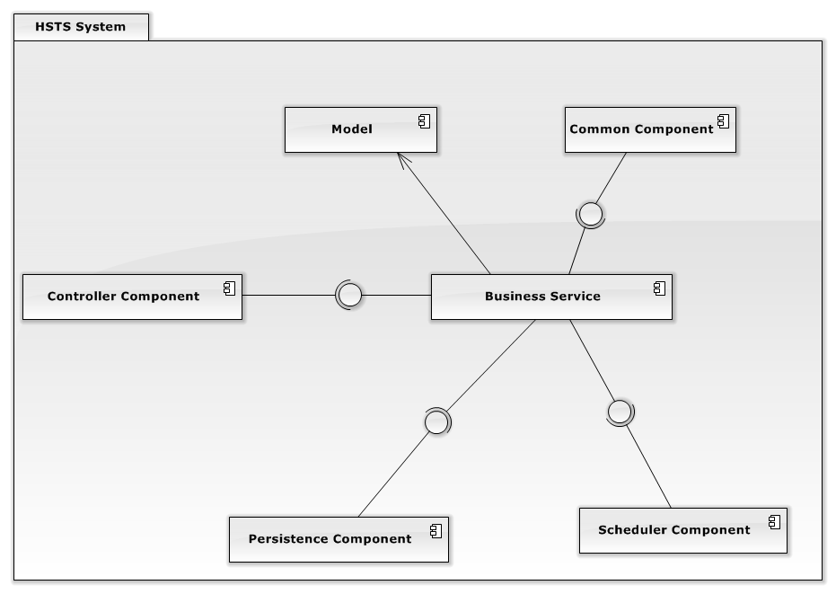

*Figure 52: Component Diagram*

|  |  |
| --- | --- |
| Component Dictionary: Describes components | |
| Controller Component | Component is used to handle request from web. |
| Persistence Component | Component is used to handle interaction between the system and database. |
| Business Service | Common services are used to handle system’s business operations. |
| Model | Common object is used in business service component. |
| Common Component | Component is used to handle common function in the system. |
| Schedule Component | Component is used to handle scheduler in the system |

*Table 49: Component Dictionary - Describes components*

## Detailed Description

### Class Diagram

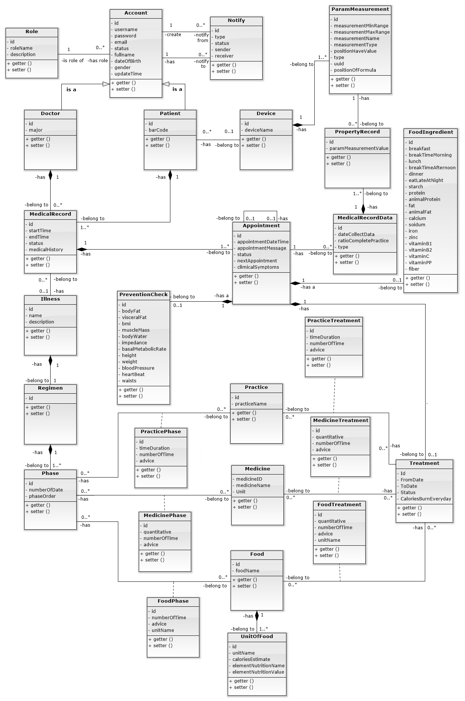

*Figure 53: Class Diagram*

|  |  |  |
| --- | --- | --- |
| Class dictionary: describe Class | | |
| Class Name | **Mapping column with Conceptual diagram** | **Description** |
| Account | Account | Contain the account information. |
| Role | N/A | Not exist in conceptual diagram. But needed in class diagram to contain role information. |
| Notify | Notify | Contain the notify information |
| Doctor | Doctor | Contain the doctor information. |
| Patient | Patient | Contain the patient information. |
| Wristband | Device | Contain the wristband information. |
| ParamMeasurement | ParamMeasurement | Contain the parameter of measurement information. |
| PropertyRecord | PropertyRecord | Contain the property record information. |
| MedicalRecord | MedicalRecord | Contain the medical record information. |
| MedicalRecordData | MedicalRecordData | Contain the medical record data information. |
| Appointment | Appointment | Contain the appointment information. |
| Illness | Illness | Contain the illness information. |
| PreventionCheck | PreventCheck | Contain the prevent check information. |
| FoodIngredient | FoodIngredient | Contain the food ingredient information. |
| Regimen | Regimen | Contain the regimen information. |
| Phase | Phase | Contain the phase information. |
| PracticePhase | N/A | Not exist in conceptual diagram. But needed in class diagram to contain the practice phase information. |
| MedicinePhase | N/A | Not exist in conceptual diagram. But needed in class diagram to contain the medicine phase information. |
| FoodPhase | N/A | Not exist in conceptual diagram. But needed in class diagram to contain the food phase information. |
| Practice | Practice | Contain the practice information. |
| Medicine | Medicine | Contain the medicine information. |
| Food | Food | Contain the food information. |
| PracticeTreatment | N/A | Not exist in conceptual diagram. But needed in class diagram to contain practice treatment information. |
| MedicineTreatment | N/A | Not exist in conceptual diagram. But needed in class diagram to contain medicine treatment information. |
| FoodTreatment | N/A | Not exist in conceptual diagram. But needed in class diagram to contain food treatment information. |
| Treatment | Treatment | Contain the treatment information. |
| UnitOfFood | N/A | Not exist in conceptual diagram. But needed in class diagram to contain the unit of food information. |

*Table 50: Class dictionary: Describe Class*

### Class Diagram Explanation

#### Account

|  |  |  |  |
| --- | --- | --- | --- |
| Attribute | Type | Visibility | Description |
| Id | int | Private | Unique identifier of an account |
| Username | String | Private | The username. |
| Password | String | Private | The password. |
| Email | String | Private | The email of user. |
| FullName | String | Private | The full name of user. |
| Status | int | Private | The status of account. |
| DateOfBirth | Timestamp | Private | The birthday of user. |
| Gender | int | Private | The gender of user. |
| UpdateTime | Timestamp | Private | The day processes updating account. |

*Table 51: Class Diagram Explanation - Account*

#### Role

|  |  |  |  |
| --- | --- | --- | --- |
| Attribute | Type | Visibility | Description |
| Id | int | Private | Unique identifier of a role. |
| RoleName | String | Private | The name of role. |
| Description | String | Private | The description about a role. |

*Table 52: Class Diagram Explanation - Role*

#### Notify

|  |  |  |  |
| --- | --- | --- | --- |
| Attribute | Type | Visibility | Description |
| Id | int | Private | Unique identifier of a role. |
| Type | int | Private | The type of notify. |
| Status | int | Private | The status of notify. |

*Table 53: Class Diagram Explanation - Notify*

#### Doctor

|  |  |  |  |
| --- | --- | --- | --- |
| Attribute | Type | Visibility | Description |
| Id | int | Private | Unique identifier of a doctor. |
| Major | String | Private | The major of doctor. |

*Table 54: Class Diagram Explanation - Doctor*

#### Patient

|  |  |  |  |
| --- | --- | --- | --- |
| Attribute | Type | Visibility | Description |
| Id | int | Private | Unique identifier of a patient. |
| BarCode | String | Private | The barcode of ordinal number. |

*Table 55: Class Diagram Explanation - Patient*

#### ParamMeasurement

|  |  |  |  |
| --- | --- | --- | --- |
| Attribute | Type | Visibility | Description |
| Id | int | Private | Unique identifier of a parameter measurements. |
| MeasurementMinRange | int | Private | The min range of measurement. |
| MeasurementMaxRange | int | Private | The max range of measurement. |
| MeasurementName | String | Private | The name of measurement. |
| MeasurementType | String | Private | The type of measurement. |
| PositionHaveValue | int | Private | The position having value of measurement. |
| Type | int | Private | The type of measurement. |
| Uuid | int | Private | The uuid of measurement. |
| PositionOfFormula | String | Private | The position having formula of measurement. |

*Table 56: Class Diagram Explanation – ParamMearsurement*

#### Appointment

|  |  |  |  |
| --- | --- | --- | --- |
| Attribute | Type | Visibility | Description |
| Id | int | Private | Unique identifier of an appointment. |
| AppointmentDateTime | DateTime | Private | The day have appointment with doctor. |
| Status | Byte | Private | Entry, Finish, Waiting. |
| NextAppointment | int | Private | The next day have appointment. |
| ClinicalSymptoms | String | Private | The clinical symptoms of patient. |

*Table 57: Class Diagram Explanation - Appointment*

#### Wristband

|  |  |  |  |
| --- | --- | --- | --- |
| Attribute | Type | Visibility | Description |
| Id | int | Private | Unique identifier of a wristband. |
| BrandName | String | Private | The name of brand. |

*Table 58: Class Diagram Explanation - Wristband*

#### Food

|  |  |  |  |
| --- | --- | --- | --- |
| Attribute | Type | Visibility | Description |
| Id | int | Private | Unique identifier of a food. |
| FoodName | String | Private | The name of food. |

*Table 59: Class Diagram Explanation - Food*

#### FoodIngredient

|  |  |  |  |
| --- | --- | --- | --- |
| Attribute | Type | Visibility | Description |
| Id | int | Private | Unique identifier of a foodIngredient |
| Breakfast | Float | Private | The value of breakfast. |
| BreakTimeMorning | Float | Private | The value of breakfast. |
| Lunch | Float | Private | The value of lunch. |
| BreakTimeAfternoon | Float | Private | The value of break time afternoon. |
| Dinner | Float | Private | The value of dinner. |
| EatLateAtNight | Float | Private | The value of eat late at night. |
| Starch | Float | Private | The value of starch. |
| Protein | Float | Private | The value of protein. |
| AnimalProtein | Float | Private | The value of animal protein. |
| Fat | Float | Private | The value of fat. |
| AnimalFat | Float | Private | The value of animal fat. |
| Calcium | Float | Private | The value of calcium. |
| Sodium | Float | Private | The value of sodium. |
| Iron | Float | Private | The value of iron. |
| Zinc | Float | Private | The value of zinc. |
| VitaminB2 | Float | Private | The value of vitamin B2. |
| VitaminB1 | Float | Private | The value of vitamin B1. |
| VitaminC | Float | Private | The value of vitamin C. |
| VitaminPP | Float | Private | The value of vitamin PP. |
| Fiber | Float | Private | The value of fiber. |

*Table 60: Class Diagram Explanation - FoodIngredient*

#### Illness

|  |  |  |  |
| --- | --- | --- | --- |
| Attribute | Type | Visibility | Description |
| Id | int | Private | Unique identifier of an illness. |
| Name | String | Private | The name of illness. |
| Description | String | Private | The Description of illness. |

*Table 61: Class Diagram Explanation - Illness*

#### MedicalRecord

|  |  |  |  |
| --- | --- | --- | --- |
| Attribute | Type | Visibility | Description |
| Id | int | Private | Unique identifier of a medicalrecord. |
| StartTime | Datetime | Private | The date begin of medical record. |
| EndTime | Datetime | Private | The date end of medical record. |
| Status | Byte | Private | Waiting for examination, No illness, Treating, Finished. |
| MedicalHistory | String | Private | The history medical of patient. |

*Table 62: Class Diagram Explanation - MedicalRecord*

#### MedicalRecordData

|  |  |  |  |
| --- | --- | --- | --- |
| Attribute | Type | Visibility | Description |
| Id | int | Private | Unique identifier of a medicalrecorddata. |
| DateCollectData | Datetime | Private | The date collect data of device. |
| RatioCompletePractice | Int | Private | The ratio complete practice of patitent. |
| Type | Byte | Private | Nurse input, uncalculated, calculated. |

*Table 63: Class Diagram Explanation - MedicalRecordData*

#### Medicine

|  |  |  |  |
| --- | --- | --- | --- |
| Attribute | Type | Visibility | Description |
| Id | int | Private | Unique identifier of a medicine. |
| MedicineName | String | Private | The name of medicine. |
| Unit | String | Private | The name unit of medicine. |

*Table 64: Class Diagram Explanation - Medicine*

#### Phase

|  |  |  |  |
| --- | --- | --- | --- |
| Attribute | Type | Visibility | Description |
| Id | int | Private | Unique identifier of a phase. |
| NumberOfDate | Int | Private | The max number of day in phase effect. |
| PhaseOrder | int | Private | The priority of phase. |

*Table 65: Class Diagram Explanation - Phase*

#### Practice

|  |  |  |  |
| --- | --- | --- | --- |
| Attribute | Type | Visibility | Description |
| Id | int | Private | Unique identifier of a practice. |
| PracticeName | String | Private | The name of practice. |

*Table 66: Class Diagram Explanation – Practice*

#### PreventionCheck

|  |  |  |  |
| --- | --- | --- | --- |
| Attribute | Type | Visibility | Description |
| Id | int | Private | Unique identifier of a preventioncheck. |
| BodyFat | Float | Private | The value of body fat. |
| VisceralFat | Float | Private | The value of visceral fat. |
| BMI | Float | Private | The value of BMI. |
| MuscleMass | Float | Private | The value of muscle mass. |
| BodyWater | Float | Private | The value of body water. |
| Impedance | Float | Private | The value of impedance. |
| BasalMetabolicRate | Float | Private | The value of basal metabolic rate. |
| Height | Float | Private | The value of height. |
| Weight | Float | Private | The value of weight. |
| BloodPressure | Float | Private | The value of blood pressure. |
| HeartBeat | Float | Private | The value of heart beat. |
| Waists | Float | Private | The value of waists. |

*Table 67: Class Diagram Explanation - PreventCheck*

#### PropertyRecord

|  |  |  |  |
| --- | --- | --- | --- |
| Attribute | Type | Visibility | Description |
| Id | int | Private | Unique identifier of a propertyrecord. |
| ParamMeasurementValue | String | Private | The value of propertyrecord. |

*Table 68: Class Diagram Explanation - PropertyRecord*

#### Regimen

|  |  |  |  |
| --- | --- | --- | --- |
| Attribute | Type | Visibility | Description |
| Id | int | Private | Unique identifier of a regimen. |

*Table 69: Class Diagram Explanation - Regimen*

#### Role

|  |  |  |  |
| --- | --- | --- | --- |
| Attribute | Type | Visibility | Description |
| Id | Int | Private | Unique identifier of a role. |
| RoleName | String | Private | The name of role. |
| Description | String | Private | The description of role. |

*Table 70: Class Diagram Explanation - Role*

#### Treatment

|  |  |  |  |
| --- | --- | --- | --- |
| Attribute | Type | Visibility | Description |
| Id | int | Private | Unique identifier of a role. |
| FromDate | Datetime | Private | The name of role. |
| Todate | Datetime | Private | The description of role. |
| Status | Byte | Private | On treating, finished, history. |
| CaloriesBurnEveryDay | int | Private | The kcal patient need burn everyday. |

*Table 71: Class Diagram Explanation - Treatment*

#### UnitOfFood

|  |  |  |  |
| --- | --- | --- | --- |
| Attribute | Type | Visibility | Description |
| Id | int | Private | Unique identifier of a unitoffood. |
| UnitName | String | Private | The name of unit of food. |
| CaloriesEstimate | String | Private | The kcal estimate of a unit. |
| AllNutritionName | String | Private | The all nutrition name. |
| AllNutritionValue | String | Private | The all nutrition value. |

*Table 72: Class Diagram Explanation - UnitOfFood*

### Interactive Diagram

#### Website

##### Guest

###### Login

Summary: This diagram show how a guest log in system.



*Figure 54: Web Sequence Diagram - <Guest>Login*

##### Authorized User

###### Logout

Summary: This diagram show how an authorized user log out of system.



*Figure 55: Web Sequence Diagram - <Authorized User>Logout*

##### Doctor

###### Make Prescription

Summary: This diagram show process of doctor to make prescription to patient.



*Figure 56: Web Sequence Diagram - <Doctor>Make Prescription*

###### View Patient Medical History

Summary: This diagram show process of how to view patient medical history.



*Figure 57: Web Sequence Diagram - <Doctor>View Patient Medical History*

##### Doctor Manager

###### Insert Regimen

Summary: This diagram show how doctor manager create regimen



*Figure 58: Web Sequence Diagram - <Doctor Manager>Insert Regimen*

###### Update Regimen

Summary:This diagram show how doctor manager update regimen



***Figure 59: Web Sequence Diagram - <Doctor Manager>Update Regimen***

###### Delete Regimen

Summary:This diagram show how doctor manager delete regimen.



*Figure 60: Web Sequence Diagram - <Doctor Manager>Delete Regimen*

##### Nutrition Doctor

###### Make Nutritional Ingredient

Summary: This diagram show process of make nutritional ingredient.



*Figure 61: Web Sequence Diagram - <Nutrition Doctor>Make Nutritional Ingredient*

###### Insert Food’s Nutrition

Summary: This diagram show process of nutrition doctor to create food.



*Figure 62: Web Sequence Diagram - <Nutrition Doctor>Insert Food's Nutrition*

###### Update Food’s Nutrition

Summary: This diagram show process of nutrition doctor to update information of food



*Figure 63: Web Sequence Diagram - <Nutrition Doctor>Update Food's Nutrition*

###### Delete Food’s Nutrition

Summary: This diagram show process of nutrition doctor to delete food



*Figure 64: Web Sequence Diagram - <Nutrition Doctor>Delete Food's Nutrition*

##### Nurse

###### Register Medical Examination

Summary: This diagram show how nurse Register Medical Examination for a patient



*Figure 65: Web Sequence Diagram - <Nurse>Register Medical Examination*

###### Register Medical Examination With Old Patient

Summary: This diagram show how a nurse Register Medical Examination for an old patient



*Figure 66: Web Sequence Diagram - <Nurse>Register Medical Examination With Old Patient*

###### Print prescription

Summary: This diagram show how to print a prescription for a patient.



*Figure 67: Web Sequence Diagram - <Nurse>Print Prescription*

##### Scheduler

###### Analyse Data Of Wristband

Summary: This diagram show process of analyse data of wristband.



*Figure 68: Web Sequence Diagram - <Scheduler>Analyse Data Of Wristband*

##### Admin

###### Insert Account

Summary: This diagram show process of administrator creates new account.

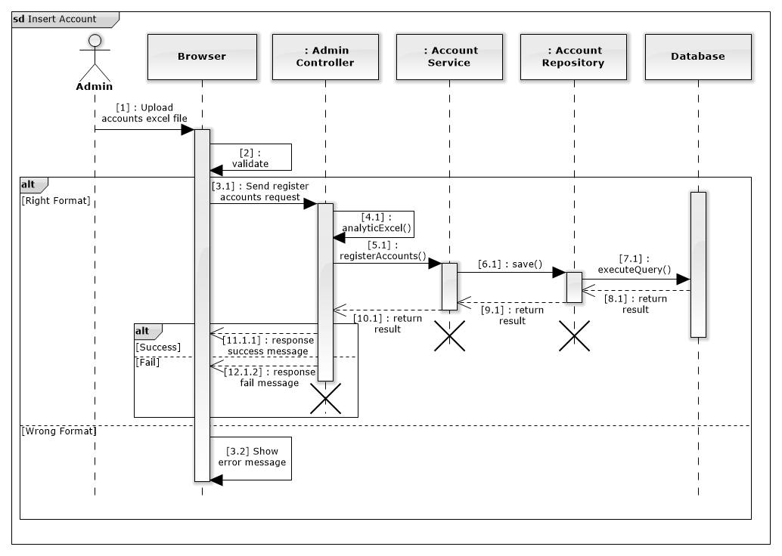

*Figure 69: Web Sequence Diagram - <Admin>Insert Account*

###### Update Account

Summary: This diagram show process of administrator updates profile of specific account.



*Figure 70: Web Sequence Diagram - <Admin>Update Account*

###### Delete Account

Summary: This diagram show process of administrator deleting specific account.



*Figure 71: Web Sequence Diagram - <Admin>Delete Account*

##### Staff

###### Insert Wristband

Summary: This diagram show process of creating new wristband.



*Figure 72: Web Sequence Diagram - <Staff>Insert Wristband*

###### Update Wristband

Summary: This diagram show process of updating wristband.

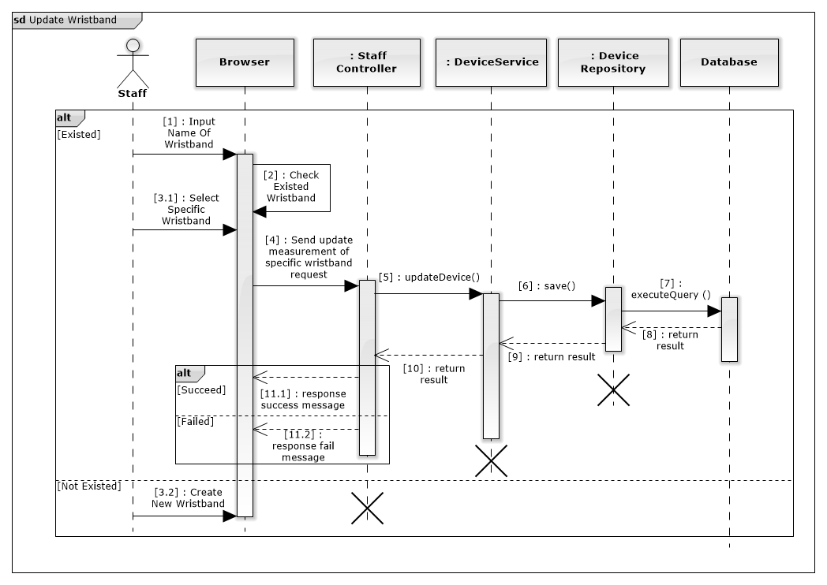

*Figure 73: Web Sequence Diagram - <Staff>Update Wristband*

###### Delete Wristband

Summary: This diagram show process of deleting specific wristband

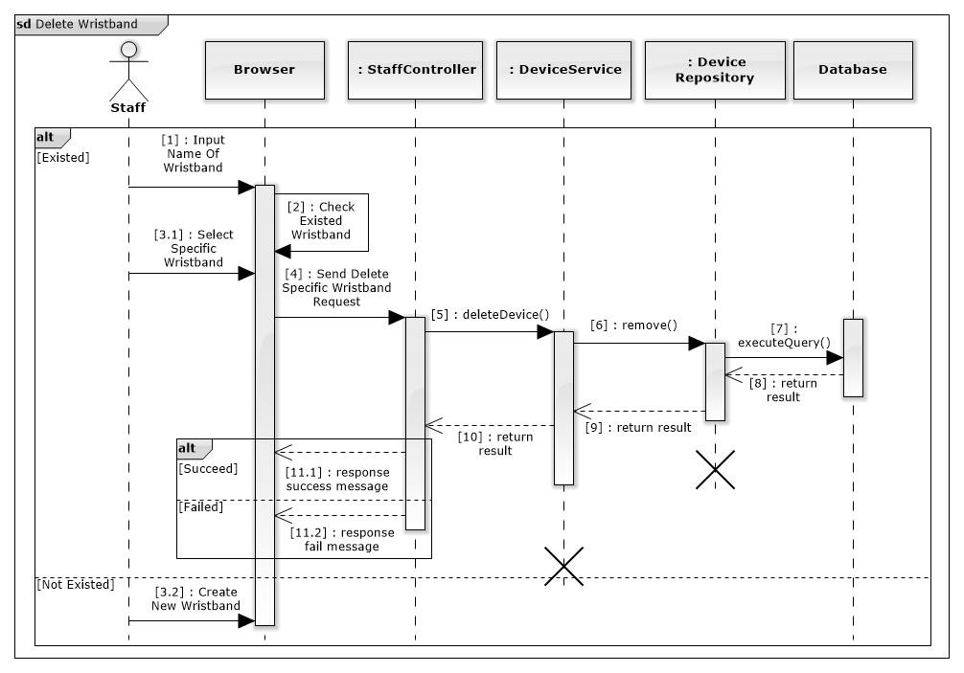

*Figure 74: Web Sequence Diagram - <Staff>Delete Wristband*

###### Update Formula

Summary: This diagram show process of updating calculating formula



*Figure 75: Web Sequence Diagram - <Staff>Update Formula*

##### Analyst

###### Suggest Treatment

Summary: This diagram show process of analyst suggest treatment for doctor.



*Figure 76: Web Sequence Diagram - <Analyst>Suggest Treatment*

###### Analyse Meal By Voice

Summary: This diagram show process of analyse meal by using voice.



*Figure 77: Web Sequence Diagram - <Analyst>Analyse Meal By Voice*

###### Analyse Meal

Summary: This diagram show process of analyse meal.



*Figure 78: Web Sequence Diagram - <Analyst>Analyse Meal*

#### Mobile Application

##### Patient

###### Logout

Summary: This diagram show process of logging out of HSTS Application.



*Figure 79: Mobile Sequence Diagram - <Patient>Logout*

###### Pair Wristband

Summary: This diagram show process of pairing wristband with patient’s smartphone.



*Figure 80: Mobile Sequence Diagram - <Patient>Pair Wristband*

##### Guest

###### Login

Summary: This diagram show process of logging in to HSTS Application.



*Figure 81: Mobile Sequence Diagram - <Guest>Login*

##### Scheduler

###### Analyse New Treatment

Summary: This diagram show process of analyse new treatment.



*Figure 82: Mobile Sequence Diagram - <Scheduler>Analyse New Treatment*

###### Remind Patient

Summary: This diagram show process of remind patient about food, practice, medicine.



*Figure 83: Mobile Sequence Diagram - <Scheduler>Remind Patient*

###### Get data from wristband

Summary: This diagram show process of get data from wristband.



*Figure 84: Mobile Sequence Diagram - <Scheduler>Get Data From Wristband*

###### Synchronize Practice Data

Summary: This diagram show process of synchronize practice data of patient.



*Figure 85: Mobile Sequence Diagram - <Scheduler>Synchronize Practice Data*

###### Notice Practice Result

Summary: This diagram show the process of notice practice result to patient.



*Figure 86: Mobile Sequence Diagram - <Scheduler>Notice Practice Result*

###### Check Notifications Of Patient

Summary: This diagram show process of checking notification of patient from server.



*Figure 87: Mobile Sequence Diagram - <Scheduler>Check Notification Of Patient*

## Interface

### Component Interface

|  |  |  |  |  |  |
| --- | --- | --- | --- | --- | --- |
| Signature | Description | Input | Output | Output Format | Exception |
| public ResponseObject getContracts(R r) | Get patient information | Request object r  barcode: String | JSON String of Patient entity | PatientExtenedModel | JsonProcessingException |
| Contractlean if the update is successntractpublic ResponseObject patientList  (R r) | Search patient by name | Request object r contains:  keyword: String  page: Integer  pageSize: Integer | JSON String list of Patient entity | PatientExtendedPageModel | JsonProcessingException |
| public ResponseObject registerPatient  (R r) | Register exam for new patient | Request object r contains:  Patient’s full name: String  Patient’s birthday: String  Patient’s email: String  Patient’s gender: Byte  Patient’s weight: Integer  Patient‘s height: Integer  Patient’s heart beat: Integer  Patient’s blood pressure: Integer  Patient’s waits: Integer  Patient’s body fat: Float  Patient’s visceral fat: Float  Patient’s muscle mass: Float  Patient’s body water: Float  Patient’s phase angle: Float  Patient’s impedance: Float  Patient’s basal metabolic rate: Float  Doctor will be assigned: Float  Patient’s medical history: Float  Patient’s current symptoms: Float  Patient’s medicine use history: Float | JSON String of Patient entity and medical order number | PatientExtenedModel | JsonProcessingException |
| public ResponseObject updatePatient  (R r) | Register exam for old patient | Request object r contains:  Patient’s id: Integer  New medical record option: boolean  Patient’s weight: Integer  Patient‘s height: Integer  Patient’s heart beat: Integer  Patient’s blood pressure: Integer  Patient’s waits: Integer  Patient’s body fat: Float  Patient’s visceral fat: Float  Patient’s muscle mass: Float  Patient’s body water: Float  Patient’s phase angle: Float  Patient’s impedance: Float  Patient’s basal metabolic rate: Float  Doctor will be assigned: Float  Patient’s medical history: Float  Patient’s current symptoms: Float  Patient’s medicine use history: Float | JSON String of Patient entity and medical order number | PatientExtenedModel | JsonProcessingException |
| public ResponseObject print  (R r) | Print prescription for a patient | Request object r contains:  patientId: Integer | PDF document of detail prescription | Byte arrays of PDF stream | IOException |
| public ResponseObject uploadImage  (R r) | Upload image of a medical history for patient | Request object r contains:  fileUploader  : MultipartFile object of image file | JSON string of file processing result | FileUploadModel | JsonProcessingException,  IOException |

*Table 73: Component Interface*

### Web Application Design

#### Nurse

##### Register Medical Examination







*Figure 88: Web Application Design - <Nurse>Register Medical Examination*

**Fields**

|  |  |  |  |  |  |  |  |
| --- | --- | --- | --- | --- | --- | --- | --- |
| No | Field Name | Description | Read Only | Mandatory | Control Type | Data Type | Length |
| 1 | Navigation bar | Navigation bar | Yes | No | N/A | N/A | N/A |
| 2 | Title bar | Title bar | Yes | No | N/A | N/A | N/A |
| 3 | txtPatientName | Patient’s full name | No | Yes | Textbox | String | 50 |
| 4 | txtBirthday | Patient’s birthday | No | Yes | Textbox | String | 50 |
| 5 | txtEmail | Patient’s email | No | Yes | Textbox | String | 50 |
| 6 | cbGender | Patient’s gender | No | No | Checkbox | Byte | 1 |
| 12 | txtWeight | Patient’s weight | No | Yes | Textbox | Integer | 3 |
| 13 | txtHeight | Patient‘s height | No | Yes | Textbox | Integer | 3 |
| 14 | txtHeartBeat | Patient’s heart beat | No | Yes | Textbox | Integer | 3 |
| 15 | txtBloodPressure | Patient’s blood pressure | No | Yes | Textbox | Integer | 3 |
| 16 | txtWaists | Patient’s waits | No | Yes | Textbox | Integer | 3 |
| 17 | txtBodyFat | Patient’s body fat | No | Yes | Textbox | Float | 3 |
| 18 | txtVisceralFat | Patient’s visceral fat | No | Yes | Textbox | Float | 3 |
| 19 | txtMuscleMass | Patient’s muscle mass | No | Yes | Textbox | Float | 3 |
| 20 | txtBodyWater | Patient’s body water | No | Yes | Textbox | Float | 3 |
| 21 | txtPhaseAngle | Patient’s phase angle | No | Yes | Textbox | Float | 2 |
| 22 | txtImpedance | Patient’s impedance | No | Yes | Textbox | Float | 4 |
| 23 | txtBasalMetabolicRate | Patient’s basal metabolic rate | No | Yes | Textbox | Float | 4 |
| 26 | optDoctor | Doctor will be assigned | No | Yes | Select box | Integer | 4 |
| 27 | txtMedicalHistory | Patient’s medical history | No | No | Textbox | String | 1000 |
| 28 | txtSymptoms | Patient’s current symptoms | No | Yes | Textbox | String | 1000 |
| 29 | txtMedicineHistory | Patient’s medicine use history | No | No | Textbox | String | 1000 |

*Table 74: Web Design – Register Patient Field*

**Buttons/Hyperlinks**

|  |  |  |  |  |
| --- | --- | --- | --- | --- |
| No | Function | Description | Validation | Outcome |
| 7 | btnNext | Next button | Validate all fields in current tab | Go to next tab (Medical Checking) |
| 8 | btnReset | Reset button | N/A | Reset all fields |
| 9 | btnTab1 | Tab Patient’s Profile | N/A | Go to tab Patient’s Profile |
| 10 | btnTab2 | Tab Medical Checking | N/A | Go to tab Medical Checking |
| 11 | btnTab3 | Tab Medical Registration | N/A | Go to tab Medical Registration |
| 24 | btnPrevious | Previous button | N/A | Go to previous tab (Patient’s Profile) |
| 25 | btnNext2 | Next button | Validate all fields in current tab | Go to next tab (Medical Registration) |
| 30 | btnUploadImage | Upload medical image | N/A | Open Upload medical history image pop-up |
| 31 | btnPrevious2 | Previous button | N/A | Go to previous tab (Medical Checking) |
| 32 | btnRegister | Register Medical Examination | Validate all input fields before submitting | Submit registration |

*Table 75: Web Design – Register Patient Button/HyperLinks*

##### Register Medical Examination with old patient







*Figure 89: Web Application Design - <Nurse>Register Medical Examination With Old Patient*

**Fields**

|  |  |  |  |  |  |  |  |
| --- | --- | --- | --- | --- | --- | --- | --- |
| No | Field Name | Description | Read Only | Mandatory | Control Type | Data Type | Length |
| 1 | txtPatientName | Patient’s full name | Yes | Yes | Textbox | String | 50 |
| 1 | txtBirthday | Patient’s birthday | Yes | Yes | Textbox | String | 50 |
| 3 | txtEmail | Patient’s email | Yes | Yes | Textbox | String | 50 |
| 4 | cbGender | Patient’s gender | Yes | No | Checkbox | Byte | 1 |
| 8 | txtWeight | Patient’s weight | No | Yes | Textbox | Integer | 3 |
| 9 | txtHeight | Patient‘s height | No | Yes | Textbox | Integer | 3 |
| 10 | txtHeartBeat | Patient’s heart beat | No | Yes | Textbox | Integer | 3 |
| 11 | txtBloodPressure | Patient’s blood pressure | No | Yes | Textbox | Integer | 3 |
| 12 | txtWaists | Patient’s waits | No | Yes | Textbox | Integer | 3 |
| 13 | txtBodyFat | Patient’s body fat | No | Yes | Textbox | Float | 3 |
| 15 | txtVisceralFat | Patient’s visceral fat | No | Yes | Textbox | Float | 3 |
| 16 | txtMuscleMass | Patient’s muscle mass | No | Yes | Textbox | Float | 3 |
| 17 | txtBodyWater | Patient’s body water | No | Yes | Textbox | Float | 3 |
| 18 | txtPhaseAngle | Patient’s phase angle | No | Yes | Textbox | Float | 2 |
| 19 | txtImpedance | Patient’s impedance | No | Yes | Textbox | Float | 4 |
| 20 | txtBasalMetabolicRate | Patient’s basal metabolic rate | No | Yes | Textbox | Float | 4 |
| 22 | optDoctor | Doctor will be assigned | No | Yes | Select box | Integer | 4 |
| 23 | optNewMedicalRecord | Option to create new medical record | No | No | Check box | Boolean | 2 |
| 24 | txtMedicalHistory | Patient’s medical history | No | No | Textbox | String | 1000 |
| 25 | txtSymptoms | Patient’s current symptoms | No | Yes | Textbox | String | 1000 |
| 26 | txtMedicineHistory | Patient’s medicine use history | No | No | Textbox | String | 1000 |

*Table 76: Web Design – Register Patient With Old Man Fields*

**Button/Hyperlinks**

|  |  |  |  |  |
| --- | --- | --- | --- | --- |
| No | Function | Description | Validation | Outcome |
| 5 | btnNext | Next button | Validate all fields in current tab | Go to next tab (Medical Checking) |
| 6 | btnReset | Reset button | N/A | Reset all fields |
| 7 | btnUseOldIndex | Auto fill old measurement indexes to all fields | N/A | Auto fill old measurement indexes to all fields |
| 14 | btnPrevious | Previous button | N/A | Go to previous tab (Patient’s Profile) |
| 21 | btnNext2 | Next button | Validate all fields in current tab | Go to next tab (Medical Registration) |
| 27 | btnUploadImage | Upload medical image | N/A | Open Upload medical history image pop-up |
| 28 | btnPrevious2 | Previous button | N/A | Go to previous tab (Medical Checking) |
| 29 | btnRegister | Register Medical Examination | Validate all input fields before submitting | Submit registration |
| 30 | btnTab1 | Tab Patient’s Profile | N/A | Go to tab Patient’s Profile |
| 31 | btnTab2 | Tab Medical Checking | N/A | Go to tab Medical Checking |
| 32 | btnTab3 | Tab Medical Registration | N/A | Go to tab Medical Registration |

*Table 77: Web Design – Register Patient With Old Man Buttons/HyperLinks*

##### Patient Management Design



*Figure 90: Web Application Design - <Nurse>Patient Management Design*

**Fields**

|  |  |  |  |  |  |  |  |
| --- | --- | --- | --- | --- | --- | --- | --- |
| No | Field Name | Description | Read Only | Mandatory | Control Type | Data Type | Length |
| 1 | Search patient | Search patient | No | No | N/A | N/A | N/A |

*Table 78: Web Design – Patient Management Field*

**Buttons/Hyperlinks**

|  |  |  |  |  |
| --- | --- | --- | --- | --- |
| No | Function | Description | Validation | Outcome |
| 2 | btnPrintPrescription | Print prescription for patient | N/A | Go to print prescription page |

*Table 79: Web Design – Patient Management Buttons/HyperLinks*

##### Print Prescription



*Figure 91: Web Application Design - <Nurse>Print Prescription*

#### Doctor Manager

##### Regimen Management



*Figure 92: Web Application Design - <Doctor Manager>Regimen Management*

**Fields**

|  |  |  |  |  |  |  |  |
| --- | --- | --- | --- | --- | --- | --- | --- |
| No | Field Name | Description | Read Only | Mandatory | Control Type | Data Type | Length |
| 2 | Search regimen | Search regimen | No | No | N/A | N/A | N/A |

*Table 80: Web Design – Regimen Management Field*

**Buttons/Hyperlinks**

|  |  |  |  |  |
| --- | --- | --- | --- | --- |
| No | Function | Description | Validation | Outcome |
| 1 | btnCreate | Create new regimen | N/A | Show create new regimen pop-up |
| 3 | btnUpdate | Update regimen | N/A | Show update regimen pop-up |
| 4 | btnDelete | Delete regimen | N/A | Show delete regimen pop-up |

*Table 81: Web Design – Regimen Management Buttons/HyperLinks*

##### Create Regimen



*Figure 93: Web Application Design - <Doctor>Manager>Create Regimen*

**Fields**

|  |  |  |  |  |  |  |  |
| --- | --- | --- | --- | --- | --- | --- | --- |
| No | Field Name | Description | Read Only | Mandatory | Control Type | Data Type | Length |
| 1 | txtIllnessName | Illness name | No | Yes | Textbox | String | 50 |
| 2 | txtDescription | Description of illness | No | Yes | Textbox | String | 500 |
| 3 | txtNumberOfPhase | Number of phase | No | Yes | Textbox | Integer | 2 |

*Table 82: Web Design – Create Regimen Fields*

**Buttons/Hyperlinks**

|  |  |  |  |  |
| --- | --- | --- | --- | --- |
| No | Function | Description | Validation | Outcome |
| 4 | btnReset | Reset button | N/A | Reset all fields |
| 5 | btnCancel | Cancel button | N/A | Hide create regimen pop-up |
| 6 | btnCreate | Create button | Validate all required fields before submit | Submit regimen creation. |

*Table 83: Web Design – Create Regimen Buttons/HyperLinks*

##### Update Regimen



*Figure 94: Web Application Design - <Doctor Manager>Update Regimen*

**Fields**

|  |  |  |  |  |  |  |  |
| --- | --- | --- | --- | --- | --- | --- | --- |
| No | Field Name | Description | Read Only | Mandatory | Control Type | Data Type | Length |
| 1 | txtIllnessName | Illness name | No | Yes | Textbox | String | 50 |
| 2 | txtDescription | Description of illness | No | Yes | Textbox | String | 500 |

*Table 84: Web Design – Update Regimen Fields*

**Buttons/HyperLinks**

|  |  |  |  |  |
| --- | --- | --- | --- | --- |
| No | Function | Description | Validation | Outcome |
| 3 | btnCancel | Cancel button | N/A | Hide create regimen pop-up |
| 4 | btnUpdate | Update button | Validate all required fields before submit | Submit regimen update. |

*Table 85: Web Design – Update Regimen Buttons/HyperLinks*

##### Delete Regimen



*Figure 95: Web Application Design - <Doctor Manager>Delete Regimen*

**Buttons/HyperLinks**

|  |  |  |  |  |
| --- | --- | --- | --- | --- |
| No | Function | Description | Validation | Outcome |
| 3 | btnCancel | Cancel button | N/A | Hide delete regimen pop-up |
| 4 | btnDelete | Delete button | N/A | Submit regimen deletion. |

*Table 86: Web Design – Delete Regimen Buttons/HyperLinks*

##### Detail Regimen



*Figure 96: Web Application Design - <Doctor Manager>Detail Regimen*

**Buttons/HyperLinks**

|  |  |  |  |  |
| --- | --- | --- | --- | --- |
| No | Function | Description | Validation | Outcome |
| 1 | btnCreate | Create new phase button | N/A | Show create new phase pop-up |
| 3 | btnUpdate | Update phase button | N/A | Show update phase pop-up |
| 4 | btnDelete | Delete phase button | N/A | Show delete phase pop-up |

*Table 87: Web Design – Details Regimen Buttons/HyperLinks*

##### Create New Phase



*Figure 97: Web Application Design - <Doctor Manager>Create New Phase*

**Fields**

|  |  |  |  |  |  |  |  |
| --- | --- | --- | --- | --- | --- | --- | --- |
| No | Field Name | Description | Read Only | Mandatory | Control Type | Data Type | Length |
| 1 | txtNumberOfDay | Number of day | No | Yes | Textbox | Integer | 50 |

*Table 88: Web Design – Create New Phase Fields*

**Buttons/HyperLinks**

|  |  |  |  |  |
| --- | --- | --- | --- | --- |
| No | Function | Description | Validation | Outcome |
| 2 | btnCancel | Cancel button | N/A | Hide create phase pop-up |
| 3 | btnCreate | Create phase button | Validate all required fields before submit | Submit phase creation. |

*Table 89: Web Design – Buttons/HyperLinks*

##### Update Phase



*Figure 98: Web Application Design - <Doctor Manager> Update Phase*

**Fields**

|  |  |  |  |  |  |  |  |
| --- | --- | --- | --- | --- | --- | --- | --- |
| No | Field Name | Description | Read Only | Mandatory | Control Type | Data Type | Length |
| 1 | txtNumberOfDay | Number of day | No | Yes | Textbox | Integer | 50 |

*Table 90: Web Design – Update Phase Fields*

**Buttons/ HyperLinks**

|  |  |  |  |  |
| --- | --- | --- | --- | --- |
| No | Function | Description | Validation | Outcome |
| 2 | btnCancel | Cancel button | N/A | Hide create phase pop-up |
| 3 | btnUpdate | Update phase button | Validate all required fields before submit | Submit phase update. |

*Table 91: Web Design – Update Phase Buttons/HyperLinks*

##### Delete Phase



*Figure 99: Web Application Design - <Doctor Manager>Delete Phase*

**Buttons/HyperLink**

|  |  |  |  |  |
| --- | --- | --- | --- | --- |
| No | Function | Description | Validation | Outcome |
| 3 | btnCancel | Cancel button | N/A | Hide delete phase pop-up |
| 4 | btnDelete | Delete button | N/A | Submit phase deletion. |

*Table 92: Web Design – Buttons/HyperLinks*

##### Detail Phase



*Figure 100: Web Application Design - <Doctor Manager>Detail Phase*

### Mobile Application Design

#### Guest

##### Guest home page



*Figure 101: Mobile Application Design - <Guest>Home Page*

**Fields**

|  |  |  |  |  |  |  |  |
| --- | --- | --- | --- | --- | --- | --- | --- |
| No | Field Name | Description | Read Only | Mandatory | Control Type | Data Type | Length |
| 1 | txtUsername | Username of patient | No | Yes | Textbox | String | 50 |
| 2 | txtPassword | Password of patient | No | Yes | Textbox | String | 50 |

*Table 93: Mobile Design – Guest Home Fields*

**Buttons/HyperLinks**

|  |  |  |  |  |
| --- | --- | --- | --- | --- |
| No | Function | Description | Validation | Outcome |
| 3 | btnSignIn | Log in button | N/A | Go to pairing wristband view |

*Table 94: Mobile Design – Guest Home Buttons/HyperLinks*

#### Patient

##### Pair Device



*Figure 102: Mobile Application Design - <Patient>Pair Device*

**ItemList**

|  |  |  |  |  |
| --- | --- | --- | --- | --- |
| No | Function | Description | Validation | Outcome |
| 1 | itemWristband | Wristband available | N/A | Go to home page view |

*Table 95: Mobile Design – Guest Home ItemList*

##### Home Page



*Figure 103: Mobile Application Design - <Patient>Home Page*

**Fields**

|  |  |  |  |  |  |  |
| --- | --- | --- | --- | --- | --- | --- |
| No | Field Name | Description | Read Only | Mandatory | Control Type | Data Type |
| 1 | txtPatientName | Name of patient | Yes | No | TextView | String |
| 2 | txtTreatment | Name of treatment | Yes | No | TextView | String |
| 3 | txtAppointment | Date of appointment | Yes | No | TextView | String |
| 4 | txtNextAppointment | Date of next appointment | Yes | No | TextView | String |

*Table 96: Mobile Design – Patient Home Page Fields*

**Buttons**

|  |  |  |  |  |
| --- | --- | --- | --- | --- |
| No | Function | Description | Validation | Outcome |
| 5 | btnFood | Send command to view list of foods | N/A | Show list of foods which must be done in a day on screen. |
| 6 | btnMedicine | Send command to view list of medicines | N/A | Show list of medicines which must be done in a day on screen. |
| 7 | btnPractice | Send command to view list of practices | N/A | Show list of practices which must be done in a day on screen. |

*Table 97: Mobile Design – Patient Home Page Buttons*

#### Scheduler

##### Remind Patient



*Figure 104: Mobile Application Design - <Scheduler>Remind Patient*

**Fields**

|  |  |  |  |  |  |  |
| --- | --- | --- | --- | --- | --- | --- |
| No | Field Name | Description | Read Only | Mandatory | Control Type | Data Type |
| 1 | txtTimeAlert | Reminding Time | Yes | No | TextView | String |

*Table 98: Mobile Design – Scheduler Remind Patient Fields*

**ListView**

|  |  |  |  |  |
| --- | --- | --- | --- | --- |
| No | Function | Description | Validation | Outcome |
| 2 | lvFood | List of reminding foods which patient must be finished in treatment | N/A | Show list of foods which in current time |
| 3 | lvMedicine | List of reminding medicines which patient must be finished in treatment | N/A | Show list of medicines which in current time |
| 4 | lvPractice | List of reminding practices which patient must be finished in treatment | N/A | Show list of practices which in current time |

*Table 99: Mobile Design – Scheduler Remind Patient ListView*

## Database Design

### Entity Relationship Diagram

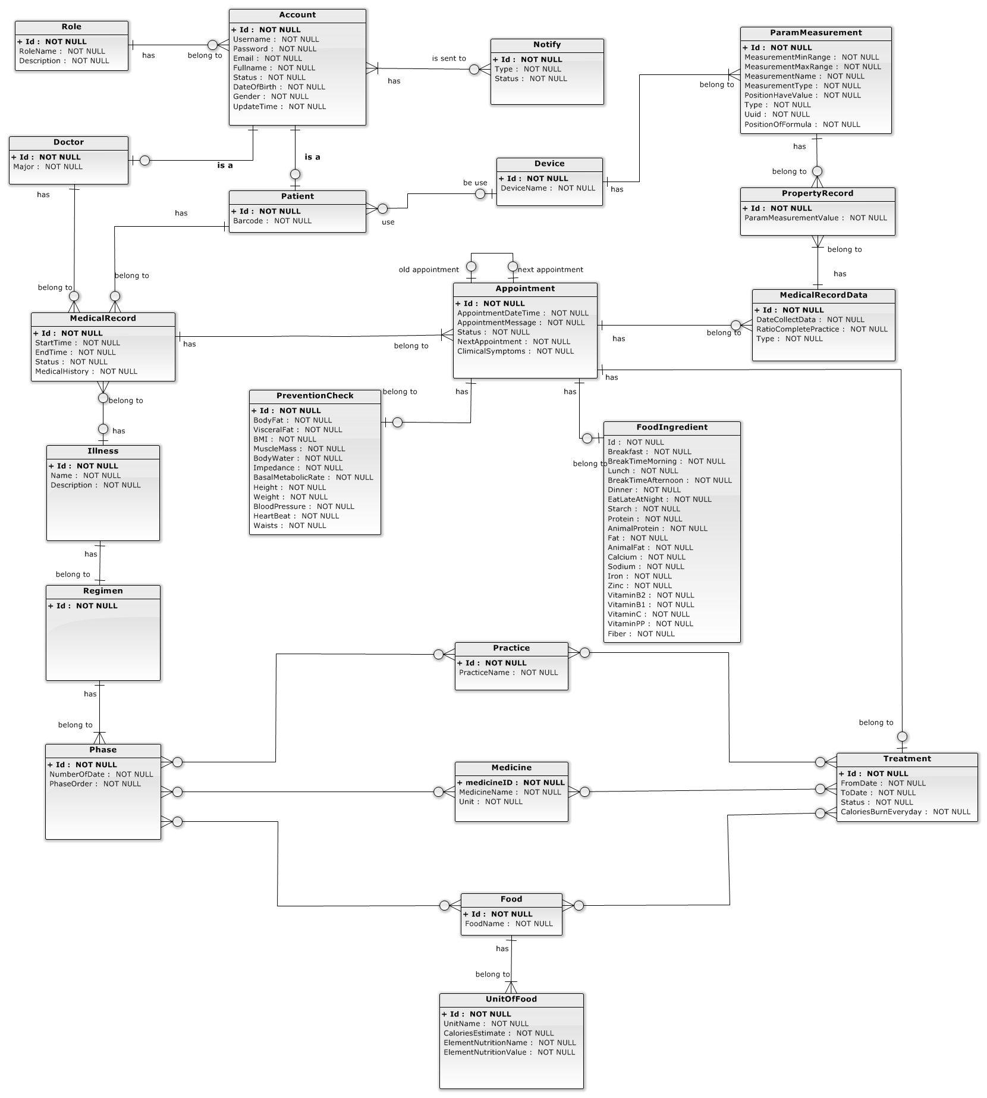

*Figure 105: ERD - Entity Relationship Diagram*

### Entity Dictionary

|  |  |
| --- | --- |
| Entity Data Dictionary: describe content of all entities | |
| Entity name | **Description** |
| Account | Abstract entity describes an account in system |
| Role | Contain the role information. |
| Notify | Contain the notify information. |
| Doctor | Contain the doctor information |
| Patient | Contain the patient information |
| Device | Contain the device information. |
| ParamMeasurement | Contain the parameter measurement information. |
| PropertyRecord | Contain the property record. |
| MedicalRecord | Contain the medical record. |
| Appointment | Contain the appointment information. |
| Illness | Contain the illness information. |
| PreventionCheck | Contain the prevention check information. |
| FoodIngredient | Contain the food ingredient information |
| Regimen | Contain the regimen information |
| Phase | Contain the phase information |
| Treatment | Contain the treatment information |
| Practice | Contain the practice information |
| Medicine | Contain the medicine information |
| Food | Contain the food information |
| UnitOfFood | Contain the unit of foods information |

*Table 100: ERD - Entity Dictionary*

## Algorithms

### Connecting Wristband Algorithm.

#### Definition

* This algorithm proposes general method to connect wristband device using Bluetooth LE standard.

#### Define Problem

* + - Every wristband has a unique way for connect and getting data. We must provide a common interface for connecting device and getting information from wristband.

#### Solution

* + - To solve this problem, we follow these steps:
      * Step 1: Request Android OS send register command:



* + - * Step 2: Get wristband’s profile.
* Android OS will send Device’s profile to GattCallback, so we will create a BluetoothGattCallback variable and override some methods of this callback.
* Device’s profile structure is:



* + - * Step 5: Analyse each Wristband’s service.
* All BLE device have to has one Device Information Service. We will find service with characteristic’s name is “0000180a-0000-1000-8000-00805f9b34fb00805f9b34fb”.
* If this service is not Device Information Service, we will check next Wristband’s service.
* Step 6: Analyse each Device Information service’s Characteristic.
* In Device Information Service. We will find characteristic save device’s name. This characteristic’s name is “00002a29-0000-1000-8000-00805f9b34fb”.
* If this characteristic is not device’s name characteristic, we will check next service’s characteristic.
* Step 7: Read value characteristic.
* In this step, we will call function readCharacteristic(characteristic name) to get Device’s name.
* When we call this function, we will request Android OS send request read characteristic to wristband.
* When Android OS receive value of characteristic, Android OS will send value to BluetoothGattCallback with value is byte array.
* Step 8: Get list Data’s characteristics follow device’s name.
* We will send device’s name to server and get list data’s characteristics.
* We will save list data’s characteristic in local and read each data’s characteristics when hit config time.

#### Flow Chart

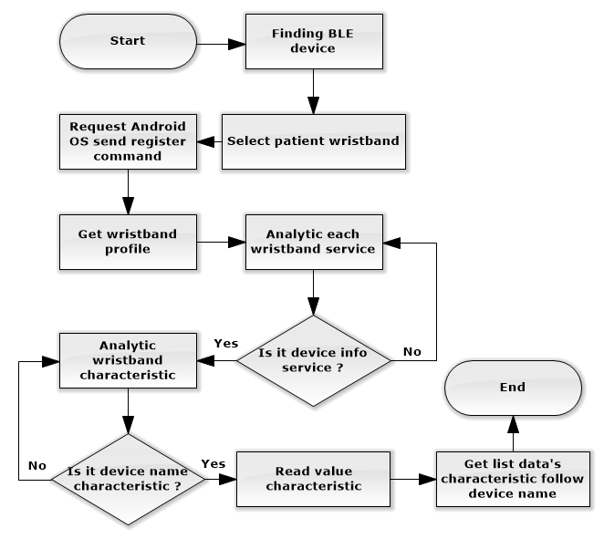

#### Complexity

The complexity of algorithms is ${O(n}^{2})$.

### Analyse Meal By Voice.

#### Defination

* + - This algorithm proposes method to analyse meal using nutrition doctor’s voice input.

#### Define Problem

* + - How to recognize voice input of nutrition doctor?
    - How to convert speech to text?

#### Solution

* + - * Step 1: Convert speech to text with “HTML5 Speech Recognition API’ (This API allows in Chrome version 25 and later).
* Because every region in Vietnam have a different voice. So, Recognition API maybe give wrong result in most of times say, such as “Răng một khổ bánh mì”, “ăn một rổ bánh mì”, … To solve this problem, we has call browser send result to Google server, Google server will analyse result and return nearest correct result. In this example, result from server will be “ăn 1 ổ bánh mì”.
  + - * Step 2: Analyse first word.
* If it is “bữa” or “buổi”, the doctor’s speech is about meal information. And then, comparing the last word to recognize it is breakfast, lunch or dinner.
* If it is “ăn” or “uống”, the doctor’s speech is about food.
  + - * Step 3: Analyse food name.
* Detele first word. Example result is “1 ổ bánh mì”.
* Create object current food.
* If text result contains strings which has same name with food name in list foods, it will set food name in list food to current food’s food name. Unless, process will finish. In this example, object current food have food name is “bánh mì”,
  + - * Step 4: Analyse unit of food
* Delete food name string in text result. Example result is “1 ổ”
* If text result contains string which is unit of food, it will set it to current food’s unit of food. Unless, process will finish. In this example, object current food have unit of food is “ổ”.
  + - * Step 5: Analyse quantity of food.
* Delete unit of food in text result. Example result is “1”
* Get all last string in text result and convert to number as quantity of food.
* Set quantity of food to current food. In this example, object current food quantity is “1”.

#### Complexity

The complexity of algorithms is ${O(n}^{2}).$

#### Flow Chart

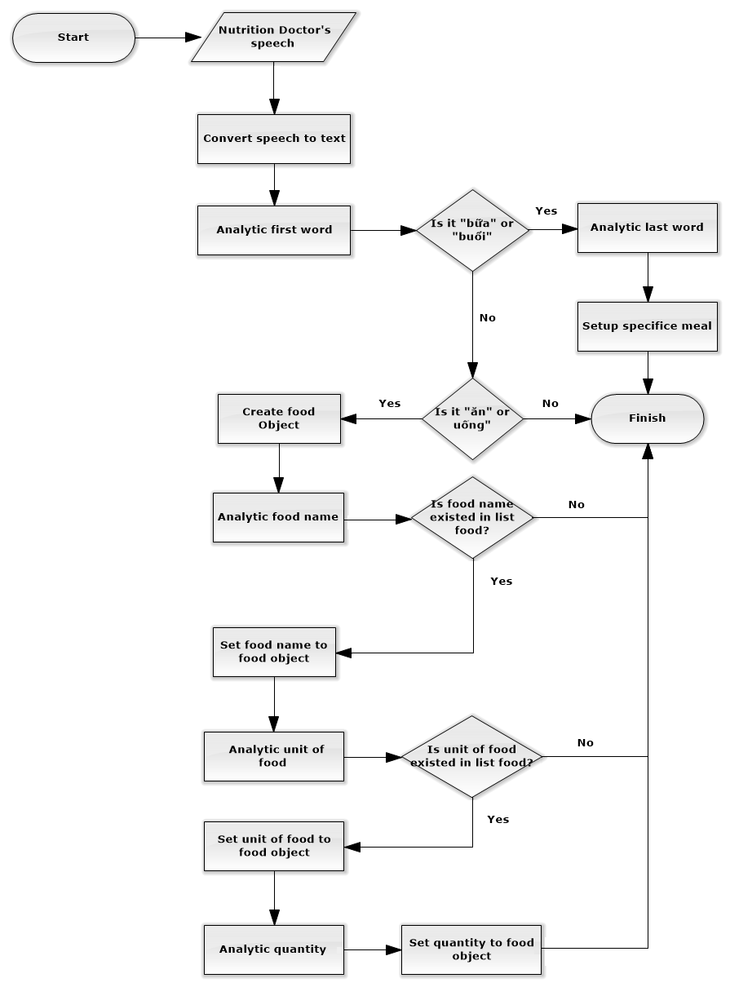

*Figure 106: Algorithms - Analyse Meal By Voice - Flow Chart*

### Mail Scheduler Process

#### Definition

System scheduler is a component of the Web application, this component is responsible for checking the changes from web application and updates information day by day.

#### Definition Problem

In Web application, we need a system scheduler that runs automatically every day to send email contains login credential information to user such as new patients, doctor, nurse, etc. For their usage, we see that it is necessary to send email to target users immediately after account had been created, or reset password request created.

#### Solution

We create an embed scheduler in our web application. The scheduler will automatically run following schedule setting that system administrator defines when deploy the system. Below are detail steps of each time that schedule running:

* + - Step 1: Check if the scheduler configuration is active to running business or not. If no, the scheduler come to finish.
    - Step 2: System accesses to a queue in memory contains list of account that necessary to send credential information.
    - Step 3: If the queue is not empty and the counter does not reach max limitation configure value, system polls first element (an Account object) from queue. If above condition is failed, the scheduler come to finish.
    - Step 4: System tries to send an email contain username and password to target email address of registered account, then increase counter 1 unit. If the email can’t be sent successfully, system will re-push Account element to the end of queue.
* Step 5: Back to step 2.

#### Complexity

The complexity of this algorithm is O(n).

#### Flow Chart



*Figure 107: Algorithms - Mail Scheduler Process - Flow Chart*

### Medical Record State

The medical record in HSTS system is complex and can be managed differently during the operation. The state chart below describes all the state of a medical record.



*Figure 108: Algorithms - Medical Record State*

### Appointment State

An appointment with doctor in HSTS system is complex and can be managed differently during the operation. The state chart below describes all the state of an appointment.



*Figure 109: Algorithms - Appointment State*

### Analyse Medical Record Data Process

#### Definition

System scheduler is a component of the Web application, this component is responsible for checking the changes from web application and updates information day by day.

#### Definition Problem

In Web application, for the purpose that make a statistics report for doctor tracking patient’s treatment status, we need to calculate all values sending from patient’s device.

#### Solution

We create a scheduler in our web application, scheduler will automatically run at specific time that system administrator defines when deploy the system. The scheduler will access to database to check the status of all medical record data and update it.

The scheduler process is describe as below:

* Parse new formula from setting file if need.
* Get all unprocessed medical record data from database.
* Calculate practice result base on distance, calories value, etc.
* Save result to database.

#### Complexity

The complexity of algorithms is $O\left(n\right).$

#### Flow Chart



*Figure 110: Algorithms - Analyse Medical Record Data Process - Flow Chart*

### Analyse Treatment From Server

#### Definition

This algorithm propose method to analyse treatment to list of activities which patient must following in treatment.

#### Definition Problem

Treatment from server just has number of times to implement, but patients need to know clearly activities which they must do in specific time. After researching in some hospital, the doctors declared 6 times for helping patient follow the treatment.

#### Solution

* Step 1: Read all amount times in configured XML file.
* Step 2: Setup list activities for each amount times, such as list activities in “7:00”, list activities in “12:00” …
* Step 3: Analyse patient’s treatment to list activities.
* Step 4: Analyse each activity in list based on number of time, for examples:
* Activity’s number of time is 2: Set activity to list activities in “7:00” and “18:00”.
* Activity’s number of time is 3: Set activity to list activities in “7:00”, “12:00” and “18:00”.
* Activity’s number of time is 4: Set activity to list activities in “7:00”, “9:00”, “12:00” and “18:00”.
* Activity’s number of time is 5: Set activity to list activities in “7:00”, “9:00”, “12:00”, “15:00” and “18:00”.
* Activity’s number of time is 6: Set activity to list activities in “7:00”, “9:00”, “12:00”, “15:00”, “18:00” and “21:00”.
* Step 5: Set activity to specific amount time’s list activity.

#### Complexity

The complexity of algorithms is $O\left(n^{2}\right).$

#### Flow Chart

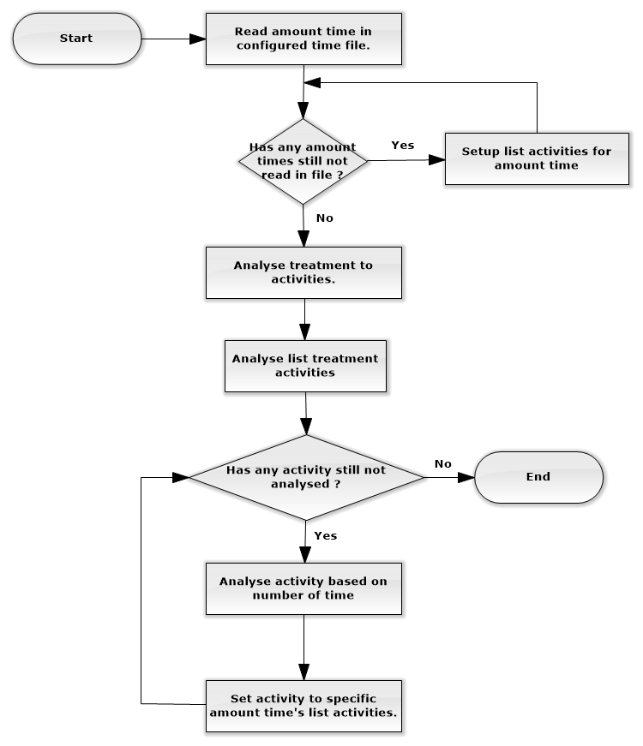

*Figure 111: Algorithms - Analyse Treatment From Server - Flow Chart*

# System Implementation & Test

## Introduction

### Overview

This section describes the approach and methodologies used by group to plan, organize and manage the testing of HSTS system. It provides in the detail all necessary information about the implementation and testing procedure of the system included test plans, test cases, test result, test environments, pass/fail criteria and risks estimations as well as a checklist to cover all possible cases.

### Test Approach

* Goal: Test all features in the whole HSTS system based on the core flow.
* Method: black-box testing
* Technique: check list

The testing for this project will consists of Integration System test level. Testing the program which was integrated and as a complete system to ensure that the software requirements have been met.

* Integration testing would be performed by all member of team and approved by team leader.
* System testing is focused on assessing the system’s reliability. This process is concerned with finding errors that result from unanticipated interactions between components and component interface problems.

## Database Relationship Diagram

### Physical Diagram



*Figure 112: Physical Diagram - Database*

### Data Dictionary

|  |  |  |
| --- | --- | --- |
| Data dictionary: describe content of all tables | | |
| Table Name | **Mapping with Conceptual diagram** | **Description** |
| Account | Account | Describe all accounts in the system. |
| Role | N/A | Not exist in conceptual diagram. Needed in physical diagram to describe all roles of account. |
| Notify | Notify | Describe all notifies in the system. |
| Doctor | Doctor | Describe all doctors in the system. |
| Patient | Patient | Describe all patients in the system. |
| Device | Device | Describe all devices in the system. |
| ParamMeasurement | ParamMeasurement | Describe all parameters of measurement in the system. |
| PropertyRecord | PropertyRecord | Describe all properties of record in the system. |
| MedicalRecordData | MedicalRecordData | Describe all data of a medical record on the system. |
| MedicalRecord | MedicalRecord | Describe all medical records on the system. |
| PreventionCheck | PreventionCheck | Describe all data of a prevent check process on the system. |
| Appointment | Appointment | Describe all appointments on the system. |
| FoodIngredient | FoodIngredient | Describe all data of a food ingredient on the system. |
| Illness | Illness | Describe all illness on the system. |
| Regimen | Regimen | Describe all regimens on the system. |
| Phase | Phase | Describe all phases on the system. |
| Treatment | Treatment | Describe all treatments on the system. |
| FoodPhase | N/A | Not exist in conceptual diagram. Needed in physical diagram to describe all food phases of account. |
| PracticePhase | N/A | Not exist in conceptual diagram. Needed in physical diagram to describe all practice phases of account. |
| MedicinePhase | N/A | Not exist in conceptual diagram. Needed in physical diagram to describe all medicine phases of account. |
| Food | Food | Describe all foods on the system. |
| Practice | Practice | Describe all practices on the system. |
| Medicine | Medicine | Describe all medicines on the system. |
| FoodTreatment | N/A | Not exist in conceptual diagram. Needed in physical diagram to describe all food treatments of account. |
| PracticeTreatment | N/A | Not exist in conceptual diagram. Needed in physical diagram to describe all practice treatments of account. |
| MedicineTreatment | N/A | Not exist in conceptual diagram. Needed in physical diagram to describe all medicine treatments of account. |
| UnitOfFood | UnitOfFood | Describe all units of a food on the system. |

*Table 101: Database - Data Dictionary*

## Performance Measures

### Web application page load speed

#### Definition

This section tests the general page load speed from all the page of the web application.

#### Test environment

**Server:**

* **Operating system:** Window 7 Ultimate 64-bit
* **RAM:** 6 GB
* **Storage:** 500 GB
* **Processor:** 2.4 GHz Intel Core i5
* **Network:** 1 Mbps

#### Test cases

Using browser from client side and go to each page of the web application. Record the page load time using Chrome Dev Tools at client side.

|  |  |
| --- | --- |
| Guest | Login |
| Nurse | Patient   * Register Medical Examination * Show list patients |
| Doctor | Patient   * Show list patients * Make prescription * View nutrition details |
| Nutrition Doctor | Patient   * Create food * View list patients * Make food ingredient * Analyse meal by voice |

*Table 102: Web application - Test Cases*

#### Test result

The test is run 10 times, each time we go through all the pages listed above and log down the average page load time.



*Figure 113: Web Application - Test Result*

|  |  |  |
| --- | --- | --- |
| Test No. | Average page load time (second) | Execute date |
| 1 | 1.28 | 23 November 2015 |
| 2 | 1.62 | 23 November 2015 |
| 3 | 0.8 | 23 November 2015 |
| 4 | 1.23 | 23 November 2015 |
| 5 | 1.39 | 23 November 2015 |
| 6 | 2.8 | 23 November 2015 |
| 7 | 1.34 | 23 November 2015 |
| 8 | 1.39 | 23 November 2015 |
| 9 | 1.76 | 23 November 2015 |
| 10 | 1.22 | 23 November 2015 |
|  | **Average: 1.48 (seconds)** |  |

*Table 103: Web application - Test Result*

### Mobile application load speed

#### Definition

This section tests the load speed of mobile apps when connection to server through API.

#### Test Environment

**Server:**

* **Operating system:** Window 7 Ultimate 64-bit
* **RAM:** 6 GB
* **Storage:** 500 GB
* **Processor:** 2.4 GHz Intel Core i5
* **Network:** 1 Mbps

**Client:**

* Android device:

|  |  |  |
| --- | --- | --- |
| Hardware Requirements | Minimum | Recommended |
| Internet Connection | 512Kbps | Wi-Fi Connection 12MB |
| Operating System | Android 4.4 | Android 5.0.2 |
| Hardware | Bluetooth LE supported | Bluetooth LE supported |
| Memory | 512MB of RAM | 2GB of RAM or more |

*Table 104: Mobile Application - Test Environment*

* Wristband device:

|  |  |  |
| --- | --- | --- |
| Hardware | Minimum Requirements | Recommended |
| Bluetooth Connection | BLE Supported | BLE Supported |
| Firmware Revision | 01011206 | 01011206 |
| Hardware | Bluetooth 4.0 | Bluetooth 4.0 |
| Memory | 64Kb of RAM | 64Kb of Ram |

#### Test Cases

Using mobile application to send the entire API request to web server.

List of APIs:

|  |  |  |
| --- | --- | --- |
| No. | API | Description |
| 1 | getPatientProfile | Get patient’s profile when patient log in. |
| 2 | getNewTreatment | Get latest treatment of patient |
| 3 | checkNotify | Check notification of analyse practice result |
| 4 | sendMedicalData | Send practice data of patient to server |

*Table 105: Mobile Application - Test Cases*

#### Test Result

The test is run 10 times, each time we run all the test cases listed above and log down the average API response time.



*Figure 114: Mobile Application - Test Result*

|  |  |  |
| --- | --- | --- |
| Test No. | Average page load time (second) | Execute date |
| 1 | 2.13 | 23 November 2015 |
| 2 | 2.33 | 23 November 2015 |
| 3 | 2.65 | 23 November 2015 |
| 4 | 2.53 | 23 November 2015 |
| 5 | 1.95 | 23 November 2015 |
| 6 | 1.62 | 23 November 2015 |
| 7 | 2.27 | 23 November 2015 |
| 8 | 2.05 | 23 November 2015 |
| 9 | 1.46 | 23 November 2015 |
| 10 | 1.57 | 23 November 2015 |
|  | **Average: 1.90 (seconds)** |  |

*Table 106: Mobile Application - Test Result*

## Test Plan

### Features to be tested

* Doctor: make prescription
* Nutrition Doctor: make food ingredient
* Analyst: analyse meal by voice, analyse meal, suggest treatment
* Nurse: Register Medical Examination, print prescription
* Admin: insert account, update account, delete account
* Login, logout
* Mobile application: login, pair device, notice practice result, remind patient, logout

### Features not to be tested

* Doctor: view patient medical history
* Nutrition Doctor: insert food’s nutrition, update food’s nutrition, delete food’s nutrition
* Nurse: Register Medical Examination with old patient
* Staff: insert wristband, update wristband, delete wristband, update formula
* Mobile application: analyse new treatment, get data from wristband, synchronize practice data, and check notification of patient.

## System Testing Test Case

### Communication Diagram

#### Web Application



*Figure 115: Communication Diagram - Web Application*

#### Mobile Application



*Figure 116: Communication Diagram - Mobile Application*

### Test cases

#### Web Application Test Case

##### <Guest> Login

|  |  |  |  |  |  |  |
| --- | --- | --- | --- | --- | --- | --- |
| ID | Test Case Description | Test case procedure | Expected output | Inter-test case dependence | Result | Test Date |
| WA01 | Login with valid nurse’s username and password | 1. Go to login page 2. Input username “nurse” and password “nurse” 3. Press “Login” button | Show target page “Register exam” |  | Pass | From 30/9/15  To 15/10/15  (20 times) |
| WA02 | Login with valid doctor’s username and password | 1. Go to login page 2. Input username “doctor1” and password “doctor1” 3. Press “Login” button | Show target page “Patient list” |  | Pass | From 30/9/15  To 15/10/15  (20 times) |
| WA03 | Login with inactive account’s username and password | 1. Go to login page 2. Input username “doctor2” and password “doctor2” 3. Press “Login” button | Show target page “Change password” |  | Pass | From 30/9/15  To 15/10/15  (20 times) |
| WA04 | Login with valid patient’s username and password | 1. Go to login page 2. Input valid username “quantd” and password “AuWzTj” 3. Press “Login” button | Show pop-up “Invalid username or password” |  | Pass | From 30/9/15  To 15/10/15  (20 times) |
| WA05 | Login with invalid username and password | 1. Go to login page 2. Input username “nurse” and password “nurse2” 3. Press “Login” button | Show pop-up “Invalid username or password” |  | Pass | From 30/9/15 t  To 15/10/15  (20 times) |
| WA06 | Login with blocked account’s username and password | 1. Go to login page 2. Input username “doctor3” and password “doctor3” 3. Press “Login” button | Show pop-up “Invalid username or password” |  | Pass | From 30/9/15  To 15/10/15  (20 times) |

*Table 107: Web Application Test Case - <Guest>Login*

##### <Authorized User> Logout

|  |  |  |  |  |  |  |
| --- | --- | --- | --- | --- | --- | --- |
| ID | Test Case Description | Test case procedure | Expected output | Inter-test case dependence | Result | Test Date |
| WA07 | Normal logout | 1. Login web application successfully. 2. Press “Logout” button at the corner. | Show “Login” page |  | Pass | From 30/9/15 to 15/10/15  (20 times) |
| WA08 | Log out after session timed out 1 | 1. Login web application successfully. 2. Don’t interactive with application in 30 minutes. 3. After 30 minutes, try to reload current page. | Show “Login” page |  | Pass | From 30/9/15 to 15/10/15  (20 times) |
| WA09 | Log out after session timed out 2 | 1. Login web application successfully. 2. Un-deploy web application then re-deploy it. 3. Try to reload current page. | Show “Login” page |  | Pass | From 30/9/15 to 15/10/15  (20 times) |
| WA10 | Log out after session timed out 3 | 1. Login web application successfully. 2. Current server time is 7:00, change it to 8:00. 3. Try to reload current page. | Show “Login” page |  | Pass | From 30/9/15 to 15/10/15  (20 times) |

*Table 108: Web Application Test Case - <Authorized User>Logout*

##### <Doctor> Make Prescription

|  |  |  |  |  |  |  |
| --- | --- | --- | --- | --- | --- | --- |
| ID | Test Case Description | Test case procedure | Expected output | Inter-test case dependence | Result | Test Date |
| MP1 | Test make prescription with valid information without suggest treatment | 1. Go to home page. 2. Select a patient in list. 3. Enter treatment detail follow these information.  * Diagnostic: Fat 1 * Medicine: Sibutramine – Time: 1 – Quantity: 1 – Unit: viên. * Food: Cơm – Time: 1 – Quantity: 1 – Unit: bát. * Practice: Chạy bộ - Time: 1 – Quantitative: 20 phút * Kcal Estimate: 800  1. Click “Done” button 2. Click “Yes” button on confirm popup | Show treatment had input. |  | Pass | From: 19/10/2015  To: 29/11/2015  (about 46 times) |
| MP2 | Test make prescription with valid information and suggest treatment | 1. Go to home page.  2. Select a patient in list.  3. Select “Fat 1” in diagnostic field.  4. Select “Suggest”  5. Click “Done” button  6. Click “Yes” button on confirm dialog | Show treatment had input. | ST1 - Suggest treatment | Pass | From: 19/10/2015  To: 26/11/2015  (about 46 times) |
| MP3 | Test make prescription with invalid information. | 1. Go to home page.  2. Select a patient in list.  3. Enter treatment detail follow these information.  - Diagnostic: Fat 1  - Medicine: Sibutramine – Time: 0 – Quantity: 0 – Unit: viên.  - Food: Cơm – Time: 0 – Quantity: 0 – Unit: bát.  - Practice: Chạy bộ - Time: 0 – Quantitative: 20 phút  - Kcal Estimate: 800  4. Click “Done” button  5. Click “Yes” button on confirm dialog | Show notify message wrong input below each input invalid. |  | Pass | From: 19/10/2015  To: 26/11/2015  (about 46 times) |
| MP4 | Test make prescription with valid information,add one food and delete one medicine. | 1. Go to home page. 2. Select a patient in list. 3. Enter treatment detail follow these information.  * Diagnostic: Fat 1 * Medicine: Sibutramine – Time: 1 – Quantity: 1 – Unit: viên. * Food: Cơm – Time: 1 – Quantity: 1 – Unit: bát. * Practice: Chạy bộ - Time: 1 – Quantitative: 20 phút * Kcal Estimate: 800  1. Click “Add” button in tab food 2. Enter food follown these information.  * Food: Cá – Time: 1 – Quantity: 100 – Unit: gam.  1. Click “Delete” button in tab medicine. 2. Click “Done” button 3. Click “Yes” button on confirm popup | Show treatment had input. |  | Pass | From: 16/10/2015  To: 29/11/2015  (about 46 times) |
| MP5 | Test make prescription with diagnostic and nothing in food, medicine, practice. | 1. Go to home page. 2. Select a patient in list. 3. Select a Diagnostic in list. 4. Delete all row in tab foods, medicine and practice. 5. Click “Done” button. 6. Click “Yes” button in confirm popup. | Show message “Please select No illness in Diagnostic, if patient does not have illness” |  | Pass | From: 19/10/2015  To: 26/11/2015  (about 46 times) |

*Table 109: Web Application Test Case - <Doctor>Make Prescription*

##### <Doctor Manager> Insert Regimen

|  |  |  |  |  |  |  |
| --- | --- | --- | --- | --- | --- | --- |
| ID | Test Case Description | Test case procedure | Expected output | Inter-test case dependence | Result | Test Date |
| CR01 | Create regimen with valid information. | 1. Login successfully with role “Doctor Manager” 2. In Regimens view, press “Create new regimen” button. 3. Input field:  * Illness name: “FAT 1”. * Illness description: “Béo phì cấp độ 1”. * Number of phase: 5.  1. Press “Create” button. | Display new regimen for illness FAT 1 at Regimen view. |  | Pass | From 15/11/15  To 7/12/15  (15 times) |
| CR02 | Create regimen with valid information. | 1. Login successfully with role “Doctor Manager” 2. In Regimens view, press “Create new regimen” button. 3. Input field:  * Illness name: “FAT 1”. * Illness description: “Béo phì cấp độ 1”. * Number of phase: 21.  1. Press “Create” button. | 1. Web application notice that field Number of phase is invalid: **“Please enter a value less than or equal to 20”.** 2. Web application notice that field Illness name is invalid: **“Illness with name FAT 1 is existence, please fix”.** |  | Pass | From 15/11/15 t  To 7/12/15  (15 times) |

*Table 110: Web Application Test Case - <Doctor>Insert Regimen*

##### <Doctor Manager> Update Regimen

|  |  |  |  |  |  |  |
| --- | --- | --- | --- | --- | --- | --- |
| ID | Test Case Description | Test case procedure | Expected output | Inter-test case dependence | Result | Test Date |
| UR01 | Update regimen by add new medicine to a regimen phase. | 1. Login successfully with role “Doctor Manager”. 2. Create regimen for illness “FAT 1” successfully. 3. Press link to detail regimen of regimen for illness “FAT 1”. 4. Press link to detail phase number 1. 5. Press button “Add new medicine”. 6. In pop-up, input valid information:  * Medicine name: Choose “Panadol” from available option. * Number of times: 3. * Quantitative: 1. * Advice: N/A.  1. Press “Add” button | Display new medicine “Panadol” in medicine list of this regimen. |  | Pass | From 15/11/15  To 7/12/15  (15 times) |
| UR02 | Update regimen with valid information. | 1. Login successfully with role “Doctor Manager” 2. In Regimens view, create regimen for illness “FAT 1” successfully. 3. Click “Update” button for regimen “FAT 1”. Input field on update pop-up:  * Illness name: “FAT 2”. * Illness description: “Béo phì cấp độ 2”. * Number of phase: 5.  1. Press “Update” button. | Display regimen for illness FAT 2 in regimen list. |  | Pass | From 15/11/15  To 7/12/15  (15 times) |
| UR02 | Update regimen with invalid information. | 1. Login successfully with role “Doctor Manager” 2. In Regimens view, create regimen for illness “FAT 1” successfully. 3. Click “Update” button for regimen “FAT 1”. Input field on update pop-up:  * Illness name: empty field. * Illness description: “Béo phì cấp độ 6”. * Number of phase: 25.  1. Press “Update” button. | 1. Web application notice that field Number of phase is invalid: **“Please enter a value less than or equal to 20”.** 2. Web application notice that field Illness name is invalid: **“This field is required.”.** |  | Pass | From 15/11/15  To 7/12/15  (15 times) |
| UR03 | Update regimen by delete a medicine to a regimen phase. | 1. Login successfully with role “Doctor Manager”. 2. Create regimen for illness “FAT 1” successfully. 3. Press link to detail regimen of regimen for illness “FAT 1”. 4. Press link to detail phase number 1. 5. Add new medicine “Panadol” to phase successfully. 6. Press button “Delete” at row of medicine “Panadol”. | Medicine “Panadol” is deleted from medicine list of this regimen. |  | Pass | From 15/11/15  To 7/12/15  (15 times) |

*Table 111: Web Application Test Case - <Doctor Manager>Update Regimen*

##### <Doctor Manager> Delete Regimen

|  |  |  |  |  |  |  |
| --- | --- | --- | --- | --- | --- | --- |
| ID | Test Case Description | Test case procedure | Expected output | Inter-test case dependence | Result | Test Date |
| CR01 | Delete regimen. | 1. Login successfully with role “Doctor Manager”. 2. Create regimen for illness “FAT 1” successfully. 3. Press button “Delete” in row of “FAT 1”. | Regimen for illness “FAT 1” is deleted from regimen list. |  | Pass | From 15/11/15  To 7/12/15  (15 times) |

*Table 112: Web Application Test Case - <Doctor Manager>Delete Regimen*

##### <Nutrition Doctor> Make Nutritional Ingredient

|  |  |  |  |  |  |  |
| --- | --- | --- | --- | --- | --- | --- |
| ID | Test Case Description | Test case procedure | Expected output | Inter-test case dependence | Result | Test Date |
| MNI1 | Test nutrition doctor make nutrition ingredient with valid information. | 1. Go to home page. 2. Select a patient in list. 3. Input nutrition information:  * Breakfast: 800 * Breaktime Morning:800 * Lunch: 1200 * Breaktime Afternoon: 800 * Dinner: 1400 * Eat late at night: 1000 * Animal Fat: 67.6 * Animal Protein: 80.2 * Calcium:50.7 * Fat: 98.9 * Fiber: 120 * Iron: 15 * Protein: 220 * Sodium: 121 * Starch: 210 * VitaminB1: 198 * VitaminB2: 187 * VitaminC: 202 * VitaminPP: 178 * Zinc: 68 | Create Nutrition Ingredient successful, show success message. |  | pass | From: 12/10/2015  To: 1/11/2015  (about 24 times) |
| MNI2 | Test nutrition doctor make nutrition ingredient with invalid information. | 1. Go to home page. 2. Select a patient in list. 3. Input nutrition information:  * Breakfast: asdf * Breaktime Morning:asdf * Lunch: 1200 * Breaktime Afternoon: * Dinner: 1400 * Eat late at night: asdf * Animal Fat: 67.6 * Animal Protein: 80.2 * Calcium:50.7 * Fat: 98.9 * Fiber: 120 * Iron: 15 * Protein: 220 * Sodium: 121 * Starch: asdf * VitaminB1: 198 * VitaminB2: 187 * VitaminC: asdf * VitaminPP: asdf * Zinc: 68 | Show error message and make red border in each field input wrong format. |  | pass | From: 12/10/2015  To: 2/11/2015  (about 18 times) |

*Table 113: Web Application Test Case - <Nutrition Doctor>Make Nutritional Ingredient*

##### <Nurse> Register Medical Examination

|  |  |  |  |  |  |  |
| --- | --- | --- | --- | --- | --- | --- |
| ID | Test Case Description | Test case procedure | Expected output | Inter-test case dependence | Result | Test Date |
| RE01 | Register exam with valid input information | 1. Login with role “Nurse” successfully. 2. Input valid information:  * Patient name: Trần Đăng Quân. * Birthday: 14/12/1993 * Email: [quantdse60878@fpt.edu.vn](mailto:quantdse60878@fpt.edu.vn) * Male check: yes. * Weight: 60. * Height: 160. * Heartbeat: 90. * Blood pressure: 100. * Waits: 70. * Body fat: 20%. * Visceral fat: 2. * Muscle mass: 20%. * Body water: 70%. * Phase angle: 7 o. * Impedance: 530 Ohm. * Basal Metabolic rate: 2000 kcal. * Doctor: choose “Doctor Huỳnh Văn Dưỡng”. * Medical history: N/A. * Clinical symptoms: Mệt mỏi, biếng ăn. * Medicine history: N/A.  1. Press “Register” button. | 1. Show medical order number with patient information. 2. Doctor see “Trần Đăng Quân” in list of awaiting patient. |  | Pass | From 1/10/15  To 15/11/15  (50 times) |
| RE02 | Register exam with invalid input information | 1. Login with role “Nurse” successfully. 2. Input valid information:  * Patient name: Trần Đăng Quân. * Birthday: 14/12/1993 * Email: [quantdse60878@fpt.edu.vn](mailto:quantdse60878@fpt.edu.vn) * Male check: yes. * Weight: 60. * Height: 160. * Heartbeat: 150. * Blood pressure: 100. * Waits: 70. * Body fat: 20%. * Visceral fat: 2. * Muscle mass: 20%. * Body water: 70%. * Phase angle: 7 o. * Impedance: 530 Ohm. * Basal Metabolic rate: 2000 kcal. * Doctor: choose “Doctor Huỳnh Văn Dưỡng”. * Medical history: N/A. * Clinical symptoms: Mệt mỏi, biếng ăn. * Medicine history: N/A.  1. Press “Register” button. | 1. Web application notice that field Email is invalid: **“This email is already use”.** 2. Web application notice that field Heartbeat is invalid: **“Invalid heart beat out of range, please fix”** |  | Pass | From 1/10/15  To 15/11/15  (50 times) |
| RE03 | Register exam with old patient. | 1. Login with role “Nurse” successfully. 2. Input field Patient name with value “Trần Đăng Quân” 3. Choose an option from available result. 4. Press “This is old patient” in pop-up. | 1. Show register exam page. Basic patient information is filled. 2. When nurse press “Register” button, system does not create new patient record. |  | Pass | From 1/10/15  To 15/11/15  (50 times) |
| RE04 | Register exam with old patient, use old measurement indexes. | 1. Login with role “Nurse” successfully. 2. Input field Patient name with value “Trần Đăng Quân” 3. Choose an option from available result. 4. Press “This is old patient” in pop-up. 5. In register patient page with basic information is filled, press button “Use old measurement index”. | 1. Show register patient page. Basic patient information and all old measurement indexes, symptoms (if have) are filled. 2. When nurse press “Register” button, system does not create new patient record. |  | Pass | From 1/10/15  To 15/11/15  (50 times) |
| RE05 | Register exam with old patient, use old measurement indexes, re-input invalid value. | 1. Login with role “Nurse” successfully. 2. Input field Patient name with value “Trần Đăng Quân” 3. Choose an option from available result. 4. Press “This is old patient” in pop-up. 5. In register patient page with basic information is filled, press button “Use old measurement index”. 6. Change Height value to 500 Kg. | Web application notice that field Height is invalid: **“Invalid height out of range, please fix”** |  | Pass | From 1/10/15  To 15/11/15  (50 times) |

*Table 114: Web Application Test Case - <Nurse>Register Medical Examination*

##### <Nurse> Print Prescription

|  |  |  |  |  |  |  |
| --- | --- | --- | --- | --- | --- | --- |
| ID | Test Case Description | Test case procedure | Expected output | Inter-test case dependence | Result | Test Date |
| PE01 | Print prescription successfully. | 1. Login successfully with role “Nurse”, register exam for patient “Trần Đăng Quân” successfully. 2. Login successfully with role “Doctor”, make prescription for a patient. 3. Login back with role “Nurse”, press link **Patients.** 4. In list of available patient, press button “Print prescription” for patient “Trần Đăng Quân”. | Display PDF document with full information about medicines and advice. | RE01 | Pass | From 1/10/15  To 15/11/15  (20 times) |
| CR02 | Print prescription successfully. | 1. Login successfully with role “Nurse”, register exam for new patient “Phan Nhật Anh” successfully. 2. In list of available patient, press button “Print prescription” for patient “Phan Nhật Anh”. | Display pop-up with message “No available prescription for current patient”. | RE01 | Pass | From 1/10/15  To 15/11/15  (20 times) |

*Table 115: Web Application Test Case - <Nurse>Print Prescription*

##### <Admin> Insert Account

|  |  |  |  |  |  |  |
| --- | --- | --- | --- | --- | --- | --- |
| ID | Test case description | Test case procedure | Expected output | Inter-test case dependence | Result | Test date |
| IA1 | Insert accounts success | 1. Download “Template.xlsx” is template of list accounts.  2. Input all value of accounts to excel file  4. Clicks on “Upload” to upload accounts excel file.  5. Clicks on “Insert Accounts” button. | Refresh view with new accounts. |  | Pass | From 1/10/15  To 10/11/15  (20 times) |
| IA2 | Insert accounts with uploading wrong extension file | 1. Download “Template.xlsx” is template of list accounts.  2. Input all value of accounts to excel file  4. Clicks on “Upload” to upload any files. | Show message “Please select a valid excel file.” |  | Pass | From 1/10/15  To 10/11/15  (20 times) |
| IA3 | Insert accounts with wrong inputs | 1. Download “Template.xlsx” is template of list accounts.  2. Input all invalid value to excel file  4. Clicks on “Upload” to upload accounts excel file.  5. Clicks on “Insert Accounts” button | Reload view with no changes. |  | Pass | From 1/10/15  To 10/11/15  (20 times) |

*Table 116: Web Application Test Case - <Admin>Insert Account*

##### <Admin> Update Account

|  |  |  |  |  |  |  |
| --- | --- | --- | --- | --- | --- | --- |
| ID | Test case description | Test case procedure | Expected output | Inter-test case dependence | Result | Test date |
| UA1 | Update specific account success | 1. Select a specific account in list accounts view. 2. Inputs updating information 3. Clicks on “Update” button. | A message notify these account information is updated. |  | Pass | From 1/10/15  To 10/11/15  (20 times) |
| UA2 | Update specific account but cancels | 1. Select a specific account in list accounts view. 2. Clicks on “Cancel” button. | Back to list of accounts view. |  | Pass | From 1/10/15  To 10/11/15  (20 times) |

*Table 117: Web Application Test Case - <Admin>Update Account*

##### <Admin> Delete Account

|  |  |  |  |  |  |  |
| --- | --- | --- | --- | --- | --- | --- |
| ID | Test case description | Test case procedure | Expected output | Inter-test case dependence | Result | Test date |
| DA1 | Delete specific account success | 1. Clicks on “Delete” button of specific account per each row. 2. Click on “OK” button of confirm box | A message notify these account information is deleted |  | Pass | From 1/10/15  To 10/11/15  (20 times) |
| DA2 | Delete specific account but cancels | 1. Clicks on “Delete” button of specific account per each row. 2. Click on “Cancel” button of confirm box | Back to list of accounts view. |  | Pass | From 1/10/15  To 10/11/15  (20 times) |

*Table 118: Web Application Test Case - <Admin>Delete Account*

##### <Analyst> Suggest Treatment

|  |  |  |  |  |  |  |
| --- | --- | --- | --- | --- | --- | --- |
| ID | Test Case Description | Test case procedure | Expected output | Inter-test case dependence | Result | Test Date |
| ST1 | Test make prescription with one illness in list. | 1. Go to home page. 2. Select a patient in list. 3. Select illness name “Fat 3” in diagnostic. 4. Click “Suggest” button. | Show list food, medicine, practices use to treatment “Fat 3”. |  | Pass | From: 09/10/2015  To: 4/11/2015  (about 40 times) |
| ST2 | Test suggest treatment with no illness | 1. Go to home page. 2. Select a patient in list. 3. Select “No illness” in diagnostic. | Show confirm popup “Patient: Hà Kim Quy. No illness!!” |  | Pass | From: 09/10/2015  To: 4/11/2015  (about 40 times) |
| ST3 | Test suggest treatment without choose anything | 1. Go to home page. 2. Select a patient in list. 3. Does not select any diagnostic. 4. Click “Suggest” button | Show notify message “Please choose diagnostic.” Below diagnostic select. |  | Pass | From: 09/10/2015  To: 4/11/2015  (about 40 times) |

*Table 119: Web Application Test Case - <Analyst>Suggest Treatment*

##### <Analyst> Analyse Meal By Voice

|  |  |  |  |  |  |  |
| --- | --- | --- | --- | --- | --- | --- |
| ID | Test Case Description | Test case procedure | Expected output | Inter-test case dependence | Result | Test Date |
| AMBC1 | Test nutrition doctor analyse meal by voice input food exist in database | 1. Go to home page. 2. Select a patient in list. 3. Click “Mic Icon” 4. Say “Buổi sáng” 5. Say “ăn một bát cơm”, “ăn 100g cá ngừ”. 6. Click “Suggest” button. | Show nutrition ingredient page had input calories, nutrition in breakfast follow value had input in breakfast. | AM1 - Analyse meal | Pass | From: 29/10/2015  To: 8/11/2015  (about 20 times) |
| AMBC2 | Test nutrition doctor analyse meal by voice input food does not exist in database. | 1. Go to home page. 2. Select a patient in list. 3. Click “Mic Icon” 4. Say “Buổi sáng” 5. Say “ăn 10 cái bánh bột lọc” 6. Click “Suggest” button. | Show nutrition ingredient page without input calories, nutrition in breakfast. | AM1 - Analyse meal | Pass | From: 29/10/2015  To: 8/11/2015  (about 20 times) |
| AMBC3 | Test nutrition doctor analyse meal by voice input multiple meal, food. | 1. Go to home page. 2. Select a patient in list. 3. Click “Mic Icon” 4. Say “Buổi sáng” 5. Say “ăn một bát cơm”, “100g thịt heo”. 6. Say “Buổi trưa” 7. Say “ăn bốn bát cơm”, “100g thịt gà, 200g thịt heo” 8. Click “Suggest” button. | Show nutrition ingredient page had input calories, nutrition in breakfast, lunch follow value had input | AM1 - Analyse meal | Pass | From: 29/10/2015  To: 8/11/2015  (about 20 times) |

*Table 120: Web Application Test Case - <Analyst>Analyse Meal By Voice*

##### <Analyst> Analyse Meal

|  |  |  |  |  |  |  |
| --- | --- | --- | --- | --- | --- | --- |
| ID | Test Case Description | Test case procedure | Expected output | Inter-test case dependence | Result | Test Date |
| AM1 | Test nutrition doctor analyse meal using input text | 1. Go to home page. 2. Select a patient in list. 3. Select breakfast. 4. Input information: “1 bát cơm”, “100g thịt heo” 5. Click “Suggest” button. | Show nutrition ingredient page had input calories, nutrition in breakfast follow value had input in breakfast | MNI1 - Make Nutrition Ingredient | Pass | From: 18/10/2015  To: 26/10/2015  (about 36 times) |
| AM2 | Test nutrition doctor make nutrition ingredient using input text does not exist in database. | 1. Go to home page. 2. Select a patient in list. 3. Select breakfast. 4. Input information: “10 cái bánh bột lọc” 5. Click “Suggest” button. | Show nutrition ingredient page without input calories, nutrition in breakfast. | MNI1 - Make Nutrition Ingredient | Pass | From: 18/10/2015  To: 26/10/2015  (about 36 times) |
| AM3 | Test nutrition doctor make nutrition ingredient using input text multiple meal, food. | 1. Go to home page. 2. Select a patient in list. 3. Select breakfast. 4. Say “ăn một bát cơm”, “100g thịt heo”. 5. Select lunch. 6. Say “ăn bốn bát cơm”, “100g thịt gà, 200g thịt heo” 7. Click “Suggest” button. | Show nutrition ingredient page had input calories, nutrition in breakfast, lunch follow value had input | MNI1 - Make Nutrition Ingredient | Pass | From: 18/10/2015  To: 26/10/2015  (about 36 times) |

*Table 121: Web Application Test Case - <Analyst>Analyse Meal*

#### Mobile Application Test Case

##### <Patient> Logout

|  |  |  |  |  |  |  |
| --- | --- | --- | --- | --- | --- | --- |
| ID | Test Case Description | Test case procedure | Expected output | Inter-test case dependence | Result | Test Date |
| LO1 | Test logout after logged in into application. | 1. Guest opens menu on the right top of android service. 2. Patient clicks on “Đăng Xuất” item. | Show login screen on android device. |  | Pass | From 20/10/15 To 23/11/15  (over 20 times) |

*Table 122: Mobile Application Test Case - <Patient>Logout*

##### <Patient> Pair Device

|  |  |  |  |  |  |  |
| --- | --- | --- | --- | --- | --- | --- |
| ID | Test Case Description | Test case procedure | Expected output | Inter-test case dependence | Result | Test Date |
| LI1 | Test pair with available Bluetooth | 1. Patient login HSTS Application success. | Show list BLE devices |  | Pass | From 20/10/15  To  23/11/15  (over 30 times) |
| LI2 | Test login with unavailable Bluetooth | 1. Patient login HSTS Application success. 2. Show dialog to ask patient for opening BlueTooth 3. Guest accepts to open Bluetooth | Show list BLE devices |  | Pass | From 22/11/15  To  23/11/15  (over 30 times) |

*Table 123: Mobile Application Test Case - <Patient>Device*

##### <Guest> Login

|  |  |  |  |  |  |  |
| --- | --- | --- | --- | --- | --- | --- |
| ID | Test Case Description | Test case procedure | Expected output | Inter-test case dependence | Result | Test Date |
| LI1 | Test login with valid account | 1. Guest opens HSTS Application. 2. Guest inputs username with “khuongmh” and password with “123” 3. Guest clicks on “Đăng Nhập” button. | Show pairing device screen on android device. |  | Pass | From 30/09/15 To 23/11/15  (over 40 times) |
| LI2 | Test login with invalid | 1. Guest opens HSTS Application. 2. Guest inputs username with “khuongmh” and password with “321” 3. Guest clicks on “Đăng Nhập” button. | Show error message “Tên Đăng Nhập hoặc Mật Khẩu bị sai.” on android device. |  | Pass | From 30/09/15 To 23/11/15  (about 30 times) |
| LI3 | Test login with empty username field or password field. | 1. Guest opens HSTS Applications. 2. Guest inputs username with “khuongmh” 3. Guest clicks on “Đăng Nhập” | Show error message “Vui lòng nhập đầy đủ thông tin.” on android device. |  | Pass | From 30/09/15 To 23/11/15  (about 30 times) |

*Table 124: Mobile Application Test Case - <Guest> Login*

##### <Scheduler> Remind Patient

|  |  |  |  |  |  |  |
| --- | --- | --- | --- | --- | --- | --- |
| ID | Test Case Description | Test case procedure | Expected output | Inter-test case dependence | Result | Test Date |
| RP1 | Test scheduler remind when setting current time. | 1. Patient changes android service’s current time to configured time. | Show remind message “Bạn đến giờ ăn, uống thuốc, tập luyện” on android device. |  | Pass | From 10/10/15 To 23/11/15  (over 50 times) |
| RP2 | Test scheduler remind when patient skip dialog | 1. Patient changes android service’s current time to configured time. 2. Show remind dialog to notice patient. 3. Patient clicks on “Làm Lại” button. | Show remind message “Bạn đến giờ ăn, uống thuốc, tập luyện” on android device every 5 minutes. |  | Pass | From 10/10/15 To 23/11/15  (over 50 times) |
| RP3 | Test scheduler remind when patient stop reminding. | 1. Patient changes android service’s current time to configured time. 2. Show remind dialog to notice patient. 3. Patient clicks on “Ngưng nhắc nhở’ button. | Sheduler stop reminding until next configured time. |  | Pass | From 10/10/15 To 23/11/15  (over 50 times) |

*Table 125: Mobile Application Test Case - <Scheduler>Remind Patient*

##### <Scheduler> Notice Practice Result

|  |  |  |  |  |  |  |
| --- | --- | --- | --- | --- | --- | --- |
| ID | Test Case Description | Test case procedure | Expected output | Inter-test case dependence | Result | Test Date |
| ADFW1 | Test analyse data from wristband with low number of step | 1. Create one medical record for patient “Ha Kim Quy” with height is 168cm, weight is 90kg, kcal require burn is 800. 2. Create file save value of wristband in android folder (number of step is 1865 steps. It mean patient only burn 220 kcal). 3. Change time on android device and server to 22:00 4. Change time on android device to 7:00 | Show remind message “Hôm qua bạn chưa hoàn thành chế độ điều trị, hãy cố gắng thực hiện để việc điều trị được tốt hơn.” on android device. |  | pass | From: 16/10/2015  To: 28/11/2015  (about 40 times) |
| ADFW2 | Test analyse data from wristband with medium number of step | 1. Create one medical record for patient “Ha Kim Quy” with height is 168cm, weight is 90kg, kcal require burn is 800 2. Create file save value of wristband in android folder (number of step is 7000 steps. It mean patient only burn 824 kcal). 3. Change time on android device and server to 22:00 4. Change time on android device to 7:00 | Does not show any message. |  | pass | From: 16/10/2015  To: 28/11/2015  (about 40 times) |
| ADFW3 | Test analyse data from wristband with high number of step | 1. Create one medical record for patient “Ha Kim Quy” with height is 168cm, weight is 90kg, kcal require burn is 800 2. Create file save value of wristband in android folder (number of step is 12000 steps. It mean patient only burn 1412 kcal). 3. Change time on android device and server to 22:00 4. Change time on android device to 7:00 | Show remind message “Hôm qua bạn hoàn thành vượt mức chế độ điều trị, hãy cố gắng điều độ để việc điều trị được tốt hơn.” on android device. |  | pass | From: 16/10/2015  To: 28/11/2015  (about 40 times) |

*Table 126: Mobile Application Test Case - <Scheduler>Notice Practice Result*

# Software User’s Manual

## Installation Guide

### Setting up environment at server side

The specifications are based on the dependencies requirements and performance test result from previous section of this document.

#### Hardware requirement

|  |  |
| --- | --- |
| Hardware | Specification |
| Internet Connection | 8 Mbps |
| Computer Processor | Intel® Core(TM) i5 CPU , M 460 @ 2.53GHz |
| Computer Memory | 4GB of RAM or more |
| Hard Disk Drive | 40GB or more |

*Table 127: Installation Guide - Hardware Requirement*

#### Software requirement

|  |  |
| --- | --- |
| Software | Application name / version |
| Operating System | Ubuntu Server 14.04.2 LTS |
| Java | 1.7.0_79 |
| Web Server | Apache Tomcat 7.0.52 |
| Database | MySQL 5.6 |

#### *Table 128: Installation Guide - Software Requirement*

### Web Application Deployment Process

#### Check environment

Check Ubuntu version: 14.04.2 LTS

|  |
| --- |
| root@HSTS:~# **lsb_release -a**  No LSB modules are available.  Distributor ID: Ubuntu  Description: Ubuntu 14.04.2 LTS  Release: 14.04  Codename: trusty |

Check Java version: 1.7.0_79

|  |
| --- |
| root@HSTS:~# **java -version**  java version "1.7.0_79"  OpenJDK Runtime Environment (IcedTea 2.5.6) (7u79-2.5.6-0ubuntu1.14.04.1)  OpenJDK 64-Bit Server VM (build 24.79-b02, mixed mode) |

Check MySQL version: 5.6

|  |
| --- |
| root@HSTS:~# **mysql --version**  mysql Ver 14.14 Distrib 5.6.19, for debian-linux-gnu (x86_64) using EditLine wrapper |

#### Import Database

Using file database.sql located under Deployment directory from this document.

|  |
| --- |
| root@HSTS:~# **mysql -u root -p hsts < database.sql** |

#### Build war artifact

Under **Source code/HSTS/src/main/resources/** directory, edit file **application.properties** and set correct MySQL username and password:

|  |
| --- |
| spring.datasource.username =**<enter username here>**  spring.datasource.password =**<enter password here>** |

Under **Source code** directory, run bellow command to build war artifact:

|  |
| --- |
| **mvn clean install** |

A **jar** artifact file will be created under **Source code /HSTS/target** directory, we will use this file for deployment.

#### Deploy war artifact

Using file **jar** built from previous step.

|  |
| --- |
| root@HSTS:~# java –jar hsts.jar |

Web application is now available at **http://server-ip-address**.

### Mobile Application Deployment Process

At mobile device, go to Setting/Security, uncheck check box **Unknown sources**.



Using apk files from **Deployment** directory under this document. Click to install application.



## User Guide

### Web Application

#### Nurse

##### Register Medical Examination



*Figure 117: User Guide - <Nurse>Register Medical Examination*

|  |  |
| --- | --- |
| Step | Description |
| 1 | Fill in fields: “Name”: Patient’s name “Birthday”: Patient’s birthday “Email”: Patient’s email “Male”: Patient’s gender |
| 2 | Click “Next” button |



|  |  |
| --- | --- |
| Step | Description |
| 3 | Fill in fields: “Weight”: Patient’s name “Height”: Patient’s birthday “Heart Beat”: Patient’s email “Blood Pressure”: Patient’s gender  “Waists” : Patient’s Waists  “Body Fat” : Patient’s Body Fat  “Visceral Fat” : Patient’s Visceral Fat  “Muscle Mass” : Patient’s Muscle Mass  “Body Water” : Patient’s Body Water  “Phase Angle” : Patient’s Phase Angle  “Impedance” : Patient’s Impedance  “Basal Metabolic Rate” : Patient’s Basal Metabolic Rate |
| 4 | Click “Next” button |



|  |  |
| --- | --- |
| Step | Description |
| 5 | Fill in fields: “Doctor”: Name of doctor who make examming for patient “Medical History”: Patient’s medical history “Clinical symptoms”: Patient’s clinical symptoms “Medical history”: Patient’s medical history |
| 6 | Click “Register” button |



|  |  |
| --- | --- |
| Step | Description |
| 7 | Confirm the inputted information and click “Next patient” button. |

#### Nutrition Doctor

##### Make Food Ingredient



*Figure 118: Mobile Application Design - <Nutrition Doctor>Make Food Ingredient*

|  |  |
| --- | --- |
| Step | Description |
| 1 | Click on specific patient such as “Man Huỳnh Khương”. |



|  |  |
| --- | --- |
| Step | Description |
| 2 | Click on “Micro” icon to enable voice.  Say “Bữa Sáng”. |



|  |  |
| --- | --- |
| Step | Description |
| 3 | Say “Ăn một ổ bánh mì”.  Say “Ăn một tô bún thịt nướng”. |



|  |  |
| --- | --- |
| Step | Description |
| 4 | Say “Bữa Trưa”.  Say “Ăn hai bát cơm”.  Say “Ăn hai trăm gam cá thu”.  Say “Ăn một trăm gam thịt bò”. |



|  |  |
| --- | --- |
| Step | Description |
| 5 | Say “Bữa Tối”.  Say “Ăn hai quả hột vị lột”.  Say “Ăn 2 bát cơm”.  Say “Ăn hai trăm gam cá ngừ”. |



|  |  |
| --- | --- |
| Step | Description |
| 6 | Click on “Suggest” button. |



|  |  |
| --- | --- |
| Step | Description |
| 7 | Click on “Suggest” button. |



|  |  |
| --- | --- |
| Step | Description |
| 7 | Click on “Done” button. |



|  |  |
| --- | --- |
| Step | Description |
| 8 | Click on “Yes” button to confirm food ingredient. |

#### Doctor

##### Make Prescription



*Figure 119: User Guide - <Doctor>Make Prescription*

|  |  |
| --- | --- |
| Step | Description |
| 1 | Click on specific patient such as “Man Huỳnh Khương”. |



|  |  |
| --- | --- |
| Step | Description |
| 2 | Fill in fields: “Diagnostic”: Patient’s illness |
| 3 | Click on “Suggest” button. |



|  |  |
| --- | --- |
| Step | Description |
| 4 | Fill in fields: “Medicine”: Medicine of treatment.  “Times”: Time using medicine per day.  “Quantity”: Quantity using for each medicine in each time.  “Unit”: Unit of medicine.  “Advice”: Advice of doctor before using medicine. |
| 5 | Click on “Next” button. |



|  |  |
| --- | --- |
| Step | Description |
| 6 | Fill in fields: “Menu”: Menu food of treatment.  “Times”: Time using food per day.  “Quantity”: quantity using for each food in each time.  “Unit”: Unit of food.  “Advice”: Advice of doctor before using food. |
| 7 | Click on “Next” button. |



|  |  |
| --- | --- |
| Step | Description |
| 8 | Fill in fields: “Name”: Practice name of treatment.  “Times”: Time practice per day.  “Quantitative”: quantity practice in each time.  “Advice”: Advice of doctor before using food. |
| 9 | Click on “Next” button. |



|  |  |
| --- | --- |
| Step | Description |
| 8 | Click on “Done” button. |



|  |  |
| --- | --- |
| Step | Description |
| 9 | Click on “Yes” button to confirm make prescription. |

### Mobile Application

#### Patient

##### Login

|  |  |
| --- | --- |
| Step | Description |
| 1 | Go to patient’s email to check username and password. |



*Figure 120: User Guide - <Patient>Login*

|  |  |
| --- | --- |
| Step | Description |
| 2 | Open HSTS Application on mobile |



|  |  |
| --- | --- |
| Step | Description |
| 3 | Fill in fields:  “Tên Đăng Nhập”: Patient’s username  “Mật Khẩu”: Patient’s password |
| 4 | Click on “Đăng Nhập” button |

##### Pair Device



*Figure 121: User Guide - Pair Device*

|  |  |
| --- | --- |
| Step | Description |
| 1 | Click on wristband to pair device. |

##### Remind Patient

When system’s time hit configured times of treatment, patient’s smartphone will notice patient.



*Figure 122:User Guide - <Patient>Remind Patient*

# Appendix